Request an Alternate User Profile
Manage Your User Profiles
When you have a record created for you as a user in the Health Data Portal, you will have a “home” organisation assigned to you. If needed though, you can request a user profile for any additional organisations you belong to or work with.
To request an alternate user profile in the Data Portal:
- Open the Data Portal through Health Data Portal.
- Log in using the information provided in the Registering for and Logging in to the Health Data Portal QRG.
The Data Portal home screen will display.
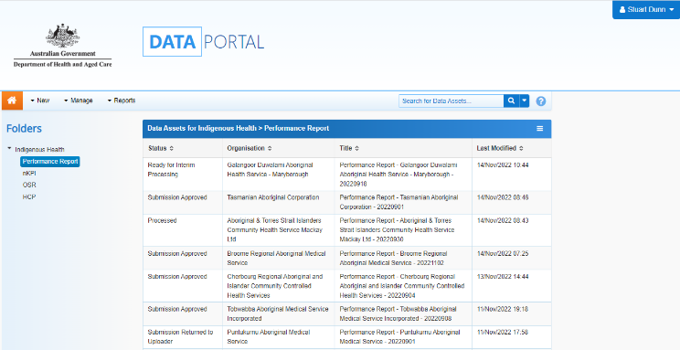
- On the Data Portal home screen, select next to your name in the top right-hand corner of the screen and select Request New Profile from the list that displays.
The Request User Profile screen will display.
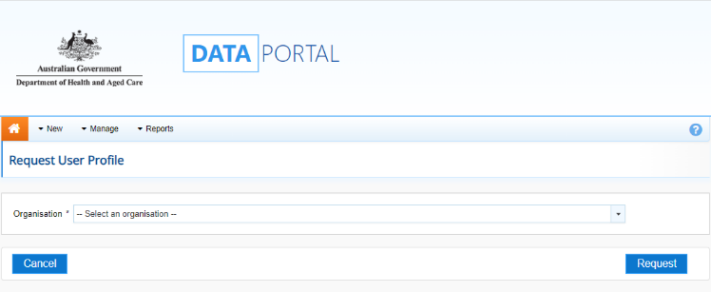
- Select in the Organisation field and select the organisation you wish to request an alternate user profile for, from the drop-down list that displays.
The Organisation drop down list contains a search field in which you can enter the name of the organisation in question to refine the list. Alternatively, you can just scroll down the list.
- Once you have selected the organisation, select .
Your request for an alternate user profile has now been submitted to the User Administrator for the nominated organisation for action.
Check the Status of the Request
Once you have submitted a request to have an alternate user profile created, you can easily check the status of your request in the Data Portal.
To check the status of a user profile request in the Data Portal:
- Ensure the Data Portal home screen is displayed.
- On the Data Portal home screen, select next to your name in the top right-hand corner of the screen and select My User Profiles from the list that displays.
The My Profiles screen will display, and a list of your Data Portal profiles will appear, including the profile you have requested.
This profile will have the status of Pending until a User Administrator for the nominated organisation actions (accepts or rejects) the request.
Switch User Profiles
If you have multiple profiles in the Data Portal, you can easily switch between them as required, depending on the organisation you need to manage your data asset for.
To switch user profiles in the Data Portal:
- Ensure the Data Portal home screen is displayed.
- On the Data Portal home screen, select next to your name in the top right-hand corner of the screen and select My User Profiles from the list that displays.
The My Profiles screen will display, listing your default profile (the one currently in use) along with any other profiles that have been created for you.
- To switch to an alternate profile for another organisation, select in the Action column for the profile you wish to use.
You can now perform the activities permitted by your selected alternate user profile.
- To return to your original user profile, just repeat the above steps.
Performing the above steps will activate the selected profile for your current session only and your default profile will be restored the next time you log in. To set an alternate profile as your default profile, simply select next to the profile instead of .
Manage Your User Profiles

