To review an nKPI data asset submission in the Data Portal:

**Review an nKPI Submission (Health Service)**

1. Open the Data Portal through [Health Data Portal](https://dataportal.health.gov.au/).
2. Log in using the information provided in the *Registering for and Logging in to the Health Data Portal* QRG.

The Data Portal home screen will display with the *Reporting Dashboard* open.

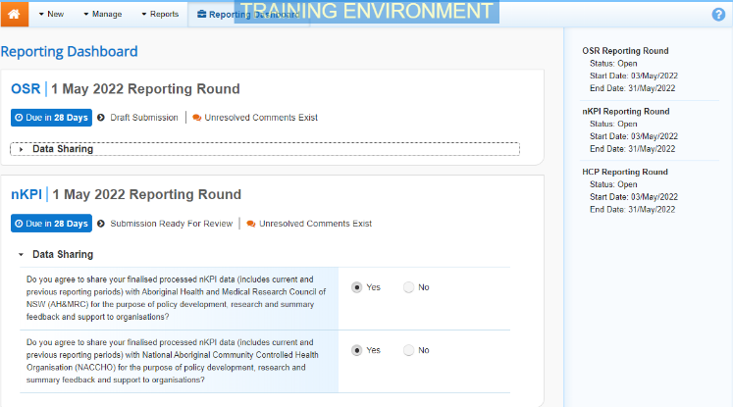

 To be eligible for review, the data asset’s status will need to be *Submission Ready for Review*.

1. To open the nKPI form, hover your mouse pointer to the right of the nKPI Reporting Round text in the **Reporting Dashboard** and select Open Submission Form.

 If you need to change the *Title* or *Description* of the data asset or switch it to a *Trial Submission*, you can do so in the Data Asset Details screen by selecting Nore Details next to Open Submission Form and then selecting *Open Data Asset.*

The nKPI form will display.

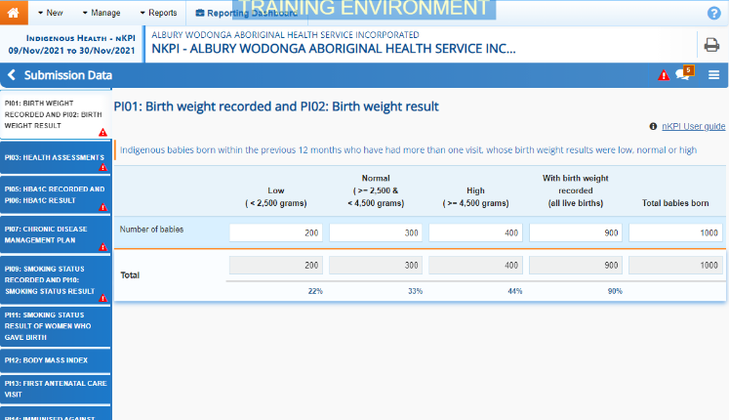

Any indicators that still have data validation flags to be addressed will display a data validation flag on the corresponding tab. If an indicator has a data validation flag that has been responded to by the *Submission* *Uploader* or a new internal comment entered by the *Submission* *Uploader*, it will show a speech bubble on the corresponding tab.

1. Review the data in each indicator and, if needed, update any values.
2. To add a comment about any changes you have made to the values or asking the *Submission Uploader* to amend the data, hover your mouse pointer to the right of the applicable data validation flag title in the **Notifications Tray**, and select the Respond button next to the most recent comment.

 If the *Notifications Tray* doesn’t display, select Open Notification tray - some comments require action or Open Notification tray - some comments require action at the top of the form to open it so you can address the data validation issues/read the comments that display.

1. Select the down arrow in the **Reason** field that displays and select the reason you are adding a comment from the drop-down list.
2. Enter your comment in the **Additional Information** field.
3. To save the comment, select the Save button.
4. Repeat this process for any other values in the form that need to be changed.

The comment has been added and can be viewed by anyone accessing the data asset.

Note If you wish to add an internal comment explaining the changes you have made, select Create New Comment at the top of the *Notifications Tray*, and add the details.

1. To exit the nKPI form and return to the Data Portal home screen, scroll to the bottom of the form, and select Close.

The Data Portal home screen will again display with the *Reporting Dashboard* open.

1. Before progressing the data asset through the submission workflow, answer either **Yes** or **No** to the data sharing consent questions that display under **Data Sharing** if the questions have not already been answered.
2. To save the changes, select Save.
3. To progress the nKPI submission through the submission workflow, select the Submission Ready for Review link.

The Change Data Asset Status dialog box will display.

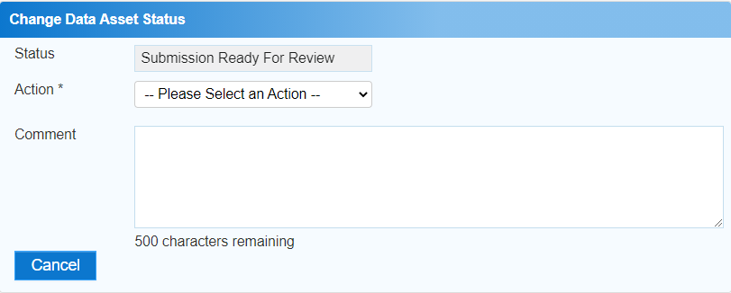

1. In the **Action** field, select the down arrow and select the appropriate action.

The available actions are:

* **Request Approval** – Select this action to send the data asset to your CEO or their representative for approval.
* **Approve for Submission** – Select this action if you are the health service’s CEO, or nominated representative, and are approving the data asset as well as reviewing it.
* **Request Interim Processing** – Select this action to send the data asset to the AIHW for review prior to it going to your CEO or their representative for approval. This process is known as *Interim Processing*.
* **Revision Required** – Select this action to return the data asset to the *Submission Uploader* for amendment.

1. In the **Comment** field, enter any comments about the action being performed on the data asset.
2. One of the following buttons can now be selected when submitting the data asset, depending on the action you have selected:
   1. To send the data asset to your CEO or their representative for approval, select the Request Approval. See the *Approve an nKPI Submission* QRG for the next step in the process.
   2. To approve the data asset and send it directly to the AIHW for processing, select the Approve for Submission button. See the *Process an Indigenous Health Data Asset Submission* QRG for the next step in the process.
   3. To send the data asset to the AIHW for review prior to sending it to your CEO or their representative for approval, select the Request Interim Processing button. See the *Interim Processing of an Indigenous Health Data Asset Submission* QRG for the next step in the process.

**Review an nKPI Submission (Health Service)**

* 1. To send the data asset back to the *Submission Uploader* for amendment, select the Revision Required button. See the *Amend an nKPI Submission* QRG for the next step in the process.

The nKPI submission has now been reviewed and either sent on to the CEO or their delegate for approval or sent back to the *Submission Uploader* for revision if needed.