There may be times when the draft publication you have submitted for review or approval is returned to you for amendment.
Amend a Draft Publication
To amend a draft publication in the Data Portal:
- Open the Data Portal through Health Data Portal.
- Log in using the information provided in the Registering for and Logging in to the Health Data Portal QRG.
The Data Portal home screen will display.
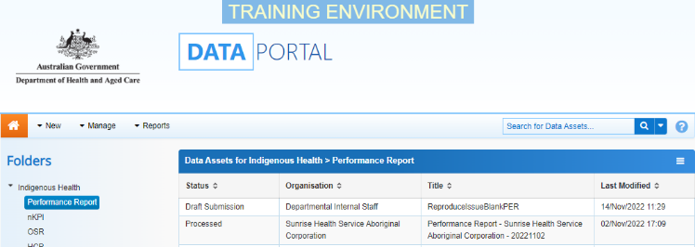
- From the home screen search for the data asset.
For more information on how to search for a data asset, see the Get Started in the Health Data Portal QRG.
- In the Data Assets section select the data asset to be amended.
The Data Asset Details screen will display.
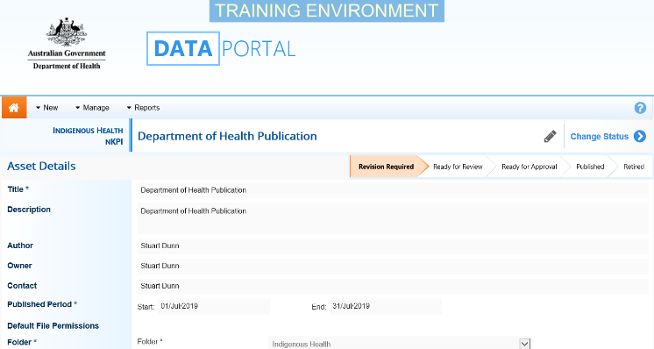
- To update the details of the data asset including the attached publication, select at the top of the screen.
The Data Asset Details screen will update so active (white) fields on the screen can be edited.
- Make any required changes to the active fields on the Data Asset Details screen.
- To review the contents of the attached publication, select the link under File Name in the Files section.
- There are several actions that can be performed on the attached publication in the Files section.

Button | Description
 | Select this button under File Name to download and view the file. A pop up will appear in the bottom left-hand corner of the screen and you can open the file from here and save it as required.
 | Select this button under File Name to replace the file with another file if you have uploaded it incorrectly.
 | Select this button under Actions to view the publication’s previous versions.
 | Select this button under Actions to add text to the Description field.
 | Select this button under Actions to remove the publication from the data asset.
 | Select this button under Actions to view the publication’s download history.
 | Select this button under Actions to see a list of users who will have the required file permissions to view the publication once it is published.
Select this button under Actions to add an updated version of the file if needed.
This will add a second file, rather than replace the existing one.
- To save your changes to the data asset details, select 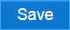.
- Once the data asset has been updated, select either or the workflow progress bar at the top of the screen and, in the Change Data Asset Status dialog box, in the Action field, select and select the required action.
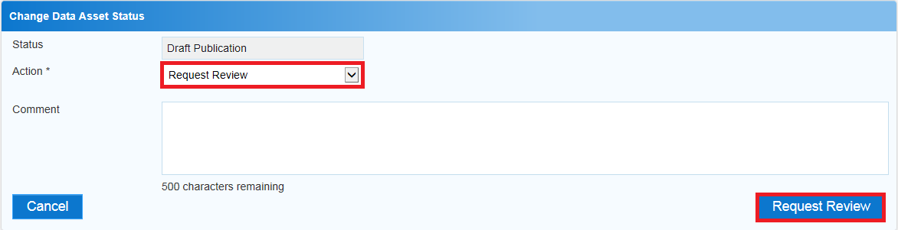
Amend a Draft Publication
The reviewer or approver should have added comments to the Comment field in the dialog box detailing the changes that need to be made to the publication.

The available actions are:
Amend a Draft Publication
- Request Review – Select to send the data asset back to the Publication Reviewer for further review.
Amend a Draft Publication
- Remove Data Asset – Select if the data asset is to be deleted from the Data Portal (it may have been created in error).
- In the Comment field, add any comments regarding your amendment of the data asset.
- One of the following options can now be selected:
  - To send the data asset for further review select 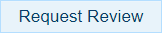. See the Review a Draft Publication QRG for the next step in the process.
  - To remove the data asset from the Data Portal, select 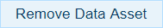.
To save the data asset as a draft select .
The data asset has now been amended and sent back to the Publication Reviewer for further review.

