Data assets can be approved by anyone within an organisation with the Submission Approver role. In smaller organisations the person approving the data asset may also be the person who has reviewed or submitted the data asset.
Approve a Data Asset Submission
To approve a data asset in the Data Portal:
- Open the Data Portal through Health Data Portal.
- Log in using the information provided in the Registering for and Logging in to the Health Data Portal QRG.
The Data Portal home screen will display.
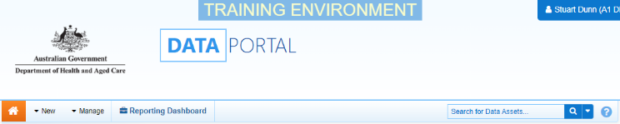
- From the Data Portal home screen search for the data asset.
For more information on how to search for a data asset, see the Get Started in the Health Data Portal QRG.
To be eligible for approval, the data asset’s status will need to be Submission Ready for Approval.
- In the Data Assets section select the data asset.
The Data Asset Details screen will display.
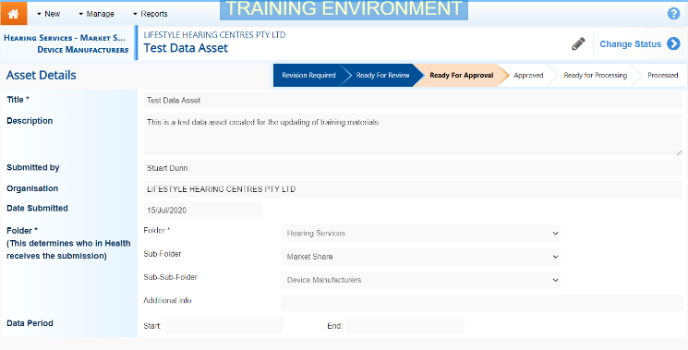
- To update the details of the data asset, select at the top of the screen.
The Data Asset Details screen will update so active (white) fields can be edited (including answering Data Submission Questions if needed).
- Make any required changes to the active fields on the Data Asset Details screen.
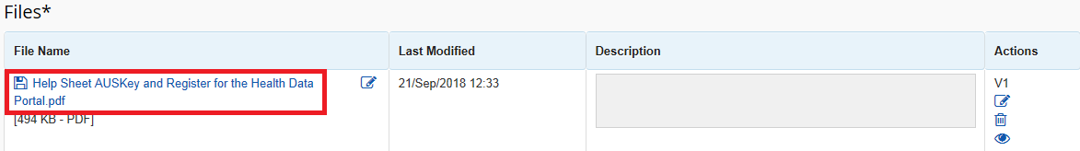
- There are several actions that can be performed on the attached file, in the Files section.
Button | Description
 | Select this button under File Name to download and view the file. A pop up will appear in the bottom left-hand corner of the screen and you can open the file from here and save it as required.
 | Select this button under File Name to replace the file with another file if it has been uploaded incorrectly.
 | Select this button under Actions to view the file’s previous versions.
 | Select this button under Actions to activate the Description field so a description of the file can be added.
 | Select this button under Actions to remove the file from the data asset.
 | Select this button under Actions to view the file’s download history.
Select this button under Actions to add an updated version of the file if needed.
This will add a second file, rather than replace the existing one.
- To save your changes to the data asset details, select .
- Once the data asset has been reviewed, select either or the workflow progress bar at the top of the screen and in the Change Data Asset Status dialog box, in the Action field, select and select the required action.
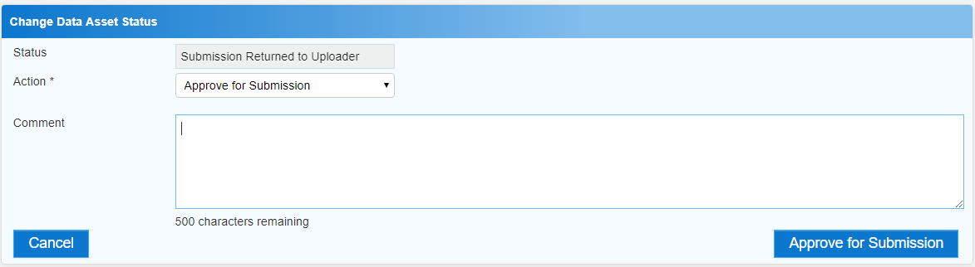
The available actions are:
- Approve for Submission – Select this action to approve the data asset submission for processing.
- Revision Required – Select if the data asset needs to be returned to the Submission Uploader for amendment.
- Add any comments regarding your approval of the data asset, in the Comment field.
Approve a Data Asset Submission
- One of the following options can now be selected:
  - To approve the data asset and send it for processing select 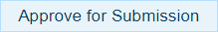. See the Process a Data Asset Submission QRG for the next step in the process.
  - To send the data asset back to the uploader for amendment, select . See the Amend a Data Asset Submission QRG for the next step in the process.
To save the data asset as a draft without sending it on to the next stage of the process, select .
The data asset has now been either returned to the Submission Uploader for amendment or approved for processing.

