Create a Draft Publication
In addition to being used for the submission of data assets for review and approval, the Health Data Portal can also be used for the publication of documents by Health so the information can be accessed and downloaded as required by users of the Data Portal, both internal to Health and external if needed.
To create a draft publication in the Data Portal:
- Open the Data Portal through Health Data Portal.
- Log in using the information provided in the Registering for and Logging in to the Health Data Portal QRG.
The Data Portal home screen will display.
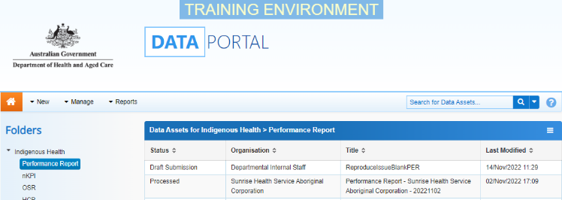
- From the Data Portal home screen, select and then select Asset for Publication from the list that displays.
The New Draft Publication screen will display, and the details of the data asset can be completed.
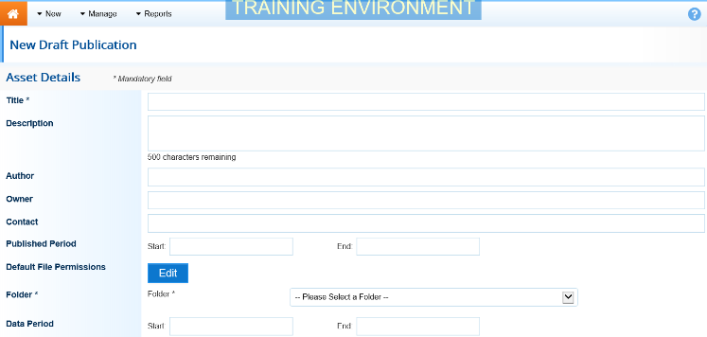
- Complete the fields on the screen as described below.
* indicates a mandatory field.
Field | Description
Title* | Enter a title for the new data asset. This should reflect the content of the attached publication. The title is important as it will be used by others when searching for the data asset in the future.
Description | Enter a description of the data asset. This would generally contain information regarding the content and purpose of the attached publication.
Author | Enter the name of the person who authored the document to be published in the data asset.
Owner | Enter the name of organisation the author of the publication belongs to.
Contact | Enter the contact information (email address or phone number) that should be used by anyone wanting to contact the author of the publication.
Published Period | Enter the start and end date for the published period. This will govern the period during which the publication can be viewed and downloaded by those users of the Data Portal with the required file permissions.
Default File Permissions | Select and choose the view file permissions that you want applied for the published data asset. Only users with the selected file permissions will be able to view and/or download the publication once it is published.  To do this:  Select the file permission from the Available field on the left and select to move the permission to the Selected field on the right. Once finished, select .  To be able to submit the draft publication to the next stage of the publication process, file permissions must be added at this point.
Folder* | Select and select the relevant folder from the list that displays. The data asset will display in the selected folder on the Data Portal home screen when published.
Sub-Folder | Select and select the relevant sub-folder from the list that displays.  This field will only display, if applicable once a folder is selected in the Folder field.
Data Period | Enter the start and end date for the period the data being published relates to.
- To add your report/information to the data asset to be published, select
The Upload Files dialog box will display.
Create a Draft Publication
- To upload the file, select 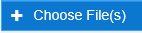.
The Windows dialog box will display.
- Locate the file you wish to upload to the data asset being published (e.g. your PDF report).
- Select the file and then select .
The Data Assets Details screen will again display, and the selected publication will now appear in the Files section of the screen.
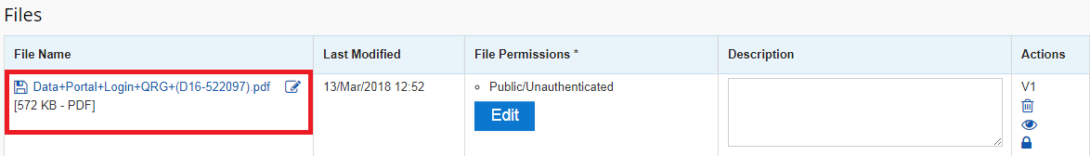
The file needs to have entries in the File Permissions column (these should flow through from the entries selected in the Default File Permissions field). If required, select to change the file permissions.
- In the Description field, enter a description of the file if required.
- There are several actions that can be performed on the publication if needed.
Button | Description
 | Select this button under File Name to download and view the file. A pop up will appear in the bottom left-hand corner of the screen and you can open the file from here and save it as required.
 | Select this button under File Name to replace the file with another file if you have uploaded it incorrectly.
 | Select this button under Actions to view the publication’s previous versions. There will be no previous versions at this stage of the process.
 | Select this button under Actions to remove the publication from the publication.
 | Select this button under Actions to view the publication’s download history. There will be no download history at this stage of the process.
 | Select this button under Actions to view the list of users who have access to view the attached publication.
Select this button under Actions to add an updated version of the file if needed.
This will add a second file, rather than replace the existing one.
- To submit the data asset, select either or the workflow progress bar at the top of the screen and, in the Change Data Asset Status dialog box, in the Action field, select and select the required action.
The available actions are:
- Request Review – Select this action to send the data asset to the Publication Reviewer within your organisation for review prior to it being submitted for publication.
- Request Approval – Select this action to send the data asset directly to the Publication Publisher within your organisation for approval.
- Remove Data Asset - Select this action to remove the data asset from the Data Portal (it may have been created in error).
If you can approve data assets for publication, you will also see the Approve for Publication option in the Action list. This allows you to approve the data asset where it will wait for the published period to start before being available to view and download.
Submit a Data Asset
- Add any comments regarding the publication in the Comment field if required.
- One of the following options can now be selected when submitting the data asset, depending on the action you have selected:
  - To submit the data asset for review, select 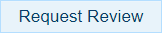. See the Review a Draft Publication QRG for the next step in the process.
  - To submit the data asset for approval, select 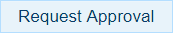. See the Approve a Data Asset for Publication QRG for the next step in the process.
  - To remove the data asset from the Data Portal, select .
To save the data asset as a draft without sending it on to the next stage of the process, select 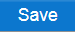.
Create a Draft Publication

