

First Nations Health Reporting:
PI26 – Ear Health Check – Best Practice

Introduction
First Nations people have a high prevalence of otitis media and hearing problems. The ‘National guide to preventative healthcare for Aboriginal and Torres Strait Islander people’ recommends regular ear and hearing health checks for the early diagnosis and management of ear problems.
PI26 is currently a pilot National Key Performance Indicator (nKPI) designed to measure regular comprehensive screening of ear health in children. It particularly focuses on assessment of the:
- Appearance of the ear canals and ear drums, of both ears, and
- Movement of the ear drums, of both ears.
While the indicator’s inclusion criteria are relatively straightforward, the complexity lies in sourcing the relevant data from multiple locations within the clinical information system (CIS), and in understanding the priority rules for counting that data.
This article explains the reporting rules to help health services better understand the reported data. It also outlines where to record ear health checks in the CIS so that health services’ activities are accurately counted and reflected in their nKPI report.
What’s happening / context
Although the indicator is designed to capture comprehensive ear health checks, the ability to record these ear checks varies by CIS.
Most CIS do not have a dedicated ear health module to record a comprehensive check in one place, and, in some CIS, recording options are limited. In systems without an ear health module, data must be recorded in alternate locations – specifically, the procedures or conditions/diagnoses fields – so it can be counted in the nKPI report. These fields act as proxies for a dedicated module so that health services’ ear check activities can be counted.
Comprehensive reporting relies on the ear check being recorded in the correct part of the CIS; otherwise, it may not be captured by the reporting tools resulting in missing data. To accommodate the multiple data sources, the indicator has a tiered approach for sourcing data, with the following defined order of priority.
- Ear health module – This is the preferred source, providing the most complete record of a comprehensive ear health check.
- Ear health procedures* – If there is no ear health module or no data is recorded in the ear health module, data from procedures (defined in the ear health coding framework) are counted.
- Ear health conditions/diagnoses* – If there is no data in the ear health module and no procedure data, then the ear health conditions/diagnoses defined in the ear health coding framework are counted. This is the least preferred source, as a diagnosis itself doesn’t definitively confirm that a comprehensive ear check was completed.
The tiered counting approach ensures that the most reliable data is used for reporting whilst also accommodating some of the CIS recording limitations. A further rule applies whereby when data is found in the first tier the count stops and doesn’t look for data in the lower tiers. This means data is only counted from the highest-priority source when relevant data is found even if parts of a check are recorded elsewhere. Data recorded in lower-priority workflows will not be counted if any relevant data exists in a higher-priority workflow. For example, if an appearance check is recorded in procedures and a movement check in diagnoses, only the appearance check from the procedure will be counted – the movement check in the diagnosis field will be ignored.
*To report ear check related procedures or conditions against an assessment of appearance and/or movement, each eligible procedure and condition is allocated to the categories of Appearance (App), or Movement (Move), or Both. These are listed in the Specifications for nKPI and OSR in Appendix E, the Condition Coding Framework. The following example from the Ear Health section shows the allocation of appearance and/or movement for each term in the far-right column. Each CIS is colour coded for quick reference.
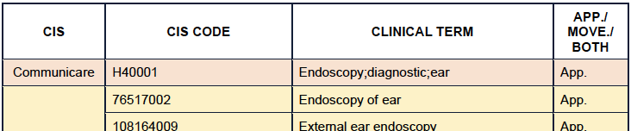
TIP: For data to be reported by the CIS’s reporting tool it's important for health services to understand how their CIS manages ear health data and know where checks should be recorded to ensure they are counted.
Best Practice data limitations
Available options for recording ear checks in the CIS affect how data for PI26 is reported. Further limitations apply when the available fields are not structured in a way the vendor can ‘use’ (extract) them for reporting.
Best Practice limitations include:
- No dedicated ear health module: Best Practice does not have a specific ear health module, meaning ear health data must be sourced from other locations within the client’s record.
- ENT module data not counted: Data entered in the ENT module (within the Enhanced Primary Care, Health Assessment menu) is not counted because it is not coded data. Best Practice advises against extracting data from this location due to concerns of negative impact on software performance.
- Limited ear health procedures: The ear health procedures available in Best Practice are limited, with notable gaps, including the absence of clinically recommended tests like ear endoscopy, otoscopy, and tympanometry. However, Best Practice does have a procedure code for ‘Ear Check’ (code 8245), which enables the recording and reporting of ear checks, regardless of whether an ear health condition is present. For guidance on recording this procedural code, refer to data management tips below.
Best Practice data management tips
Note the 12-month window
PI26 only counts checks conducted in the last 12 months. This is particularly important when sourcing proxy ear check data, because the date of the recorded procedure or condition must fall within the specified period.
Understand the included procedures and conditions
Some notable principles for exclusion apply to PI26 specifically where an activity, procedure or condition, is not deemed evidence of a comprehensive ear check. For example:
- Hearing tests are excluded because there is insufficient information to confirm the assessment of appearance and/or movement.
- Hearing loss is also excluded.
TIP: Un-coded 'free text' fields are excluded from nKPI reporting. Procedures or conditions must be selected from the available coded / pick-list options (i.e. not typed as free text).
Knowing which procedures and conditions are included will help you determine when an ear health check will be counted. These are documented in the ear health coding framework (Specifications: Appendix E, Section 6).
TIP: If your service uses an audiologist to perform ear health assessments that include an appearance and movement check consider how to record this for the activity to be counted in nKPI reports. For the assessment to be counted, a valid coded procedure or condition must be recorded. If the audiologist doesn’t have access to the CIS, perhaps a practice nurse or Aboriginal Health Worker may be able to assist with this.
Recording ear checks under the term "Ear Check" or "Check Ear", when there is no other relevant procedure or condition to record, will ensure checks on children with healthy ears are counted.

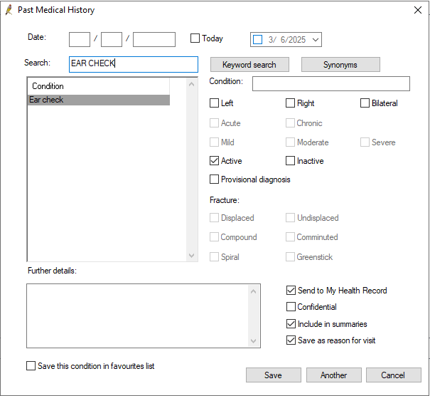

These procedural terms can be selected from the drop-down menu in Best Practice's Past History section, just as you would when selecting a diagnosis.
TIP: When entering the ear check retrospectively, remember to change the date to match the service date.
715 health checks aren’t counted
Ear checks recorded within the 715 health check are not counted. This is because the 715 alone isn’t considered sufficient evidence of a complete ear health assessment. For the check to be counted in Best Practice, it needs to be recorded as a coded procedure or diagnosis.

Key takeaway(s):
- Although PI26 is complex, options exist in each CIS to record ear checks so they are counted for reporting.
- Know where to record ear check data in your CIS and share that information within your health service.

Resources
Links to supporting documents, information and further reading:
- Specifications for nKPI and OSR: This document outlines the counting rules for PI26 in detail. Appendix E, Section 6 includes a list of the procedure and condition codes and terms that are either included or excluded. Section 6.5 explains how each vendor has implemented the ear health counting rules. Access the full Specifications here: https://www.solvinghealth.au/specifications.
- CIS User Guides: These explain how each vendor reports PI26 and where data need to be recorded to optimise reporting. Refer to the article CIS User Guides for links or visit the link in the Specifications (dot point above) which has links to vendor documents at the end of the web page.
For more data management tips see the other articles in this series available at: Clinical Information System (CIS) Education Articles

