Quick Facts

To register for the Health Data Portal, you must first have set up your personal myGovID and had a profile created in the Relationship Authorisation Manager (RAM) by your organisation’s Principal Authority (PA).

 For more information on how to obtain your myGovID, see [*Registering for myGovID*](https://www.mygovid.gov.au/).

Register for the Data Portal

To register for the Data Portal:

1. Open the Data Portal through [*Health Data Portal*](https://dataportal.health.gov.au/).

The Data Portal home screen will display.

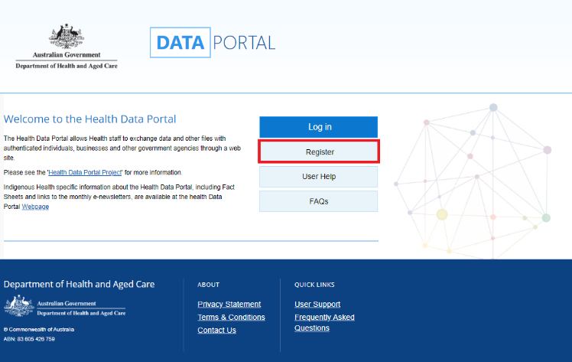

1. From the Data Portal home screen, select Register.

The Registration – Authentication screen will display.

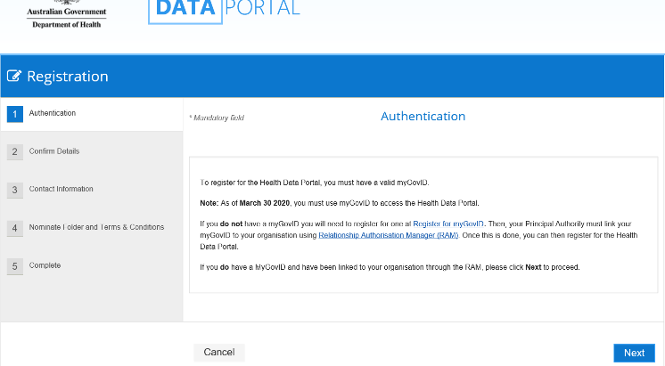

This screen confirms you need to have a valid myGovID to be able to register for the Data Portal.

1. To continue registration, select the Next button.

 If you don’t have a valid myGovID, select the Cancel button and follow the previous links to obtain one.

The Health Authentication Gateway screen will display.

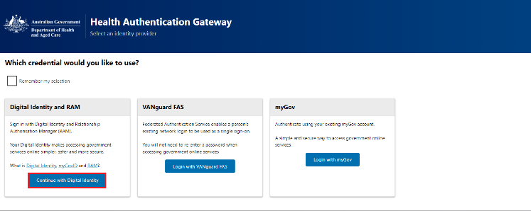

1. To continue, select Continue with digital identity.

 Do not select Login with myGov as this will take you to a different system.

The Select your identity provider screen will display.

picture of the Select your identity provider screen

 If you select the **Remember my choice** check box before selecting Select myGovID the Select your identity provider screen will not display again.

1. To continue, select Select myGovID.

The myGovID screen will display.

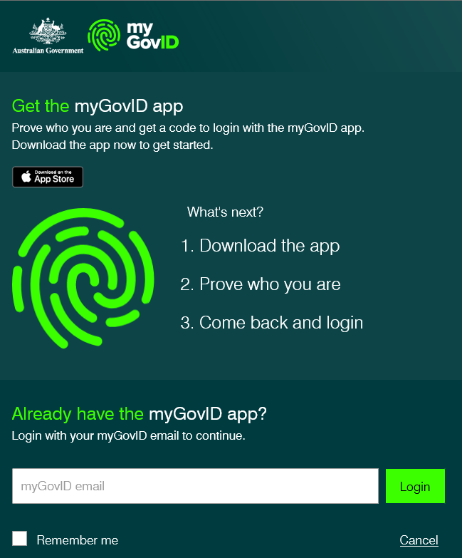

1. Enter your myGovID email address in the **myGovID email** field at the bottom of the screen.
2. To continue, select Login.

 If your myGovID is linked to more than one organisation, select the organisation you wish to register under and then select **Continue**.

1. Enter the 4-digit code that appears into the applicable fields that have appeared on your smart phone.

The Your consent screen will display your myGovID details.

picture of the Your Consent screen

1. To continue, select Consent.

The Registration - Confirm Details screen will display.

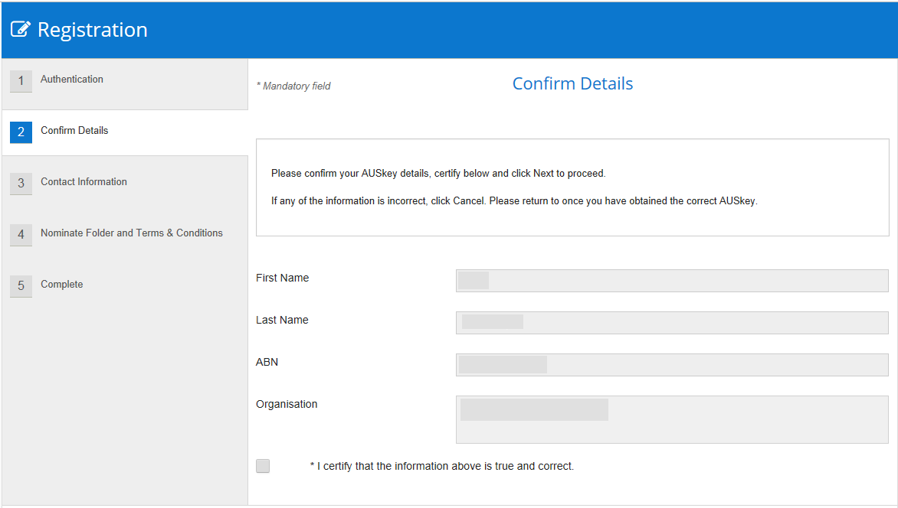

1. Check to ensure your details are correct.
   1. If your details are incorrect, selectthe Cancel button and restart the registration process with the correct myGovID.
   2. If your details are correct, select the **I certify that the information above is true and correct** check box and select the Next button.

The Registration - Contact Information screen will display.

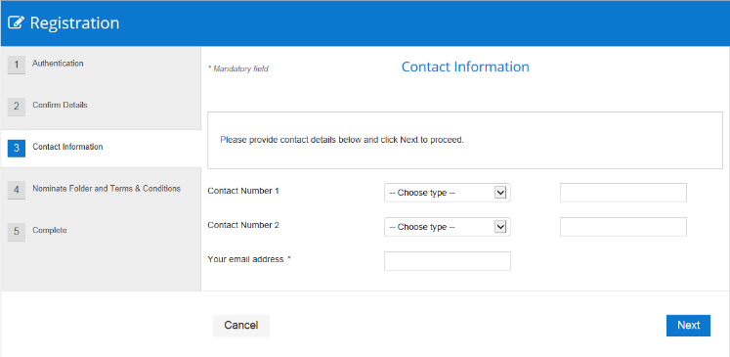

1. In the **Contact Number 1** field, select the down arrowand select **Office**.
2. In the blank field next to **Contact Number 1**, enter your contact phone number. Ensure you include your area code.
3. In the **Your email address** field, enter a contact email address.

 You do not have to enter a second contact number.

1. To continue, select the Next button.

The Registration - Nominate Folder and Terms and Conditions screen will display.

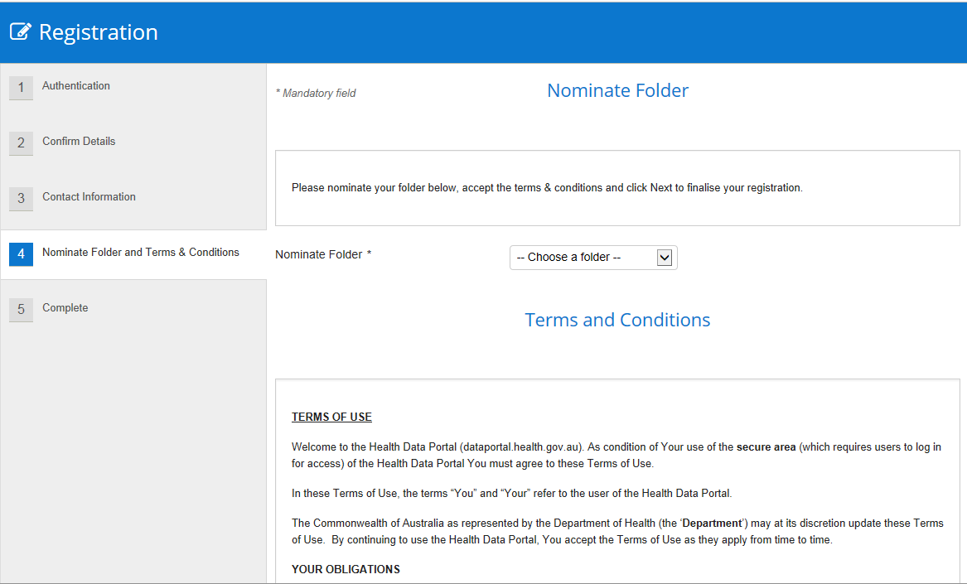

1. In the **Nominate Folder** field, select the down arrow and pick the folder you need to have access to from the drop-down list.

 Please select the folder carefully as this determines who is notified of your Data Portal registration.

1. Scroll to the bottom of the screen and select the **I accept the terms and conditions listed above** check box.
2. To continue, select the Next button.

The Data Portal Complete screen will display.

1. To complete the registration process, select the Finish button.

You have now successfully registered for the Data Portal. Your *User Administrator* will receive an email informing them they need to finalise your profile so you can use the Data Portal.

Log in to the Data Portal

Once you have registered for the Data Portal and your user profile has been completed by your *User Administrator*, you can log in to the Data Portal as needed.

To log in to the Data Portal:

1. Open the Data Portal through [Health](https://dataportal.health.gov.au) Data Portal.

The Data Portal home screen will display.

1. From the Data Portal home screen, select Log In.

The Health Authentication Gateway screen will display.



1. To continue, select Continue with digital identity.

 Do not select Login with myGov as this will take you to a different system.

The Select your identity provider screen will display if you didn’t select *Remember my choice* when registering.

picture of the Select your identity provider screen

 If you select the *Remember my choice* check box before selecting Select myGovID the Select your identity provider screen will not display again.

1. To continue, select Select myGovID.

The myGovID screen will display.



1. Enter your myGovID email address in the **myGovID email** field at the bottom of the screen.
2. To continue, select Login.

 If your myGovID is linked to more than one organisation, select the organisation you wish to register under and then select **Continue**.

1. Enter the 4-digit code that appears into the applicable fields that have appeared on your smart phone.

The Your consent screen will display your myGovID details.

picture of the Your Consent screen

1. To continue, select Consent.

The Data Portal home screen will update, and you can now work in the Data Portal as required.

 If you can’t see any options on the blue bar near the Home button on the left-hand side of the Data Portal home screen, you have not been assigned any Data Portal roles. To resolve this, contact your *User Administrator* and ask them to update your profile.