To extract a report containing a history of all the data validation flags in a data asset, along with their accompanying responses, in the Health Data Portal:
Extract the Data Validation History Report from a Data Asset
- Open the Health Data Portal through Health Data Portal.
- Log in using the information provided in the Register for and Log in to the Health Data Portal QRG.
The Data Portal home screen will display with the Reporting Dashboard open.
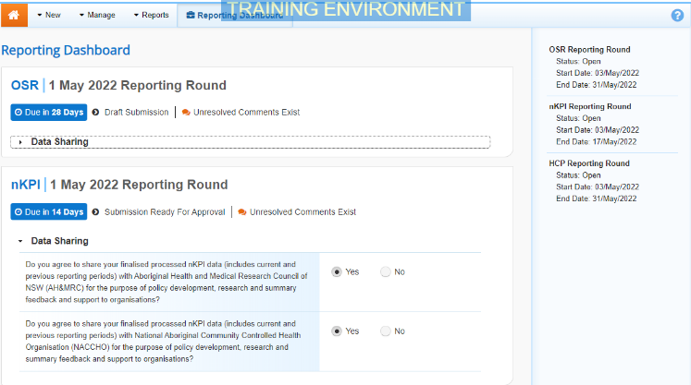
- In the Reporting Dashboard, hover your mouse pointer to the right of the reporting period text for the applicable data asset, select and then select Open Data Asset.
The Data Asset Details screen will display.
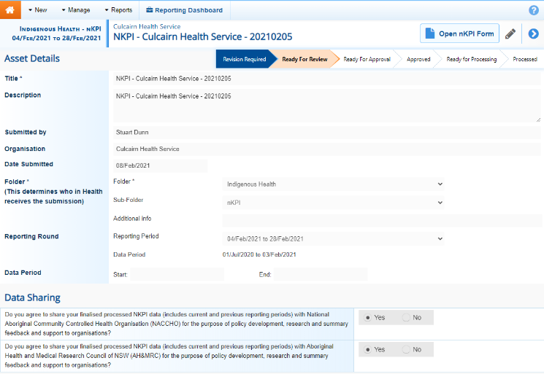
- To extract the data validation history report, in the Files section of the screen, in the Actions column, select .
The report has now been added to in the top right-hand corner of your browser.
- To continue, select and select the Excel report from the list that displays.
The Data Validation History report will now open in Microsoft Excel.
This report will contain the following information:
- The type of data validation issue appearing,
- The indicator each data validation issue applies to,
- The applicable data validation flag text,
- The name of the user who responded to each of the data validation flags,
- The reason the user selected when responding to a flag, and
- The content of the response.
- Now you can save and/or use the data validation history report as needed.
In order to see all the required information in the Excel report, you will need to expand some of the columns in the report.

