Interim Processing of an nKPI Submission

Initiate Interim Processing (Health Service)
To start interim processing of an nKPI data asset in the Data Portal:
- Open the Data Portal through Health Data Portal.
- Log in using the information provided in the Register for and Log in to the Health Data Portal QRG.
The Data Portal home screen will display with the Reporting Dashboard open.
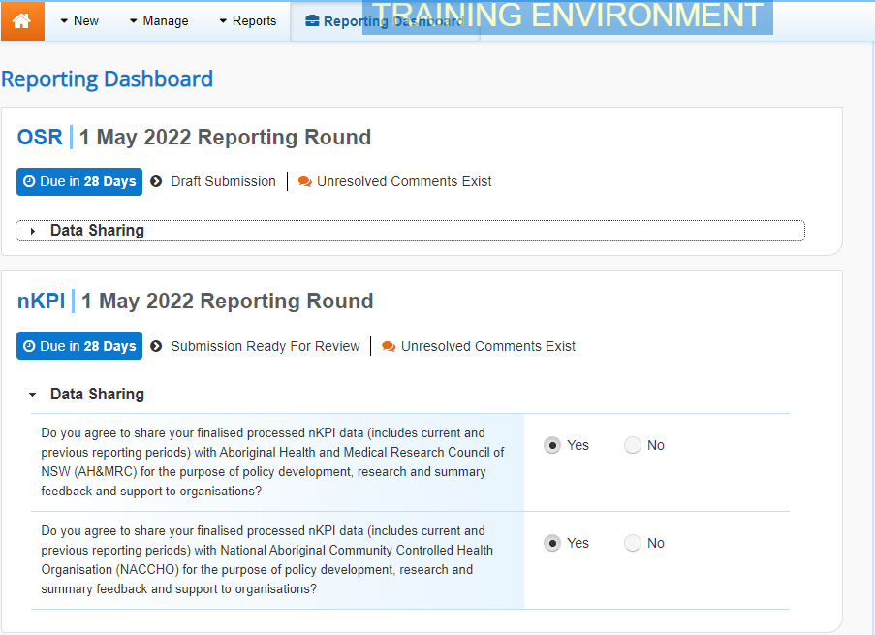
To be eligible for interim processing, the data asset’s status can be at either Draft Submission or Submission Ready for Review, if the user has the Submission Reviewer role.
- Before progressing the nKPI data asset through the interim submission workflow, answer either Yes or No to the data sharing consent questions that display under Data Sharing if the questions have not already been answered.
- To save the changes, select .
- To start interim processing, select in the Reporting Dashboard and, in the Change Data Asset Status dialog box, in the Action field, select and select Request Interim Processing.
- In the Comment field, enter any comments you wish to add for the AIHW.
- To send the nKPI data asset to the AIHW for interim processing, select.
The status of the nKPI data asset has now been set to Interim Submitted and the AIHW can review the data asset as needed to assess its suitability before it goes to the health service’s CEO, or their representative, for approval.
Review the Data Asset (AIHW)
To review the nKPI data asset:
- Ensure the Date Portal home screen is displayed.
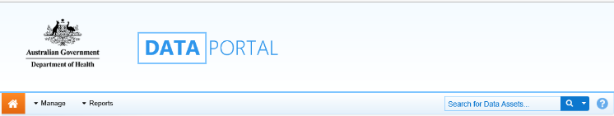
- From the Data Portal home screen, search for the nKPI data asset to be reviewed.
For more information on how to search for a data asset, see the Get Started in the Health Data Portal QRG.
The data asset will have the status of Interim Submitted.
- Select the nKPI data asset to be reviewed.
The Data Asset Details screen will display.
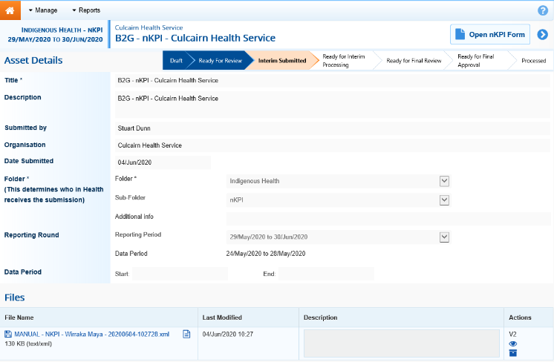
- Review the details of the data asset as needed.
- To review the contents of the form, select at the top of the screen.
- Once finished, select at the bottom of the nKPI form to exit the form and return to the Data Asset Details screen.
- To action the data asset, select either or the workflow progress bar at the top of the screen and, in the Change Data Asset Status dialog box, in the Action field, select and select Ready for Interim Processing.
If the health service has asked you to return the data asset as it has been submitted in error, select Return to Uploader.
- In the Comment field, enter any comments about the action being performed on the data asset.
- To prepare the data asset for processing, select .
Process the Data Asset (AIHW)
To complete interim processing on the nKPI data asset in the Data Portal:
- Ensure the Date Portal home screen is displayed.
- From the Data Portal home screen, search for the nKPI data asset with the status of Ready for Interim Processing.
For more information on how to search for a data asset, see the Get Started in the Health Data Portal QRG.
- Select the nKPI data asset to be processed.
The Data Asset Details screen will display.
- Review the details of the data asset as needed.
- To review the contents of the form, select at the top of the screen.
- Once finished, select at the bottom of the nKPI form to exit the form and return to the Data Asset Details screen.
- To action the data asset, select either or the workflow progress bar at the top of the screen and, in the Change Data Asset Status dialog box, in the Action field, select and select Request Review to send the data asset back to the health service’s Submission Reviewer, who will review the data asset and move it to the next stage of the process. This action will progress the data asset to the status of Submission Ready for Final Review.
Interim Processing of an nKPI Submission

- In the Comment field, enter any comments about the action being performed on the data asset.
- To send the nKPI data asset on to the health service’s Submission Reviewer, select.
Conduct a Final Review of the Data Asset (Health Service)
To conduct a final review of the nKPI data asset in the Data Portal:
- Ensure the Date Portal home screen is displayed, and the Reporting Dashboard is open.
The data asset will have the status of Submission Ready for Final Review.
- To open the Data Asset Details screen for the data asset, hover your mouse pointer to the right of the Reporting Round text in the Reporting Dashboard, select and then select Open Data Asset.
- Review the details of the data asset as needed.
- To review the contents of the form, select .
- Once finished, select at the bottom of the nKPI form to exit the form and return to the Data Portal home screen.
- To action the data asset from the Reporting Dashboard, select and, in the Change Data Asset Status dialog box, in the Action field, select and select Request Approval.
If changes need to be made to any of the data in the data asset, select Revision Required to send the data asset back to the Submission Uploader for amendment.
- To send the data asset on to the CEO or their representative for approval, select.
The nKPI data asset has now been sent to the CEO or their representative within the health service for final approval.
Approve the Data Asset Submission (Health Service)
Interim Processing of an nKPI Submission

To approve the nKPI data asset that has been through interim processing in the Data Portal:
- Ensure the Date Portal home screen is displayed.
The data asset will have the status of Submission Ready for Final Approval.
- To open the Data Asset Details screen for the data asset, hover your mouse pointer to the right of the Reporting Round text in the Reporting Dashboard, select and then select Open Data Asset.
- Review the details of the data asset as needed.
- To review the contents of the form, select .
- Once finished, select at the bottom of the nKPI form to exit the form and return to the Data Portal home screen.
- To action the data asset from the Reporting Dashboard, select and, in the Change Data Asset Status dialog box, in the Action field, select and select Approve for Submission.
If changes need to be made to any of the data in the data asset, select Revision Required to send the data asset back to the Submission Uploader for amendment.
- In the Comment field, enter any comments about the action being performed on the data asset.
- To approve the data asset, select.
The nKPI data asset has been progressed to the status of Processed and the data asset submission process is now complete.

