Overview
Get Started with the QLIK Health Service nKPI and OSR Report
The QLIK Health Service nKPI and OSR Report provides access to reports that allow you to view trends and patterns in your health service’s data and compare your data with that of other similar health services.
When your health service submits data assets in the Health Data Portal, the contents of these data assets can be viewed as interactive sheets in QLIK. QLIK is accessed through the Data Portal using the Interactive Report Viewer role.
To access QLIK, you need to have been given the appropriate role in the Data Portal by your Data Portal User Administrator.
Access the Qlik Health Service nKPI and OSR Report
To access the QLIK Health Service nKPI and OSR Report:
- Navigate to the Data Portal home screen.
- To continue, select Reports > Interactive Reports on the menu bar.
- On the left-hand side of the screen that displays, select Indigenous Health.
- On the right-hand side of the screen that displays, select the top half of the IHD Health Service nKPI Report app.
The Health Service nKPI and OSR Report screen will display.
The Health Service nKPI and OSR Report screen
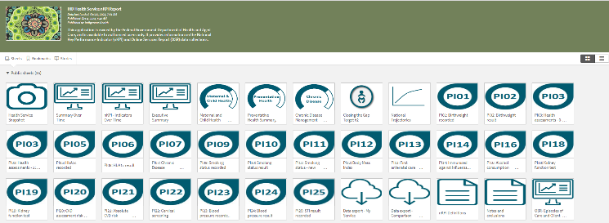
The Health Service nKPI and OSR Report screen is the launch screen from where you can access your Executive Summary and Closing the Gap Target #2 sheets, all your nKPI summary and individual indicator sheets, as well as the Health Service and Comparison Group Data Export sheets and the Online Services Report sheet.
- To access a particular sheet from the Health Service nKPI and OSR Report screen, simply select the tile representing the required sheet.
Getting started with QLIK Sheets
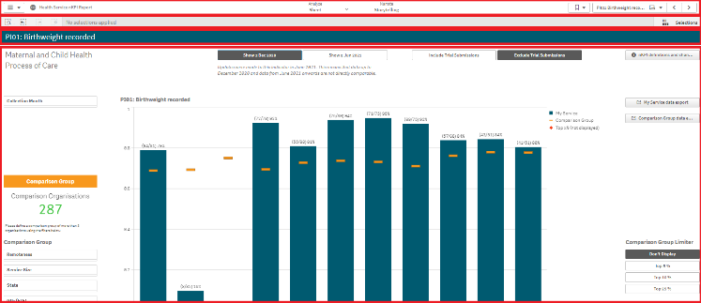
All QLIK sheets are divided into four sections:
- The Menu Bar
- The Selections Bar
- The Title Bar
- The Layout View/Main window.
The Menu Bar (Top)
The Menu Bar enables you to perform the following tasks in QLIK (from left to right):
- Select to access QLIK help or learn more about the software.
- Select to open and close the report header, which displays the title of the report and the last time data was added to the report.
- Select 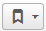 to bookmark and save the location of a particular sheet, or a filter/comparison group you have created. You can then return to the sheet or filter/comparison group as required later.
- Select (the name of your sheet) to open a list of all available QLIK sheets so you can quickly jump to a particular sheet as/if needed. The name listed on this button will display the sheet you are currently viewing.
- Select to move forward and back between the sheets in the report.

The Selections Bar (2)
Get Started with the QLIK Health Service nKPI and OSR Report
The Selection Bar, beneath the Menu Bar, contains the following functions (from left to right):
- Select and enter in key words to search the entirety of your data within the sheets.
- Select to move back and forth between the various data filters you have selected.
- Select to clear any filters you have selected.
- When viewing a sheet, if you select various filers, they will group together for your analysis. These filters will display as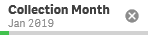.
- Select 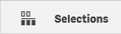 to open a view containing more filter options for the report. Simply select it again to return to the sheet.
The Title Bar (3)
The Title Bar contains the name of the sheet you currently have open (e.g. PI01: Birthweight recorded).
The Layout View/Main window (4)
The Layout view/Main window of any sheet contains the graph or graphs showing your health service’s results (and those of any comparison groups you have created) for the selected indicator(s).
More QLIK Report Features
In addition to the four common sheet sections discussed earlier, there are other standard functions available from any sheet within QLIK.
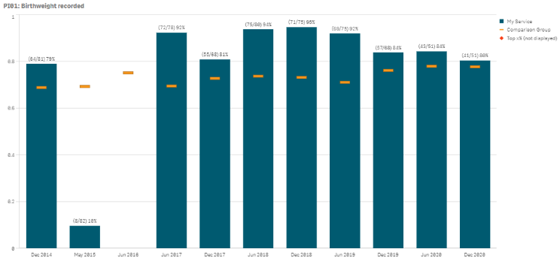

The Hover Menu
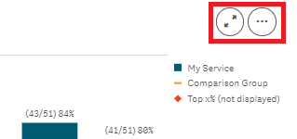
When you hover your mouse pointer over a graph or a table on a sheet, a hover menu will display, presenting you with options regarding what you can do with the data in the selected graph/table.
Full Screen – Allows you to expand the selected graph to full screen view so the results can be viewed and analysed more easily.
More – Opens up a menu that allows you to perform the following functions:
- Allows you to expand the selected graph to full screen view so the results can be viewed and analysed more easily.
- Allows you to quickly change the properties of the results you are viewing without making selections or editing the report. For more information, see Explore Selections in the QLIK Health Service nKPI Report user guide.
- Allows you to view the selected graph as a table. To return to the graph, right click on the table and select .
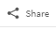 - Allows you to embed the graph into a webpage by selecting the arrow and then Embed.
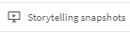 - Takes you to:
- Opens a list of all snapshots you have taken in the sheet so you can add them to your data presentation if needed.
- Allows you to take a snapshot of the data that can then be used in a presentation you may wish to give about your data. For more information, see Take Snapshots in the QLIK Health Service nKPI Report user guide.
- Image - Allows you to export the selected graph as an image so it can be downloaded and saved as required.
PDF - Allows you to export the selected graph as a PDF document.
Get Started with the QLIK Health Service nKPI and OSR Report
Data - Allows you to export the contents of the selected graph into an Excel spreadsheet.
The Shortcut Menu
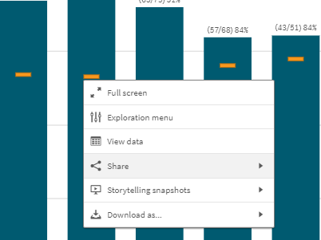
The options available in the Shortcut menu are the same as those available through the Hover menu.

