

First Nations Health Reporting:
nKPI and OSR - how to use Best Practice reports

Introduction
Best Practice software enables health services to submit National Key Performance Indicators (nKPI) and Online Services Reports (OSR) to the Health Data Portal. In this process, Best Practice produces several nKPI and OSR reports that can be used locally by health services to monitor and improve data. These are the only reports currently approved, and validated, for nKPI and OSR reporting for Best Practice users and accurately reflects the data sent to the portal.
Two of the reports contain client level data by indicator, which can help health services track progress against internal targets and support data quality improvement. It is important to note that the patient level reports are only available for local health service use; patient level data is not submitted to the portal.
This article provides step by step instructions to access the different nKPI and OSR reports contained within the Bp Premier Reporting Tool, how to save them locally and some tips for using the reports. Any data shown in this article is from sample (dummy) data.
BP Premier Reports for nKPI and OSR
Although the data sent to the Health Data Portal is stored in the portal, the reports produced locally by the Bp Premier Reporting Tool aren’t saved unless you choose to save them.
Each time you run the Best Practice nKPI and/or OSR reports you may wish to save a copy of the reports to use later. You can rerun the report and save copies any time.
TIP: To support good data governance, it is recommended to save local reports in a secure location such as a limited access data folder.
For instructions to install and set up the Reporting tool see https://kb.bpsoftware.net/bppremier/Spectra/Integrations/nKPI.htm.

How to run the reports
Double click the Bp Premier Reporting Tool icon (from your desktop) to launch the reporting tool:
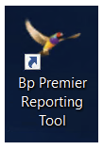
When the Bp Premier Reporting Tool window opens, click the ‘Federal Dept of Health nKPI Report’ button to launch the reporting function (Report Utility).

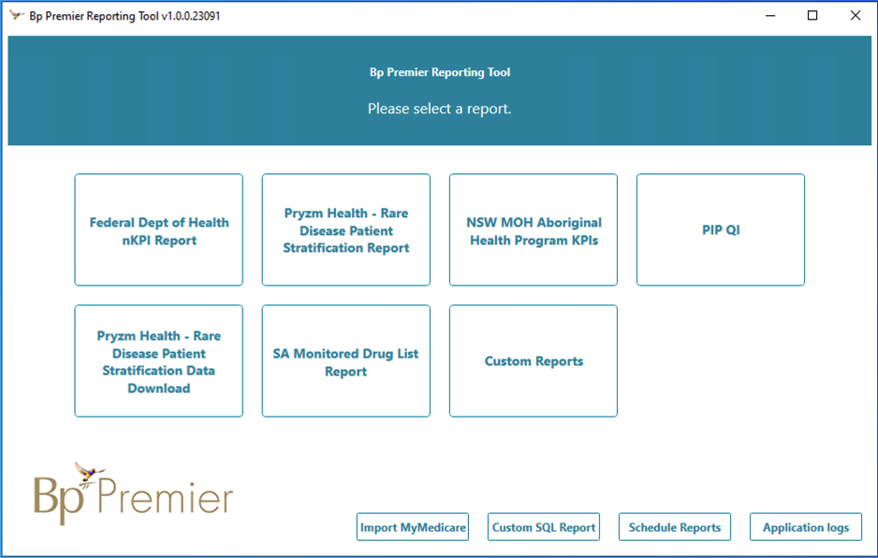

Step 1: On the Login window of the Report Utility, enter the username and password for a Bp Premier user with Reports access and click Next. You do not need to select the same user selected during setup.
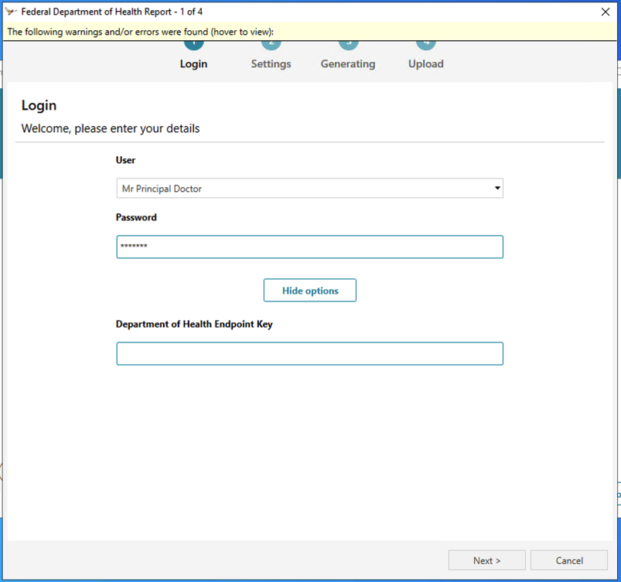

NOTE: An endpoint key is needed to submit data to the Health Data Portal (this is not required to run and view the reports locally). A warning will pop up if this hasn’t been entered: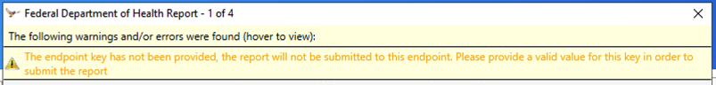
TIP: Contact the First Nations Health Division on indigenousreporting@health.gov.au if you don’t have an endpoint key.

Step 2: The Report Utility will open at the Settings window.
The options you select on the Settings window will depend on the reporting round (time of year) and which reports you want to run. Unless otherwise directed by the Health Data Portal team, to create nKPI and/or OSR reports:
- For the July reporting round, all three options will be selected (Report End Date: 30 June of the same year as the reporting round)
- For the January reporting round, only NKPI will be selected (Report End Date: 31 December of the previous year to the reporting round).
Tick the relevant Data to include box(es) to select nKPI, OSR, HCP or all. Set the Report End Date and click Next:

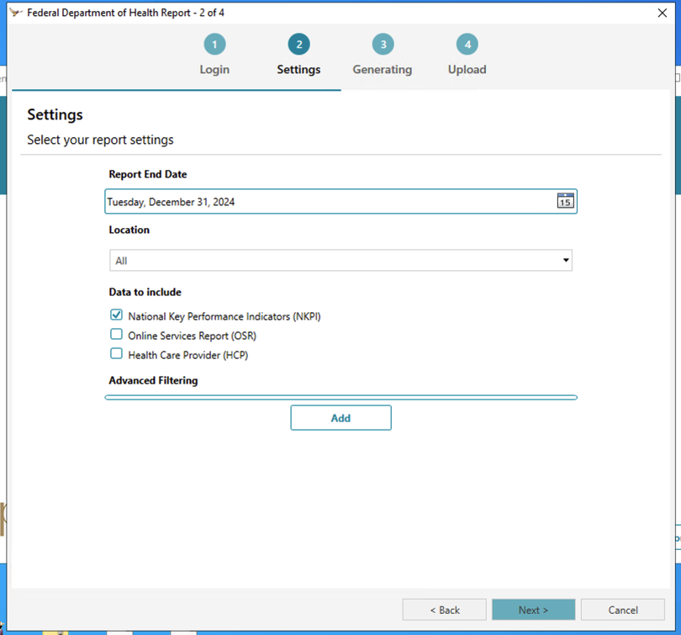

You may choose to run multiple reports together or run them individually.
TIP: When running reports locally to save and review (i.e. when you don’t need to send to the Health Data Portal) you may prefer to select and run the nKPI and OSR reports separately so you can save them as separate files. This might be more useful for interim reporting and monitoring progress against targets outside of the reporting window. Selecting more than one report at the same time, results in a long report, which is displayed in this order: NKPI, followed by OSR, then HCP.
Step 3. The Generating window of the Report Utility will open as Bp Premier generates the report. Progress is indicated in the Generating report progress bar:
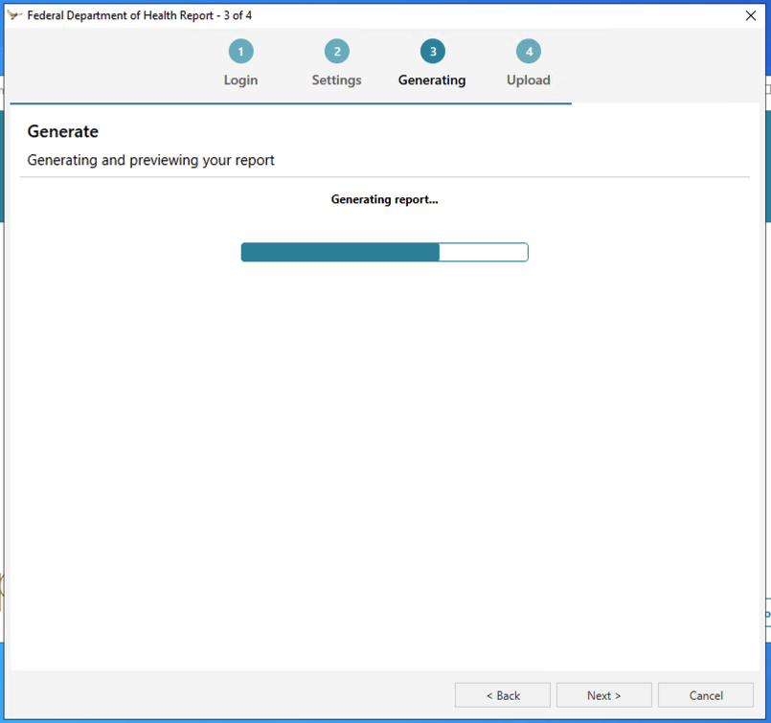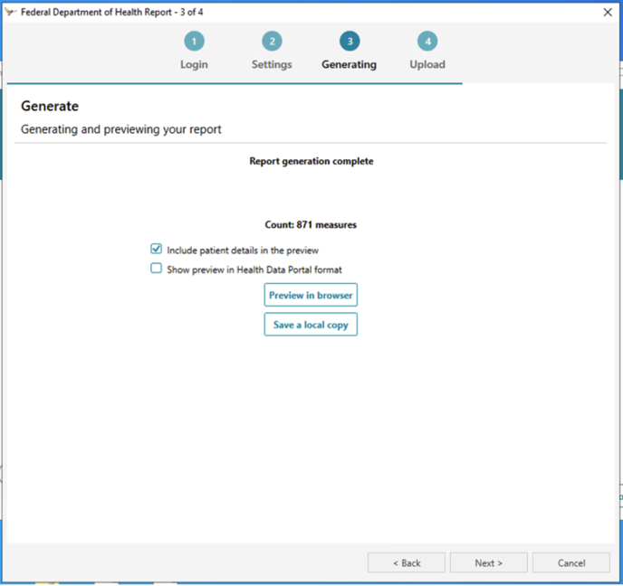
Once the report has been generated, a message appears on screen confirming its completion ’Report generation complete’. On this window two tick boxes AND two buttons (Preview in browser and Save a local copy) become available:
What you select at this stage depends on what you want to do and how you want to use the data. Information on saving and using the reports and data for practice improvement is covered in the section How to use Best Practice reports for improvement below.
Step 4. To submit to the Health Data Portal:
Don’t tick any boxes. You can preview the data using the Preview in browser button to confirm it looks correct and then click Next.
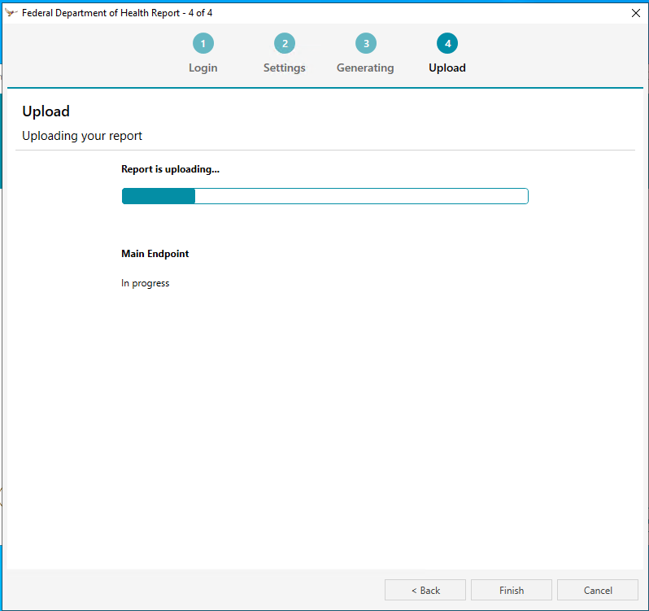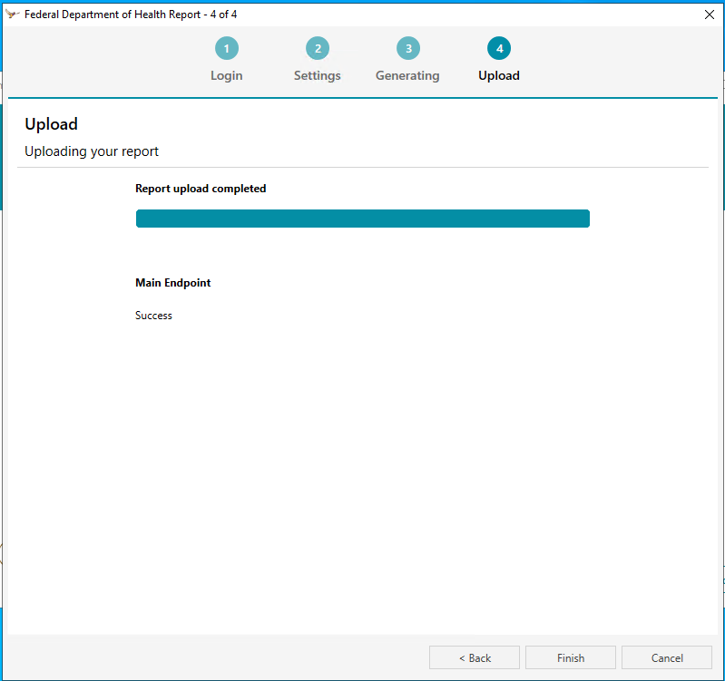

NOTE: For Health services using Best Practice Orchid the steps may be slightly different. Please refer to the Best Practice Orchid knowledge base for relevant information:
https://kb.bpsoftware.net/bppremier/Orchid/Integrations/nKPI.htm
How to use Best Practice reports for improvement
This section explains how to view and save the different reports in the Report Utility Generating window:
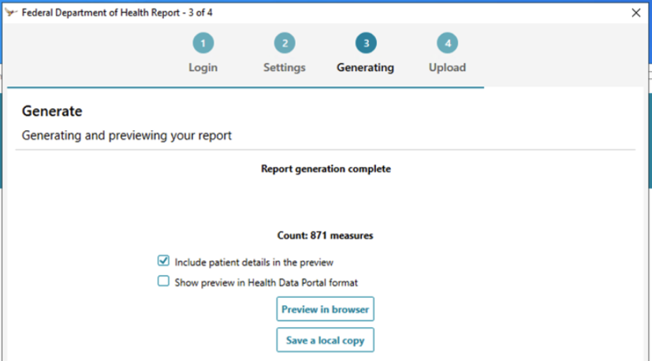
To review the data there are two tick boxes and two buttons to choose from. What you select in this window determines what the output report looks like, and which data is available for you to use for quality improvement.
The button you choose depends on whether you want to preview the report or save it:
- Preview in browser: For a quick look and for speedy access to the results. The report opens in another window.
- Save a local copy to download a copy of the file (as an HTML report in a folder of your choice) Then locate the saved file when you are ready to use it.
Before you select one of these buttons consider which report you want. The tick boxes you select impact the style of the report and which content is displayed in the output report. The next few sections explain the options.
Show preview in Health Data Portal format
Due to familiarity with the Health Data Portal, health services often tick the second box.
Ticking the Show preview in Health Data Portal format box (or ticking box boxes) results in a report that looks similar to the portal layout (as per the next image). This only works for nKPI data.
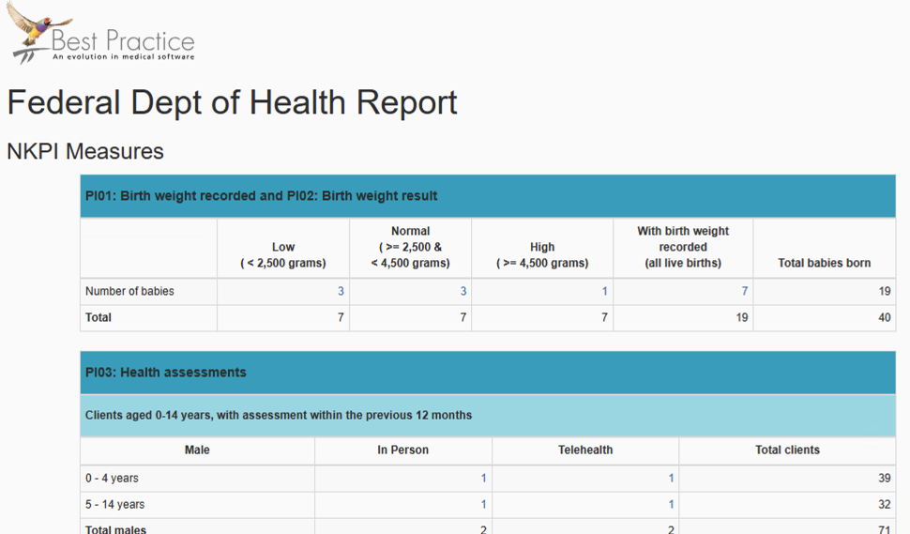
The report is responsive when you also select the Include patient details in the preview tick box; clicking on the relevant numbers will pop up the list of clients behind the data in a Patient Details window:
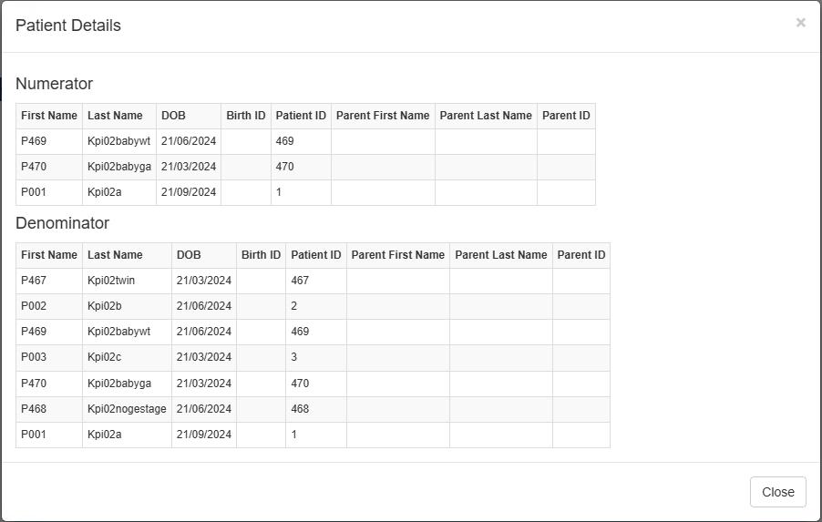

Include patient details in the preview
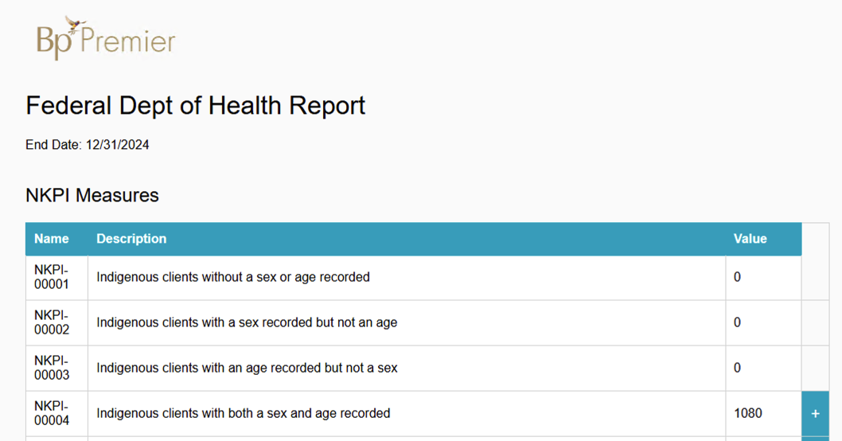
When you tick ONLY the first tick box Include patient details the report provides other useful information including percentage progress. It looks look like this:

This Best Practice report displays the four measures and counts for the Total Number of Aboriginal and Torres Strait Islander Regular Clients (TNATSIRC) that are sent to the Health Data Portal. The four rows for these are at the top of the report: NKPI-00001 to NKPI-00004. This is a useful report for finding any clients with no age and/or no sex, i.e. clients who will not be counted in most of the nKPIs unless their sex AND gender are recorded.
This report includes client information by measure. To see the client information behind each section of the report just expand the blue plus sign(s) on the right-hand side (as shown in the image above) and the list of clients will appear below the relevant measure.
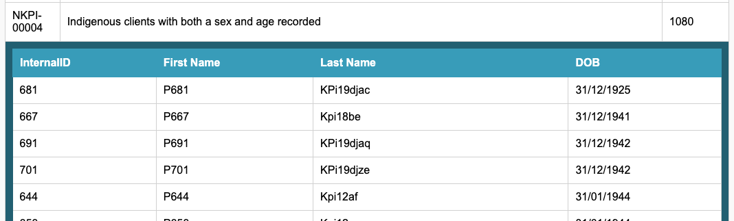
This report also includes the percentage achievement for each indicator (nKPI-01 to nKPI-26). In the nKPI-01 example below the percentage achievement is only 36.8%.
Also available in this report, is a list of the clients that are included in each part of the indicator (i.e. each measure). Using the example below we can see that only 7 clients are counted in the numerator. It also shows that 19 are eligible for inclusion (those in the denominator). By expanding the blue check box to reveal the list of clients you can ascertain who is in which section.
The 7 clients counted in the numerator can be compared to the eligible list of 19 counted in the denominator to work out which clients weren’t counted (a difference of 12). For example, you can see in the example below, the first client listed in the denominator section, whose first name is P1076 (Patient ID 1076) is not listed in the numerator section and has therefore not been counted. Using this information from your Best Practice report, you can then go into Best Practice to ascertain which data are missing and why they were not counted. From there you can either correct the data or arrange follow-up etc.
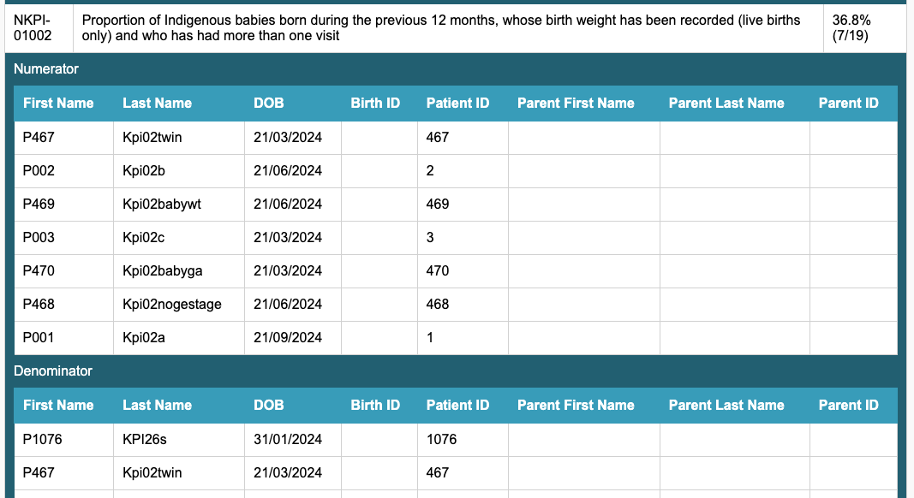

The reports list all measures across all indicators.
TIP: Expand and collapse these lists by indicator – this keeps the report looking more condensed and can make it easier to work through the data for your focus areas.
By focussing on your priority areas or your individual targets you can work through the reports to identify targeted activities to improve your data.
TIP: Data analysts or statisticians may prefer to save reports as CSV files to further manipulate the data in CVS or Excel. The layout of the CSV file is different to those shown above and does require familiarity with data filtering functions and the labels used for data ’measure codes’. Codes ending in ‘-N’ are numerators; those ending in ‘-D’ are denominators.
Reports for OSR
If at Step 2 above, you only selected nKPI, you can now go back to preview and/or save the report for the OSR data. Use the back button to go back to the Settings window of the Report Utility. On the Settings window, change the tick box from NKPI to OSR and click Next.

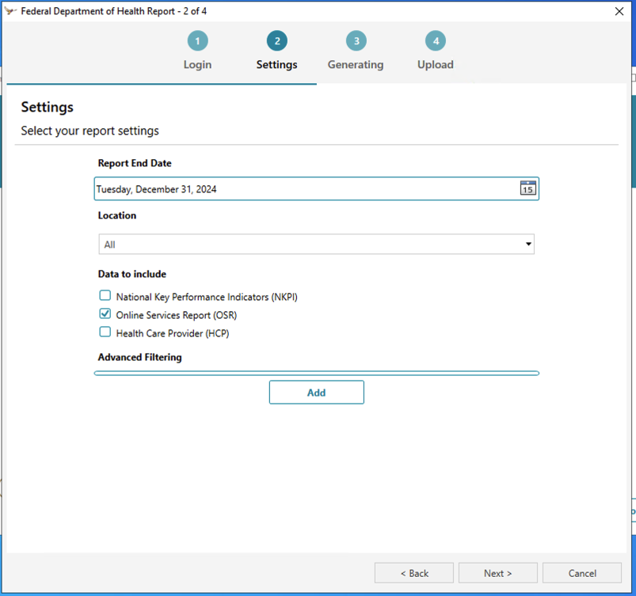

TIP: This only works if you have kept the Report Utility open. If you have closed it then you will need to start from the beginning.
When the report has finished generating and says ‘Report generation complete’ tick ONLY the first 'Include patient details in the preview' tick box and then choose to preview or save the file using the relevant button.

NOTE: Show preview in Health Data Portal format doesn’t work for the OSR report or HCP report.
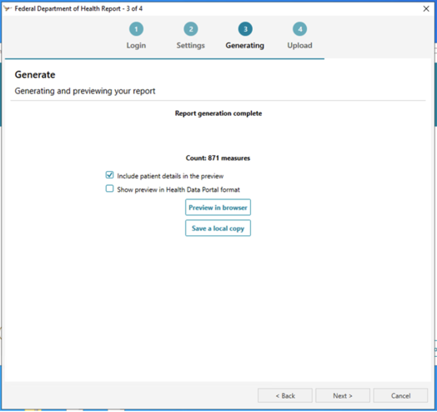

The OSR report looks like this:
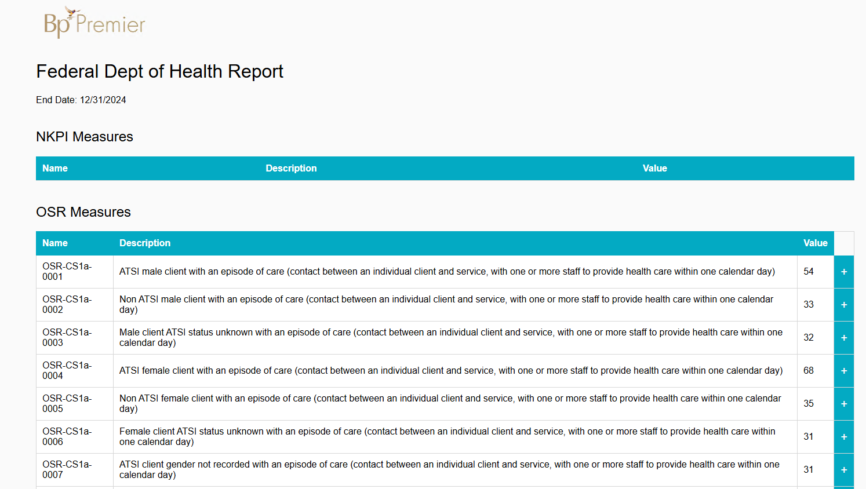

Key takeaway(s):
- Best Practice reports can be used to support continuous quality improvement
- The information in each of the reports differs
- Reports produced by the clinical information system vendors i.e. Best Practice are more accurate for nKPI and OSR reporting than other data extraction tools.

Resources
Links to supporting documents, information and further reading:
- Bp Premier nKPI and OSR Field Mappings: This is the Best Practice nKPI and OSR user guide; it outlines the rules for reporting and where data are sourced in the CIS. The most current version is accessed via this persistent link:
https://kb.bpsoftware.net/docs/BpPremier_OSRandnKPIMappingsReference.pdf
or from the Knowledge Base by searching for ‘nKPI’ and selecting ‘Bp Premier Reporting Tool: nKPI’; you’ll find the link to the document in the section titled ‘Run the reporting tool for Federal nKPI’.
- Specifications for nKPI and OSR: This document is intended for health services and clinical information system vendors. It provides a detailed overview of foundation data elements (including differences between nKPI and OSR) and a full explanation of each indicator - covering inclusions, exclusions, counting rules and disaggregation points (including the related data ‘measure codes’ that you may see in your CIS reports). It also highlights variances in vendor implementation for some data. You can access the Specifications here: https://www.solvinghealth.au/specifications or by following Projects > then Specifications from the home page. Links to CIS vendor user guides are also listed at the bottom of the webpage. Make sure you have the most recent version as the specifications are updated periodically.
For more data management tips see the other articles in this series available at: Clinical Information System (CIS) Education Articles

