Overview
The QLIK IHD nKPI Dashboard
The QLIK IHD nKPI Dashboard contains 37 sheets that Indigenous Health Division (IHD) users can access to obtain a graphical view of health services’ aggregated nKPI data, back to December 2014. These are made up of an Executive Summary sheet, three nKPI summary sheets covering the three indicator groupings, 26 individual indicator sheets, the two Data Export sheets, the Notes and Exclusions sheet and four new OSR ratio sheets.
When working in these sheets, you can compare data for selected health services for the current collection period to data from previous periods or to other health services in a particular comparison group, which you can create within the sheets. Comparison groups can be built using different information such as remoteness, service size, state and workforce characteristics.
Upon accessing the QLIK IHD nKPI Dashboard, the IHD nKPI Dashboard screen displays, containing individual “apps” for all summary and indicator-level sheets, the two data export sheets and the four OSR ratio sheets.
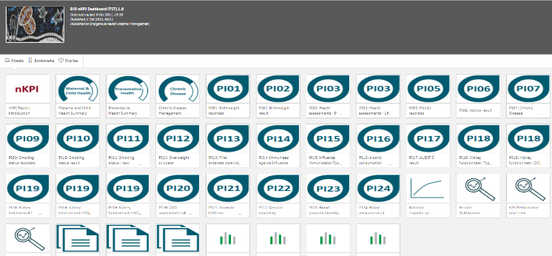
The nKPI Summary sheets
The QLIK IHD nKPI Dashboard contains three nKPI summary sheets:
- Maternal and Child Health
- Preventative Health
- Chronic Disease Management
- To open one of the nKPI Summary sheets, select the top half of the app for the required sheet on the IHD nKPI Dashboard screen.

The selected nKPI Summary sheet will display.
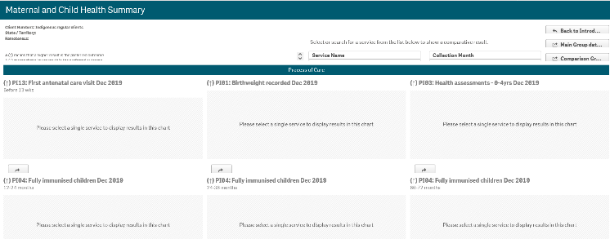
- To display results for a particular health service, select the Service Name filter field towards the top of the sheet and select the health service you wish to view the summary data for.
If needed, you can filter the results that display by collection month using
The sheet will now update to display the selected health service’s summary data for the selected indicator grouping.
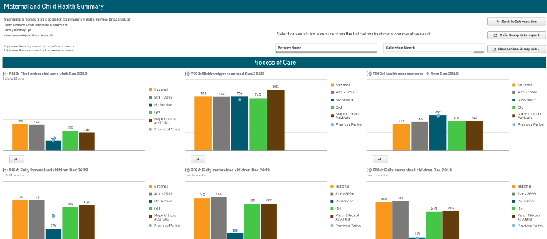
The top half of each of the summary sheets shows how the selected health service’s data for the applicable Process of Care indicators, for the current (dark blue bar) and immediately previous collection periods (light blue dot) compares to the national average (orange bar) and the results for services of the same size (grey), state (green) and remoteness (brown).
The bottom half of the sheet contains the same information as the top half of the sheet, but for the Outcome indicators.

Other nKPI Summary Sheet Functions/Buttons
The QLIK IHD nKPI Dashboard
- An arrow displays next to the title of each indicator in the sheet and will point up if a high result is the preferred outcome for the indicator or down if a low result is preferred.
- This button displays beneath each indicator graph and, when selected, opens the individual sheet for the selected indicator.
- Select this button to go to the Data Export – Main Group sheet and display (in table form) nKPI data for the selected health service(s) for every data collection period, back to December 2014. From here, you can export the data to Excel as needed.
The QLIK IHD nKPI Dashboard

- Select this button to go to the Data Export – Comparison Group sheet and display (in table form) the national data set for every indicator, for every data collection period, back to December 2014. From here you can export the data to Excel as needed.
The Preventative Health and Chronic Disease Management Summary sheets are in the same format and contain the same parameters as the Maternal and Child Health Summary sheet so they are not specifically covered in this guide.
Individual Indicator sheets
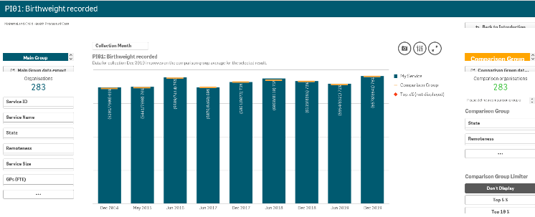
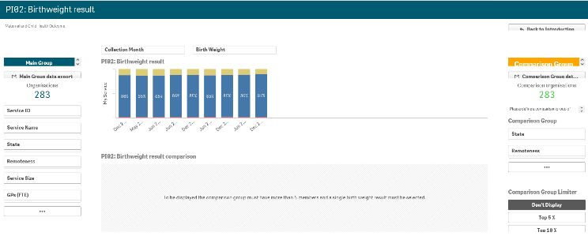
In addition to the summary sheets for the three indicator groupings, the QLIK IHD nKPI Dashboard also contains individual sheets for each of the 24 indicators reported on by health services.
The screenshots shown are of PI01: Birthweight recorded and PI02: Birthweight result as they represent the two different individual nKPI sheets (single dimension indicator sheets and sheets for indicators with multiple result bands). The features detailed below are common to both sheet types.
Layout view/Main Screen Window
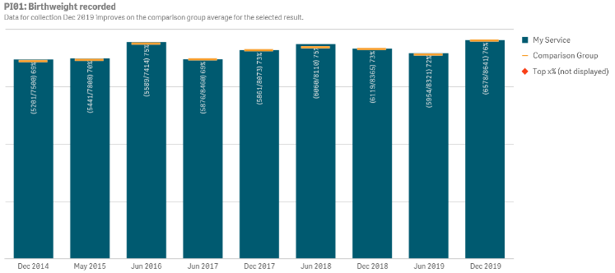
The main section of an individual nKPI sheet shows, if a particular health service has not yet been selected, the national averages for the selected indicator, back to December 2014, using a bar graph (showing the national averages in blue).
The line on each bar of the graph represents the results of any selected comparison group for each collection period. If you have not yet created a comparison group, this will also represent the national averages for all health services.
For the five indicators for which the AIHW has set national trajectories, a line will appear on the graph from June 2021 onwards, showing the health service’s self-determined targets for the indicator.

Main Group Section
The QLIK IHD nKPI Dashboard
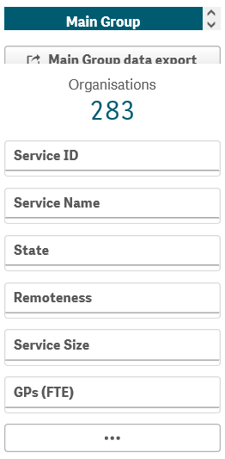
The Main Group section of the individual nKPI sheets within the QLIK IHD nKPI Dashboard displays on the left-hand side of each of the sheets, and can be used to filter the bar graph to display results for particular health services, states, remoteness categories etc, rather than the default national averages.
- To filter the national averages initially displayed in the graph, select the applicable filter field 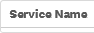 in the Main Group section (e.g. Service Name, as you wish to compare the results for a particular service to those of the rest of their state).
- Select the applicable option from the list that displays and then select .
The selected filter will be applied to the graph and the results will update accordingly.
- Repeat the process for all other filters to be added.
To remove any of your selections, simply select against the selection in the grey Selection Bar at the top of the screen 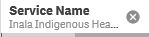.
The button detailed above for the nKPI Summary sheets is also available in the Main Group section of each of the individual indicator sheets.

Comparison Group Section
The QLIK IHD nKPI Dashboard

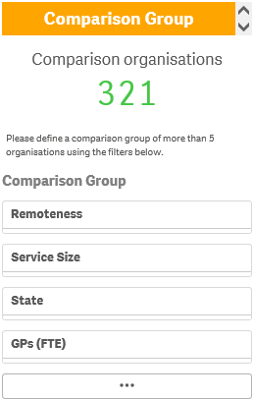
The Comparison Group section displays on the right-hand side of all individual nKPI sheets and is used to build a comparison group of health services sharing similar characteristics (such as state, remoteness category etc). When a comparison group is created, the graph will be redrawn and the on the graph will now represent the results of the selected comparison group rather than the default national averages.
- To create your comparison group, select the applicable option 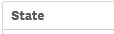 in the Comparison Group section (e.g. State as you wish to compare the state results to those of a particular health service within that state).
- Select the applicable option from the list that displays, and then select .
- Repeat the process for any other characteristics to be added to your comparison group.
Your comparison group has now been created and the comparison group results shown in the graph (represented by ) will update accordingly.
To remove your selections, simply select against each selection in the grey Selection Bar at the top of the screen 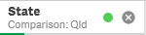.
The button detailed above for the nKPI Summary sheets is also available in the Comparison Group section of each of the individual indicator sheets.

Comparison Group Limiter Section
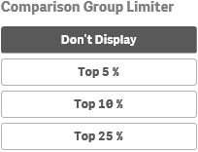
In addition to comparing results for the selected health service(s) for the current/latest collection period to other health services with similar characteristics, you can also compare the selected health service results for the selected indicator to the Top 5, 10 and 25 percent of health services in any comparison group you have created in the Comparison Group section of the sheet.
To do this, simply select the applicable button in the Comparison Group Limiter section in the bottom right-hand corner of the sheet. Once selected, the average results for the selected grouping of higher performing organisations will display as in the graph, while the averages for the entire comparison group will continue to be represented by the .
nKPI Targets
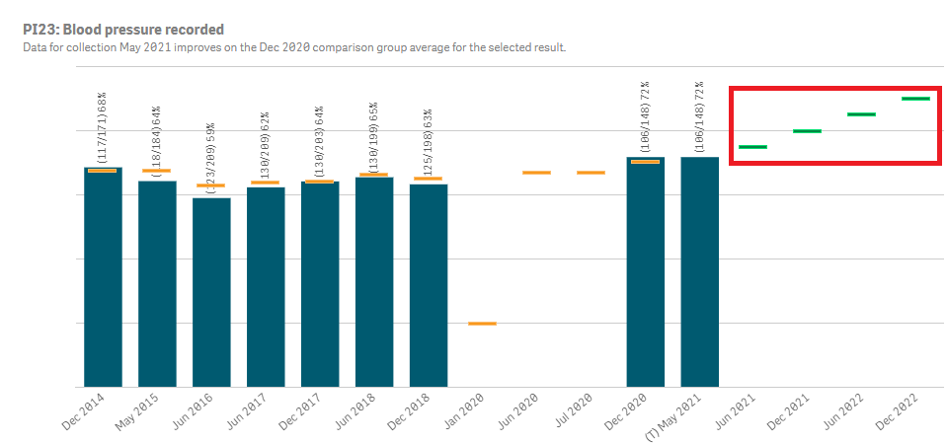
Once health services have entered their self-determined targets for PI03, 05, 14, 18 and 23 into their nKPI form, these targets will then display as green lines () on the graphs within the applicable individual indicator sheets (as highlighted above). The target lines will allow you to see, for each collection period, whether your selected service has reached or exceeded their targets for the selected indicator or are yet to do so.
While the targets for some of the indicators will display as soon as you select the applicable sheet, some selections will need to be made to get the targets to display for others. With this in mind, bookmarks have been created in QLIK for these indicators to make it easier for you to display health service targets
The QLIK IHD nKPI Dashboard
To display the targets for each applicable indicator in QLIK:
- PI03 (0-4 years) – Open the PI03 0-14 yrs sheet, select and then right click on “My Service Targets-PI03-0-4YRS-In Person” and select Apply selections. The targets will display.
- PI03 (25-54 years) - Open the PI03 15-65yrs+ sheet, select and then right click on “My Service Targets-PI03-25-54YRS-In Person” and select Apply selections. The targets will display.
- PI03 (55YRS+) - Open the PI03 15-65yrs+ sheet, select and then right click on “My Service Targets-PI03-55yrs+-In Person” and select Apply selections. The targets will display.
- PI05 – Open the PI05: HbA1c recorded sheet, select and then right click on “My Service Targets-PI05-Previous 12 months” and select Apply selections. The targets will display.
- PI14 – Open the PI14: Immunised against influenza sheet and the targets will display. The targets will display.
- PI18 – Open the PI18: Kidney function test – Type 2 Diabetes sheet and the targets will display. The targets will display.
- PI23 – Open the PI23: Blood pressure recorded sheet and the targets will display. The targets will display.

The National Trajectories sheet
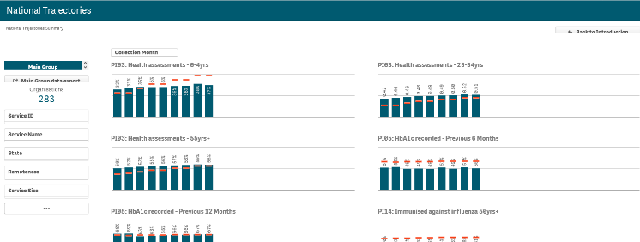
The National Trajectories sheet displays the national nKPI results (represented by the blue bars) along with the corresponding national trajectories (represented by ) back to December 2014, for the five indicators that have had national trajectories set for them by the AIHW. There are eight graphs on the sheet across the five applicable indicators, due to some of the indicators containing multiple result bands.
Main Group Section
The Main Group section of the National Trajectories sheet displays on the left-hand side of the sheet, and can be used to filter the bar graphs for each of the applicable indicators to display results for particular health services, states, remoteness categories etc, rather than the default national results.
- To do this, select the applicable filter field(s) in the Main Group section (e.g. Service Name, as you may wish to see the results against the set trajectories for a particular service).
- Select the applicable option from the list that displays, and then select .
- Repeat the process for any other filters to be added.
When this is done, the selected filter(s) will be applied to each of the graphs and the results (represented by the blue bars) will update accordingly.
The QLIK IHD nKPI Dashboard
To remove your selection(s), simply select against the selection in the grey Selection Bar at the top of the sheet .
The button detailed above for the nKPI Summary sheets, is also available in the National Trajectories sheet.
The Data Export – Main Group sheet
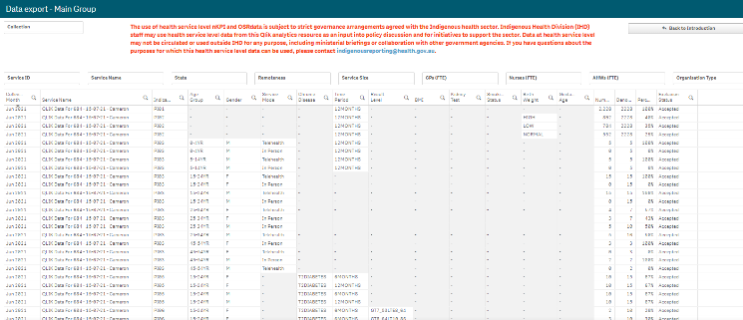
The Data Export – Main Group sheet displays (in table form) nKPI data for the selected Health Service(s) for every collection period, back to December 2014.
If you haven’t selected a particular health service on one of the other sheets, then data for all health services will display here.
- To select a particular health service to export data for, select .
- Select the applicable service from the list that displays, and then select .
If you wish to, you can the further filter the data by selecting at the top of any column in the table and making the required selection. For example, you may only require the service’s data for a particular collection period or for a subset of indicators.
- To export the data to Excel right click anywhere on the table, select Export > Export data and then select the link to download the file.
The selected data has now been downloaded into a Microsoft Excel spreadsheet for use as needed.

The Data Export – Comparison Group sheet
The QLIK IHD nKPI Dashboard
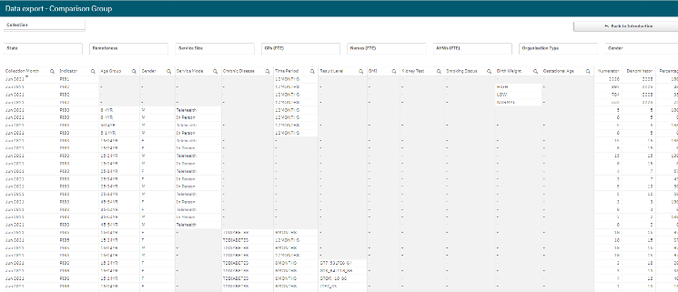
The Data Export – Comparison Group sheet displays (in table form) national nKPI data set for every collection period, back to December 2014.
- To filter the data that displays in the table, select the applicable filter field(s) above the table as required. For example, you may wish to export data only for services in Queensland without GPs.
- Select the applicable option from the list that displays, and then select .
If you wish to, you can the further filter the data by selecting at the top of any column in the table and making the required selection. For example, you may only require data for the latest collection period or for a subset of indicators.
- To export the data to Excel, right click anywhere on the table, select Export > Export data and then select the link to download the file.
The selected data has now been downloaded into a Microsoft Excel spreadsheet for use as needed.
The Notes and exclusions sheet
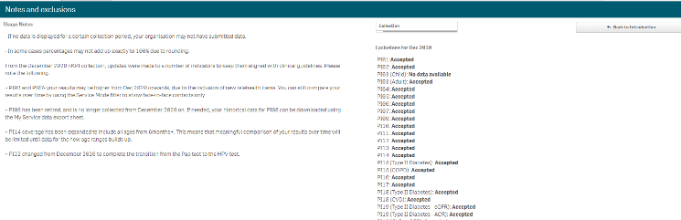
The Notes and exclusions sheet contains disclaimers and additional information regarding the different sheets in the Dashboard, in the Usage Notes section. The Exclusions section will show (if you have a health service selected from a different sheet) whether the data for your selected service has been excluded or accepted by the AIHW for the most recent collection period
The OSR – Operational Ratios sheet
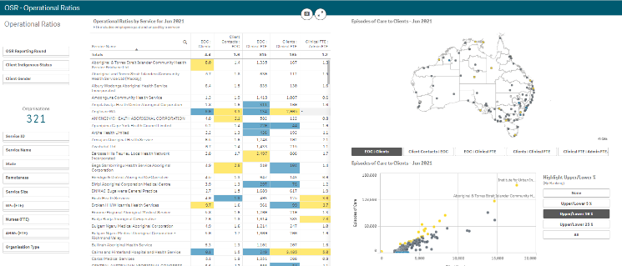
The OSR – Operational Ratios sheet allows you to analyse operational ratios, either nationally or for a selected health service as/if needed. When you open the sheet the ratios for all health services will display unless you have previously selected a health service in another sheet in the dashboard.
The following operational ratios are covered in the OSR – Operational Ratios sheet:
- EOC : Clients – measures the level of service a client receives from a health service during a given year, and will help provide an indication of the number of short term or visiting clients for a service.
- Client Contacts : EOC – measures the number of different services a client receives when visiting the clinic. A high ratio may indicate that a service has a more diverse offering.
- EOC : Clinical FTE – measures the utilisation rate for each clinical staff member. A higher ratio may indicate that the service is very busy or provides briefer client contacts.
- Clients : Clinical FTE – measures the number of patients managed by each clinical staff member. A higher ratio may indicate a larger proportion of visiting or short-term clients.
- Clinical FTE : Admin FTE – measures the proportion of salary costs allocated to clinical services vs administrative services.
- To display the operational ratios for a particular health service, select in the Organisations section on the left-hand side of the sheet.
- Select the applicable service from the list that displays, and then select .
You can use the other filter fields in the Organisations section of the sheet if needed to display the operational ratios for a particular cohort of health services. For example, all NSW/ACT services with a remoteness category of “Major Cities”.
Operational Ratios by Service for xxx section - shows the operational ratios for either all health services (by default) or the selected service(s) for the most recent collection period. A service’s ratio will be shaded (in either blue or yellow) if it is outside the expected range for that ratio.
Episodes of care to Clients – xxx map – shows the selected service(s) as a dot on the map. A service’s dot will display as blue if the service’s ratio is outside of the expected range for the ratio that is selected through the buttons beneath the map, for the most recent collection period. There is a button for each of the operational ratios described earlier.
Episodes of care to Clients – xxx graph – shows the selected health service(s) as a dot on the graph, located based on the ratio button that has been selected above the graph. A service’s dot will display as either blue or yellow if the service’s ratio is outside of the expected range for the most recent collection period. The labels on the graph will change based on the selected ratio
Highlight upper/Lower % (By Ranking) - allows you to view the upper or lower 5, 10 or 25% of services in the selected cohort, if applicable.
The OSR – Service Summary Sheet
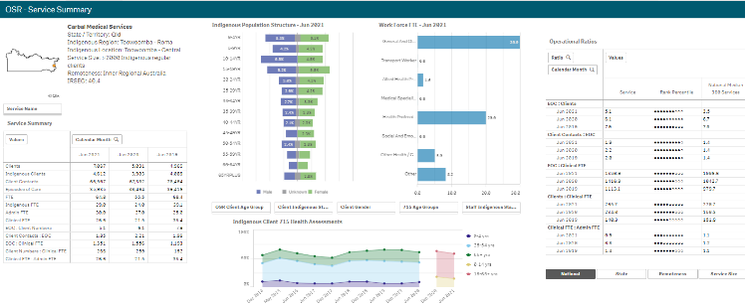
The QLIK IHD nKPI Dashboard
The QLIK IHD nKPI Dashboard
The OSR – Service Summary sheet allows you to
- Select and select the health service you wish to view the summary data for.
- To continue, select .
Service Summary section – shows key summary information for the selected service, such as their client numbers, episodes of care and FTE numbers.
Indigenous Population Structure – xxx graph – shows the gender breakdown for the selected service’s Indigenous population, by age group, for the current collection period.
Work Force FTE – xxx graph – shows the selected service’s FTE numbers for the different position types, for the current collection period.
Indigenous Client 715 Health Assessments graph – plots the number of 715 health assessments conducted by the selected service, by age group, back to December 2014. The information displayed here can be filtered by age group, indigenous status and gender, using the buttons above the graph.
Operational Ratios table – shows the service’s operational ratios for the two most recent collection periods. The table also shows the national average for each of the services. The information displaying here can be changed to display the ratios by state, remoteness and service size, using the buttons beneath the table.
The OSR – Service Workforce Sheet
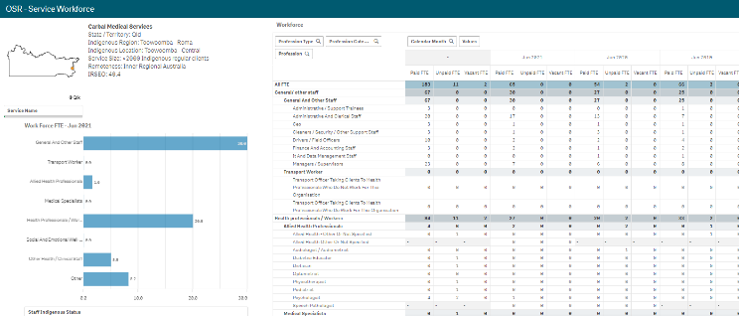
The OSR – Service Workforce sheet displays more detailed workforce information for the selected health service.
- Select and select the health service you wish to view the workforce data for.
- To continue, select .
Work Force FTE - xxx graph – shows the selected service’s FTE numbers for the different worker types, for the most recent collection period. The data in the graph can be filtered by Indigenous status if needed, using the Staff Indigenous Status filter field beneath the graph.
Workforce table – displays the Paid, Unpaid and Vacant FTE values for the selected service, by position grouping first and then by individual position (e.g., CEO, Pharmacist, Cardiologist). The data in the graph can be filtered by Indigenous status if needed, using the Staff Indigenous Status filter field beneath the Work Force FTE - xxx graph.
The OSR – Data Export Sheet
The QLIK IHD nKPI Dashboard
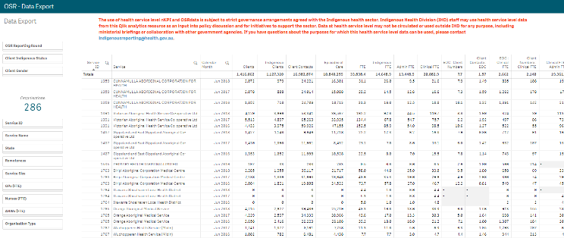
The OSR – Data Export sheet allows you to export summary OSR data for your selected service(s), to a Microsoft Excel spreadsheet.
- Select in the Organisations section of the sheet and select the health service you wish to view the OSR data for.
- To continue, select .
You can use the other filter fields in the Organisations section of the sheet if needed to display the data set for a particular cohort of health services. For example, all NSW/ACT services with a remoteness category of “Major Cities”.
Once you have applied the required filters to the data set, you can then export the data to Excel as needed.
- To do this, right-click on the data export table and select Export > Export data.
In the window that displays, select the Click here to download your data file link.
- In the Download bar that displays at the bottom of the sheet, select the arrow and then select Open.
The Microsoft Excel spreadsheet containing the selected data set will now display and can be edited, saved and shared as needed.

