MMEx Security Token Tip Sheet
Health services using the Clinical Information System (CIS) MMEx will need to add security token information for the Health Data Portal to their MMEx account’s Administration section to connect MMEx to the Data Portal. This security token would have been given to your service by the Department of Health and Aged Care when you registered for Health Data Portal reporting.
A security token is a device that is used in order to obtain access to an electronic or digital system. The security token is used in addition to your password and can be thought of like an electronic key.
To enter the Data Portal security token information into MMEx:
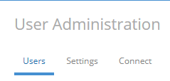
- An Organisation Administrator can navigate to the MMEx Organisation Centre / Users tab
- Modify the User who will be submitting the nKPI / OSR reports to the DoH Portal and scroll down to the bottom of the page to enter the security token in the “Security token…” field.
- Click the OK button.

Alternatively, please contact the MMEx Helpdesk for assistance.
Once you have added the security token details, a confirmation of this is sent to the Health Data Portal.
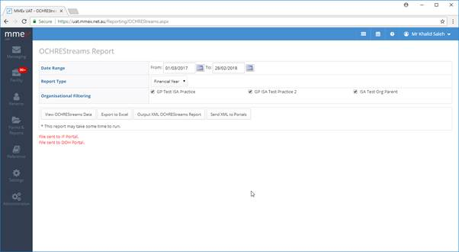
You have now successfully connected MMEx to the Health Data Portal by entering in the security token information provided.
If you ever need to re-enter your security token information for any reason, please email indigenousreporting@health.gov.au and the Health Data Portal team will send you your security token.

