Attach a Supporting Document to your IAHP PHC AWP
Submit a Data Asset
As part of the submission of your IAHP PHC Activity Work Plan (AWP) to your DSS Funding Agreement Manager (FAM) through the Health Data Portal, you may have some additional, supporting documentation that you would like to include as part of your submission, such as your budget or your assets register. You can easily attach this documentation to your AWP in the Data Portal.
To attach a document to your IAHP PHC AWP:
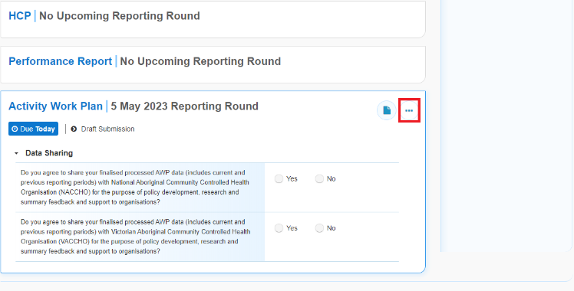
- On the Data Portal home screen, in your Reporting Dashboard, hover your mouse pointer to the right of the Activity Work Plan reporting round text and select and then select Open Data Asset.
The Data Asset Details screen will display.
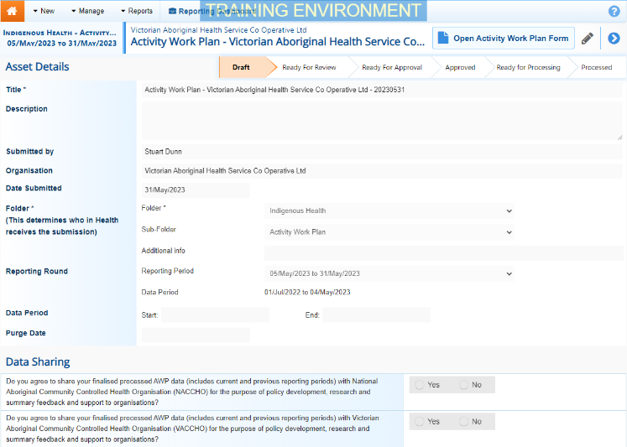
- Put the screen into edit mode by selecting in the top right-hand corner of the screen.
- To upload your supporting document(s), scroll to the bottom of the screen and select .
The Upload Files dialog box will display.
- Select .
The Windows dialog box will display.
- Locate the document you wish to upload to the data asset.
- Select the file and then select .
The Data Assets Details screen will display, and the selected document will now appear in the Files section of the Data Asset Details screen.
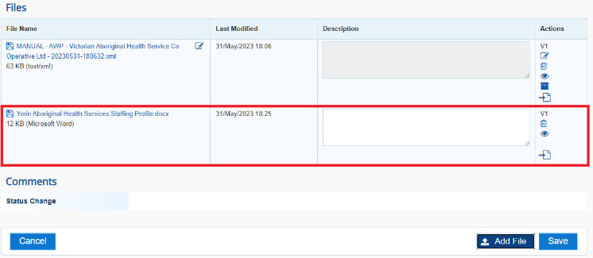
- If needed, you can enter some information into the Description field explaining to your DSS FAM which section(s) of your IAHP PHC AWP the attached document refers to.
If you have uploaded the incorrect document and need to remove it, simply select from the Actions column of the Files section.
- Repeat steps 3 to 6 for any other documents you need to attach.
- To save the upload of your document(s), select at the bottom of the screen.
- To return to the Data Portal home screen, select .
Once you have attached your supporting documentation to your IAHP PHC AWP. you should inform your DSS FAM that you have done so, so they know to look out for this documentation when reviewing your AWP.

