To approve your service’s IAHP PHC AWP as a Submission Approver, after it has been amended by your Submission Uploader as requested by your DSS FAM:
Approve your IAHP PHC AWP based on DSS FAM Feedback (Submission Approver)
- Open the Data Portal through Health Data Portal.
- Log in using the information provided in the Register for and Log in to the Health Data Portal QRG.
The Data Portal home screen will display with the Reporting Dashboard open.
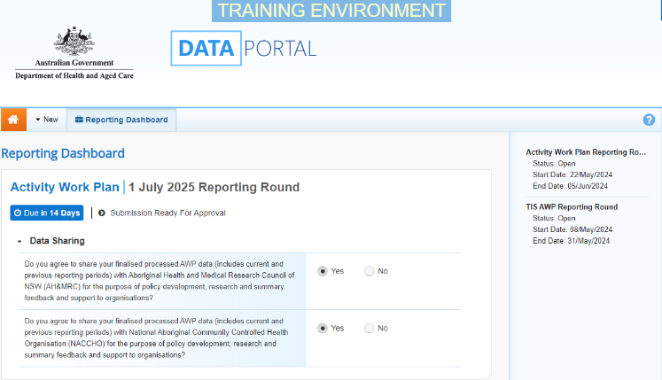
To be eligible for approval, your AWP’s status will need to be Submission Ready for Approval.
- To open your IAHP PHC AWP form, hover your mouse pointer to the right of the AWP reporting round text in the Reporting Dashboard and select.
The IAHP PHC AWP form will display.
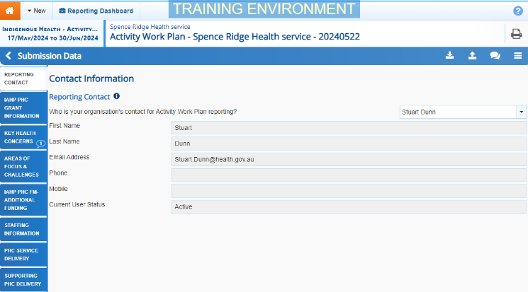
- You can now perform a final review of the AWP form, focussing primarily on the sections with a displaying on the corresponding tab on the left-hand side of the form.
- In the first section of the AWP form displaying a , read the comment that has been left for you in the Notifications Tray.
If the Notifications Tray doesn’t display, select in the top right-hand corner of the form to open it.
- If the comment is just for your information or you’re happy it has been addressed as needed through the data that has been added in the section, select at the top of the comment in the Notifications Tray.
- In the Notifications window that displays, select .
The comment has now been removed from the nKPI form.
- Repeat steps 4 to 7 as needed for each comment that has been left in the form by your Submission Uploader/Reviewer.
If you need to respond to one of the comments that has been left, select in the comment in the Notifications Tray. In the window that displays, select a Reason, and enter your response in the Additional Information field and select . Your response has now been added and can be addressed by your Submission Uploader as needed once you send the nKPI submission back to them for amendment.
- To exit your IAHP PHC AWP form and return to the Data Portal home screen, scroll to the bottom of the form, and select .
The Data Portal home screen will again display with the Reporting Dashboard open.
- To progress your AWP form through the submission workflow, select .
- In the Change Data Asset Status dialog box, in the Action field, select and select Approve for Submission.
If you responded to one of the comments in the form and need to send your AWP back to your Submission Uploader so they can address your response, select Revision Required and then select .
- In the Comment field, enter any comments about the action being performed on your AWP.
- To approve your AWP and send it for processing by your DSS FAM again, select . See the Process an IAHP PHC AWP QRG for the next step in the process.
Approve your IAHP PHC AWP based on DSS FAM Feedback (Submission Approver)
Your IAHP PHC AWP has now been approved and sent to your DSS FAM again for processing.

