

First Nations Health Reporting:
nKPI - Best Practice Data Limitations

Introduction
The National Key Performance Indicators (nKPI) is a suite of process of care and health outcome indicators focussing on maternal and child health, preventive health, and chronic disease management for First Nations people. Accurate reporting is essential to support continuous quality improvement in primary health care delivery.
Differences in how clinical information systems (CIS) capture and report data (whether due to system capability, reporting limitations, or both) can affect the accuracy and completeness of these indicators. Understanding these system-specific limitations and how they translate into CIS reports, as well as knowing where to record data within the CIS, is critical for ensuring your activities are comprehensively reported and results interpreted correctly.
This article outlines some key CIS limitations that may impact health service’s data and some practical tips to help manage data.
Best Practice limitations and data quality tips
Telephone visits
Best Practice doesn't distinguish between clinical and non-clinical encounters for telephone visits. As a result, all telephone encounters are counted as eligible visit types for counting Regular Client status in the nKPI report. This may lead to an inflated Regular Client count, particularly if non-clinical staff are recording their client interactions as telephone encounters.
The Specifications allow for, and accept, this limitation in scenarios where a CIS can’t distinguish between clinical and non-clinical telephone visits.
NOTE: Telehealth visits are categorised separately.
TIP: Knowing this limitation helps you better understand which data are included in the calculation of Regular Client status.

Pathology results – PI05, PI06, PI18, PI19, PI25
Pathology results are only included in nKPI reports if the result has been recorded in the client’s medical record. Incoming pathology results received electronically from pathology laboratories must be fully actioned for them to be added to the client record. Results that are received in correspondence and scanned into the record, i.e. stored as a document, will not be counted. Some manual entry of these results may be needed.
Each CIS identifies relevant pathology results differently, usually based on specific test names or codes. You can find the detail for this in Best Practice’s user guide, the BP Premier nKPI an OSR Field Mappings.
TIP: Review the BP Premier nKPI and OSR Field Mappings document to understand which tests are recognised for specific indicators. This is particularly important for indicators like PI05, PI06, PI18, PI19 and PI25 where pathology results play a key role in the reported data.
Smoking status – PI09, PI10, PI11
In PI09, PI10 and PI11, the Specifications for nKPI and Online Service Reports (OSR) (the Specifications) state that smoking status should be recorded within specific time periods or events. Limitations in recording the date of a smoking status assessment have historically made it difficult to enforce this requirement across all CIS. Because of this, the Department of Health, Disability and Ageing accepted that CIS reports would count the most recently recorded smoking status, based on the assumption that clinicians would update the status if it was known that the status had changed.
Best Practice currently includes all eligible clients with a recorded smoking status, no matter when it was recorded. The last recorded smoking status is used. While this approach aligns with historical reporting practices, it may lead to an overcount of clients who appear to have had a smoking status assessment within the required timeframe.
TIP: Best Practice now enables a simple update to the smoking assessment date without needing to change the status. Clinical staff are encouraged to use this feature to confirm data are current in case indicator requirements for smoking status change. This screenshot shows where to update the assessment date in Best Practice.
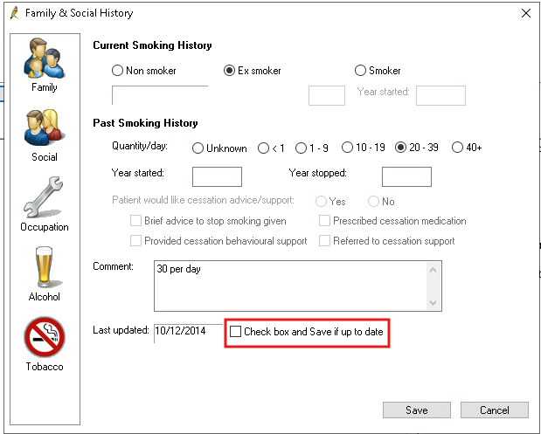
Baby birthweight – PI13 enhancement
Best Practice has not historically applied filters for birthweight or gestational age when counting births for PI13; this meant all recorded births were included in the indicator. As of the January 2025 reporting round, the Best Practice reporting tool has been updated to align with the Specifications which specify inclusion only for births with a birthweight of 400g or more, or a gestational age of 20 weeks or more.
The Specifications and reporting requirements haven’t changed; this update just ensures Best Practice is now correctly applying the reporting rules.
NOTE: You may notice a slight decrease in reported birth numbers compared to previous rounds.
Alcohol status – PI16
The Best Practice nKPI report only counts alcohol consumption status that’s recorded in the alcohol history tab. This means that if an AUDIT-C assessment has been completed for a client, but no alcohol history is recorded, they will not be counted in the measure.
For alcohol history to be counted as recorded, either tick the ‘Non drinker’ checkbox or fill out ‘Days per week’ and/or ‘Standard drinks per day’, in the Alcohol tab of the Family and Social History section as illustrated in the screenshot below.
TIP: Encourage clinicians to update the alcohol history after completing an AUDIT-C to ensure clients are counted in the report.
Alcohol consumption must be recorded within the past 24 months to be counted towards PI16. Even when there is no change in status the alcohol history needs to be updated for it to be counted as assessed within the specified time period.
TIP: If there is no change in the client’s drinking status, Best Practice recommends in the alcohol tab either adding a note in the Description field or adding a Comment to indicate the client’s alcohol status has been assessed; this will ‘date stamp’ the alcohol status to reflect the assessment date.
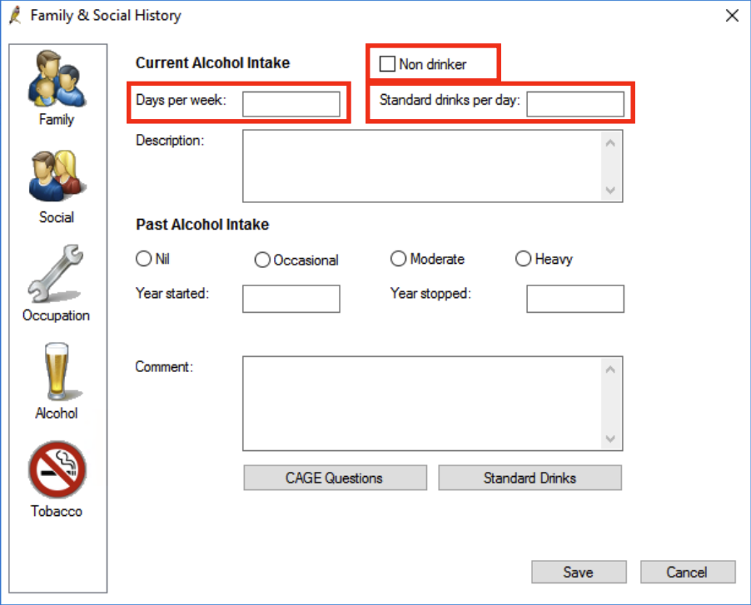
Cervical Screening (HPV) – PI22
Best Practice counts cervical screening recorded in the cervical screening record. Results received electronically as investigations must be actioned, just like other pathology investigation requests. The button labelled ‘Add CST result’ ensures the investigation is added to the client’s cervical screening record.
Screening that is self-collected, and results performed elsewhere, should be manually added in the cervical screening record. Results performed elsewhere are sometimes received electronically as results copied to the health service; in these scenarios they are managed as electronically received pathology. When confirmation of screening elsewhere is received in correspondence and scanned into the record, for example in a referral letter stored as a document, it will need to be manually entered for it to be counted in PI22.
TIP: When actioning an investigation result remember to use the ‘Add CST result’ button to add the test to the client’s cervical screening record.
NOTE: The National Cancer Screening Register (NCSR) is integrated with Best Practice. This allows you to view a client’s latest NCSR data. However, there is no facility yet to automatically write this data back to the client’s record. Cervical screening history in the NCSR may be relevant to PI22. If you want that information to be counted towards PI22, it must be manually added to the client’s Best Practice cervical screening record.

Ear checks – PI26
Best Practice currently has limited recording options to capture ear checks and related tests. There is no dedicated ear health module to record ear checks. Data recorded in the Ear Nose Throat (ENT) section of the ‘History & Examination’ screen are not counted because the data are stored as free text. There are currently no specific procedure codes to record ‘otoscopy’ or ‘tympanometry’. This means ear checks need to be recorded another way for the ear check to be counted.
There is a general ‘Ear check’ procedure that can be used to record, and therefore will count, ear checks when there is no other relevant procedure or condition to record, which is often the case in children with healthy ears.
TIP: For more guidance on how to record the ‘Ear check’ procedure for it to be counted, refer to the Best Practice article for PI26 (detailed in the Resources at the end of this article).
Report end date enhancement
In previous reporting rounds, Best Practice counted service provision of the MBS item 715 health assessment using a calculated start date based on either 12 or 24 months prior to the report end date (e.g. 31 December 2024). This approach aligned with the reporting specifications, which state that only service records with a service date within the reporting period should be included.
However, a recent review found that although the start date was applied correctly, there was no upper limit set for the service date. By not restricting the count to only those services delivered up to the end of the reporting period, health assessments completed up to the date of the nKPI report were also included in the count. This meant the later the report was run in the reporting round the greater the potential for discrepancy because there were more days from which to count completed health assessments.
The same issue was also identified in PI11 (smoking status of females who gave birth), PI12 (Body Mass Index of clients), and PI13 (first antenatal visit), where service records outside the reporting period may have been unintentionally included in the results.
This is unlikely to have had any significant impact in data from health services running their Best Practice reporting tool early in the reporting window. If the Best Practice reporting tool was historically run later in the reporting window, this error may have caused an overcount and contributed to discrepancies in reported figures across these indicators.
NOTE: This was corrected for the July 2025 reporting round i.e. only those services performed on or after the calculated start date and before the reporting date are included. Some health services may see a change in data over time following this fix.

Key takeaways:
- All telephone encounters are counted as eligible visits. This may inflate Regular Client numbers if non-clinical staff record their client interactions this way.
- Pathology results must be fully actioned to be included in reports; results in scanned documents are not counted unless manually entered.
- Alcohol consumption is only counted if recorded in the alcohol history tab – AUDIT-C alone is not sufficient.
- Best Practice now allows users to quickly update the smoking status assessment date without changing the smoking status.
- Know how to use procedural codes to record ear checks so they are counted.

Resources
Links to supporting documents, information and further reading:
- Specifications for nKPI and OSR: This document is for service providers and clinical information system vendors. It gives a detailed overview of foundation data concepts, related data, and a full explanation of each measure—covering inclusions, exclusions, counting rules, measure code disaggregation points, and the nKPI Condition and Pathology Coding Frameworks. It also highlights variances in vendor implementation for selected measures. You can access the Specifications here: https://www.solvinghealth.au/specifications
- CIS User Guides: These explain how vendors report indicators and where data need to be recorded in the CIS to optimise reporting. Refer to the article CIS User Guides for links or visit the link in the Specifications (dot point above) which has links to vendor documents at the end of the web page.
- Vendor scorecard: The vendor scorecard is a one page visual that compares results for nKPI and OSR across CIS: https://www.solvinghealth.au/scorecard
For more data management tips see the other articles in this series available at: Clinical Information System (CIS) Education Articles

