To review your TIS Performance Report in the Data Portal as a *Submission Reviewer*:

**Review your TIS Performance Report (Submission Reviewer)**

1. Open the Data Portal through [Health Data Portal](https://dataportal.health.gov.au/).
2. Log in using the information provided in the *Registering for and Logging in to the Health Data Portal* QRG.

The Data Portal home screen will display with the Reporting Dashboard open.

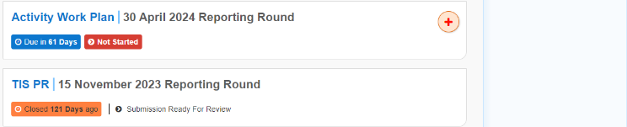

 To be eligible for review, your TIS Performance Report’s status will need to be *Submission Ready for Review*.

1. To open your TIS Performance Report form, hover your mouse pointer to the right of the TIS PR reporting round text in the ReportingDashboard and select Open Submission Form.

 If you need to change the *Title* or *Description* of the Performance Report, you can do so in the Data Asset Details screen by selecting Nore Details next to Open Submission Form and then selecting *Open Data Asset.*

Your TIS Performance Report form will display.

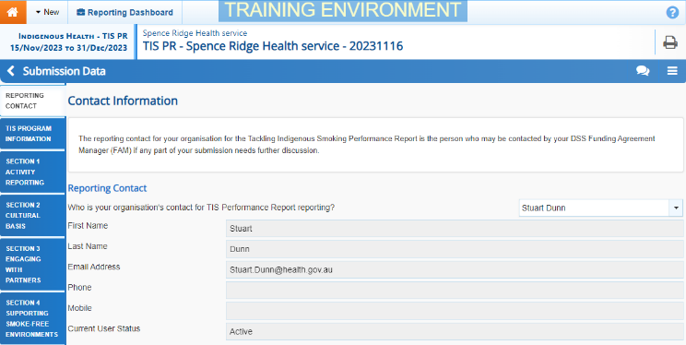

Any sections that still have completion flags to be addressed will display a data validation flag on the corresponding tab. If a section has a completion flag that has been responded to by your *Submission* *Uploader* or a new internal comment entered by your *Submission* *Uploader*, a speech bubble will display on the corresponding tab.

1. If there is a section of the form that still has a data validation flag displaying, go to this section and enter the required information.
2. To save the changes, select Save at the bottom of the form.

The data validation flag should now be removed from the corresponding tabs on the left-hand side of the form.

1. Repeat this process as needed for any other sections of the form displaying a data validation flag.
2. Review the rest of the information in the form and, if needed, update/add any information, saving as you go.
3. If you wish to add a comment regarding any of the changes you have made to the information in the form, select Create New Comment in the Notifications Tray.

 If the *Notifications Tray* doesn’t display, select Open Notification tray - some comments require action or Open Notification tray - some comments require action at the top of the form to open it.

The Notifications window will display.

1. Select the down arrow in the **Reason** field that displays and select the reason you are adding a comment from the drop-down list.
2. Enter your comment in the **Additional Information** field.
3. If you don’t want your DSS FAM to be able to see your comment, select the **Private Conversation** check box.
4. To save the comment, select the Save button.

The comment has been added and can be viewed by anyone accessing your submission.

1. To exit your Performance Report form and return to the Data Portal home screen, scroll to the bottom of the form, and select Close.

The Data Portal home screen will again display with the Reporting Dashboard open.

1. Before progressing the report through the submission workflow, answer either **Yes** or **No** to the data sharing consent questions that display under **Data Sharing** if the questions have not already been answered.
2. To save the changes, select Save.

 If your TIS Performance Report needs to be reviewed at this point by the applicable NBPU representative, you should let them know so they can review the report, add any comments as needed and then return the report to your *Submission* *Uploader* for action. You don’t need to move your report through the workflow at this point.

1. To progress your TIS Performance Report through the submission workflow, select the Submission Ready for Review link.

The Change Data Asset Status dialog box will display.

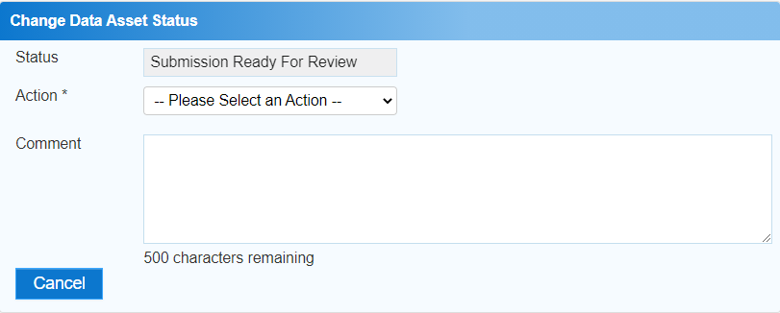

1. In the **Action** field, select the down arrow and select the appropriate action.

The available actions are:

* **Request Approval** – Select this action to send your Performance Report to your CEO or their representative for approval.
* **Approve for Submission** – Select this action if you are the health service’s CEO, or nominated representative, and are approving the Performance Report as well as reviewing it.
* **Request Interim Processing** – Select this action to send your Performance Report to your DSS FAM for review prior to it going to your CEO or their representative for approval. This process is known as *Interim Processing*.
* **Revision Required** – Select this action to return your Performance Report to the *Submission Uploader* for amendment.

1. In the **Comment** field, enter any comments about the action being performed on your Performance Report.
2. One of the following buttons can now be selected when submitting your Performance Report, depending on the action you have selected:
   1. To send your TIS Performance Report to your CEO or their representative for approval, select the Request Approval. See the *Approve your TIS Performance Report (Submission Approver)* QRG for the next step in the process.
   2. To approve your TIS Performance Report and send it directly to your DSS FAM for processing, select the Approve for Submission button. See the *Process a TIS Performance Report* QRG for the next step in the process.
   3. To send your TIS Performance Report to your DSS FAM for review prior to sending it to your CEO or their representative for approval, select the Request Interim Processing button. See the *Interim Processing of a TIS Performance Report* QRG for the next step in the process.

**Review your TIS Performance Report (Submission Reviewer)**

* 1. To send your TIS Performance Report back to your *Submission Uploader* for amendment, select the Revision Required button. See the *Amend your TIS Performance Report (Submission Uploader)* QRG for the next step in the process.

Your TIS Performance Report has now been reviewed and either sent on to the CEO or their delegate for approval or sent back to the *Submission Uploader* for revision if needed.