**Medical Director Security Token Tip Sheet**

Health services using the Clinical Information System (CIS) **Medical Director** will need to add security token information for the Health Data Portal into Medical Director Insights in order to link Medical Director to the Data Portal as part of Indigenous health data reporting in the Data Portal.

This security token information should have been issued to your service by the Department of Health and Aged Care when you commenced reporting to the Data Porta.

 A Security Token is a device (usually a physical one) that is used in order to obtain access to an electronic or digital system. The Security Token is used in addition to your password and can be thought of like an electronic key.

To enter Data Portal security token information into Medical Director:

1. Log in to Medical Director Insights as normal.

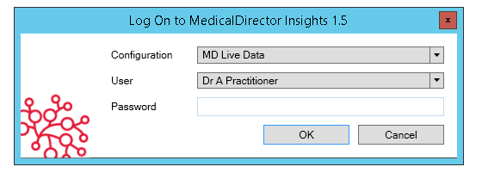

The Medical Director Insights Landing Page will display.

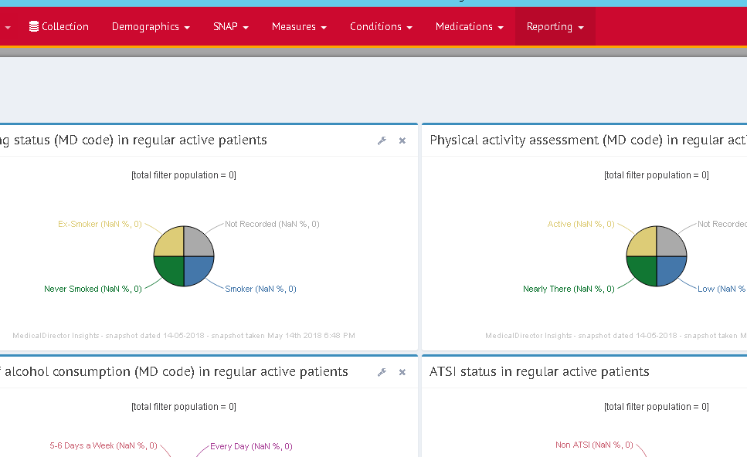

1. In the menu bar at the top of the screen, select the down arrow next to **Reporting** and select **Submit to Health Data Portal** from the list that displays.

The Health Data Portal dialog box will display.

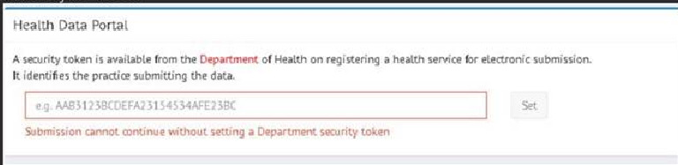

1. Enter the security key you have been given by the Department of Health and Aged Care’s Indigenous health Data Portal team in the field provided and select **Set**.

You have now successfully connected Medical Director to the Data Portal.

**To submit your data to the Data Portal:**

1. Within the **Submission** section, indicate which collection to base your data on (*e.g. ‘Active’ snapshot*) and which reports to include in your submissions (e.g., *nKPI*, *OSR*, *HCP*).
2. To submit your data, select **Submit**.

If you ever need to re-enter your security token information in Medical Director, please email [indigenousreporting@health.gov.au](mailto:indigenousreporting@health.gov.au) and the Health Data Portal team will send you your security token.