**Submit your nKPI Report (Manual Submission)**

To manually submit your nKPI submission in the Data Portal as a *Submission Uploader*:

1. Open the Data Portal through [Health Data Portal](https://dataportal.health.gov.au/).
2. Log in using the information provided in the *Register for and Log in to the Health Data Portal* QRG.

The Data Portal home screen will display with the *Reporting Dashboard* open.

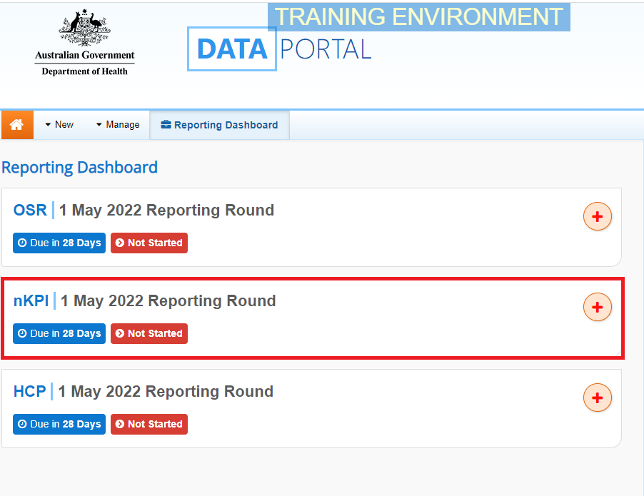

1. To commence the creation of your manual nKPI submission, select Start Submission to the right of the nKPI reporting round in the Reporting Dashboard(*as highlighted above in red*).

 You can also create a manual nKPI submission by selecting New and then selecting *Asset for Submission* from the list that displays.

A blank nKPI form will display, broken down by tabs/indicators on the left-hand side, and can now be populated with your data as required.

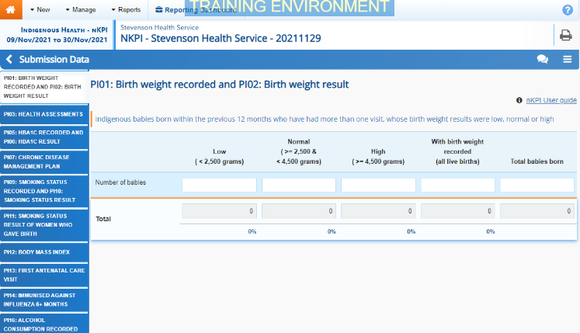

1. The required nKPI data can now be entered into the first indicator/tab on the form as needed.

Some tips for completing indicators as part of a manual nKPI submission are:

* Enter data for each indicator/tab by selecting the applicable indicator/tab on the left-hand side of the form.
* If you have no results to report for cells in an indicator, you can select Options Menu on the right of the blue *Submission Data* bar and then select **Populate empty cells with zeros** to insert zeros into any cells left empty.
* If your health service doesn’t report on a particular indicator, leave the indicator’s cells blank (enter a value initially to bring up Save and then remove the value) and select Save at the bottom of the form to generate a data validation flag for the indicator. Then respond to the flag using the reason *Not funded to provide this service, indicator not applicable,* explaining that you don’t report on the indicator.
* Only positive whole numbers or zeros are accepted as values in the cells (i.e. 10, not 10.5 etc).
* Be aware that if you leave a cell empty (with no positive whole numbers or zeros) you will need to explain these empty cells.
* If you wish to remove values from several cells in an indicator (e.g. removing zeros from the cells as they should be blank) select Options Menu at the top of the screen and then select **Clear all cells**.

1. Once the required data has been entered for the first indicator, select Save at the bottom of the form.

Data validation will now run on the cells you have completed in the indicator and if there are any data validation issues with your data, data validation flags will appear in the *Notifications Tray*.

1. If data validation flags appear, read the messages in the *Notifications Tray* to determine whether any values in the indicator are incorrect and need to be amended, or if the values are correct in your view but require further explanation.

 To open the *Notifications Tray* if it doesn’t display,select Open notifications tray - Some comments require action in the blue *Submission Data* bar at the top of the form.

**If values need to be amended:**

* 1. Update the applicable value(s) in the required cell(s) to address the data validation issues.

 If you are unsure which value(s) needs to be updated, in the *Notifications Tray*, hover your mouse pointer to the right of the data validation flag title, select the Eye button and the applicable cells(s) will be highlighted in red.

* 1. To save the amendment and run data validation again, select Save at the bottom of the form.

The data validation flag relating to the data value you have just amended should now have disappeared from the *Notifications Tray*.

**Submit your nKPI Report (Manual Submission)**

* 1. If the data validation flag hasn’t disappeared, repeat the process of making amendments to the data and selecting Save until this occurs.

 If you wish to add a comment for your colleagues explaining the changes you have made to the values, select Create New Comment at the top of the *Notifications Tray* and add the details.

**If explanatory comments need to be added to the data:**

1. In the **Notifications Tray**, hover your mouse pointer to the right of the data validation flag title, and select the Respond button.
2. Select the down arrow in the **Reason** field that displays and select the reason you are adding a comment from the drop-down list.
3. Enter your comment in the **Additional Informatio**n field.
4. To save the comment, select the Save button.
5. Repeat this process for any other values in the indicator that need to be explained.

The comment(s) has been added and can be viewed by anyone accessing your nKPI submission in the Data Portal.

1. Repeat the above steps for each indicator on the form as required.
2. Once you have finished entering your data into the different indicators on the form and have saved the data, select Close at the bottom of the form.

The Data Portal home screen will again display with the Reporting Dashboard open.

1. Before progressing the submission through the submission workflow, answer either **Yes** or **No** to the data sharing consentquestions that display under **Data Sharing** and then select Save.
2. To progress your nKPI submission through the submission workflow, select the Draft Submission link in the nKPI section of your *Reporting Dashboard*.

The Change Data Asset Status dialog box will display, informing you that your draft submission cannot be removed.

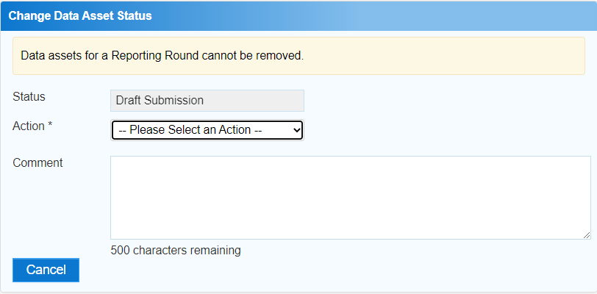

1. In the **Action** field, select the down arrow and select the appropriate action.

The available actions are:

* **Request Review** – Select this action to send your nKPI submission to your *Submission Reviewer* for review prior to it being submitted for approval.
* **Request Approval** – Select this action to send your nKPI submission to your CEO or their representative for internal approval.
* **Request Interim Processing –** If you are a *Submission* *Reviewer* as well as a *Submission* *Uploader*, you can select this action to send your nKPI submission to the AIHW for review prior to it going to your CEO or their representative for approval. This process is known as *Interim Processing*.

 If you can approve your nKPI submission yourself, you will also see the *Approve for Submission* option in the *Action* list. This allows you to approve your submission and submit it directly to the AIHW for processing.

1. In the **Comment** field, enter any comments regarding the action being performed on your submission.
2. One of the following buttons can now be selected when submitting your nKPI report, depending on the action you have selected:

**Submit an nKPI Report (Manual Submission)**

* 1. To send your submission for internal review, select the Request Review button. See the *Review your nKPI Submission* QRG for the next step in the process.
  2. To submit your submission directly for approval to your CEO or their representative, select the Request Approval. See the *Approve your nKPI Submission* QRG for the next step in the process.

Your nKPI submission has now been manually created and submitted to either your *Submission Reviewer* for review or your CEO or their representative for approval.

An automated email will be sent to all staff within your health service that have been assigned the applicable role in the Data Portal (*Submission Reviewer* or *Submission Approver*) notifying them the report has been submitted to them for action.

 For a more detailed description of how to manually submit your nKPI report in the Data Portal, see *Submit your nKPI Report (Manual Process)* in the *nKPI Reporting in the Health Data Portal* user guide on the *User Support* page of the Data Portal.