To review your IAHP PHC Performance Report as a *Submission Reviewer*, after it has been amended by your *Submission Uploader* at the request of your DSS FAM:

**Review your IAHP PHC Performance Report based on DSS Feedback (Submission Reviewer)**

**Review an nKPI Submission as Part of Exception Reporting (Health Service)**

1. Open the Data Portal through [Health Data Portal](https://dataportal.health.gov.au/).
2. Log in using the information provided in the *Register for and Log in to the Health Data Portal* QRG.

The Data Portal home screen will display with the Reporting Dashboard open.

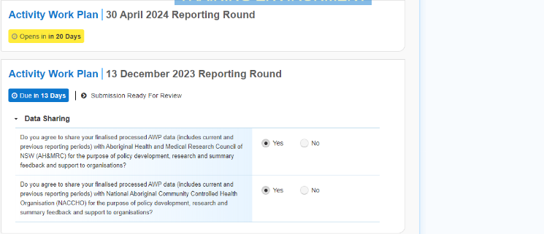

 To be eligible for review, your IAHP PHC Performance Report’s status will need to be *Submission Ready for Review*.

1. To open your IAHP PHC Performance Report form, hover your mouse pointer to the right of the Performance Report reporting round text in the Reporting Dashboard and select Open Submission Form.

Your service’s IAHP PHC Performance Report form will display.

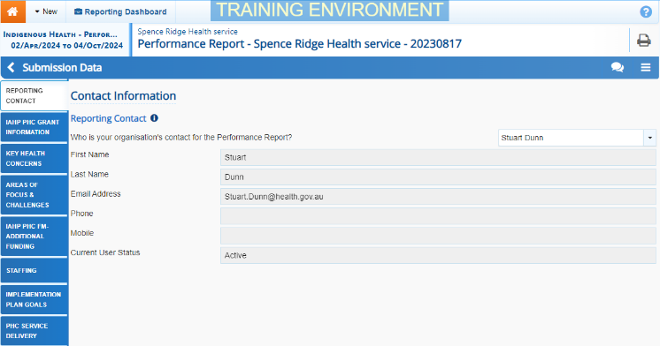

1. Review the information in the different sections of the form as required.
2. If any of the information in the form needs to be updated, make the required changes, and select Save at the bottom of the form to save your changes.
3. If any sections of the form display a speech bubble on the corresponding tab, review the applicable comment in the Notifications Tray to see if the comment is for you and if there is anything you need to do.

 To open the Notifications Tray if it doesn’t display by default, select Open Notifications tray - Some comments require season in the blue Submission Data bar at the top of the form.

1. If your DSS FAM or *Submission* *Uploader* has left a comment for you that you need to respond to, in the Notifications Tray, select the Respond button.
2. Select the down arrow in the **Reason** field that displays and select the reason you are adding a comment from the drop-down list.
3. Enter your comment in the **Additional Information** field.
4. To save the comment, select the Save button.

The comment(s) has been added and can be viewed by anyone accessing your IAHP PHC Performance Report in the Data Portal.

 If there are still sections of the form displaying a data validation flag because some cells in the form are yet to be completed, complete the applicable cells in each secition as needed and select Save. The data validation flag for each section should now disappear.

 If you would like to leave your own comment for others accessing/reviewing the Performance Report form, select Create new comment in the *Notifications Tray* and add your comment, linking it to a particular cell and making it a private comment if needed. Once you are done, select the Save button.

1. To exit your IAHP PHC Performance Report form and return to the Data Portal home screen, scroll to the bottom of the form, and select Close.

The Data Portal home screen will again display with the Reporting Dashboard open.

1. To progress your IAHP PHC Performance Report through the submission workflow, select the Submission Ready for Review link.
2. In the Change Data Asset Status dialog box, in the **Action** field, select the down arrow and select the required action.

The available actions are:

**Review your IAHP PHC Performance Report based on DSS Feedback (Submission Reviewer)**

* **Request Approval** – Select this action to send your Performance Report to your CEO or their representative for approval again.
* **Approve for Submission** – Select this action if you are the CEO, or nominated representative, and are approving your Performance Report as well as reviewing it.
* **Request Interim Processing** – Select this action to send your Performance Report to your DSS FAM for review prior to it going to your CEO or their representative for approval. This process is known as *Interim Processing*.
* **Revision Required** – Select this action to return your Performance Report to the *Submission Uploader* for further amendment.

1. In the **Comment** field, enter any comments regarding the action being performed on your Performance Report.
2. One of the following buttons can now be selected when submitting your Performance Report, depending on the action you have selected:
   1. To send your Performance Report to your CEO or their representative for approval again, select the Request Approval. See the *Approve your IAHP PHC Performance Report based on DSS Feedback (Submission Approver)* QRG for the next step in the process.
   2. To approve your Performance Report and send it directly to your DSS FAM for processing again, select the Approve for Submission button. See the *Process an IAHP PHC Performance Report* QRG for the next step in the process.
   3. To send your Performance Report to your DSS FAM for initial review prior to sending it to your CEO or their representative for approval, select the Request Interim Processing button. See the *Interim Processing of your IAHP PHC Performance Report* QRG for the next step in the process.
   4. To send your Performance Report back to your *Submission Uploader* for amendment again, select the Revision Required button. See the *Amend your IAHP PHC Performance Report based on DSS Feedback (Submission Uploader)* QRG for the next step in the process.

Your IAHP PHC Performance Report has now been reviewed and either sent to your *Submission Approver* for re-approval or sent back to your *Submission Uploader* for further revision as required.