

First Nations Health Reporting:
OSR – Medical Director Data Limitations

Introduction
The Online Services Report (OSR) collects data on the services your organisation provides, like Client Numbers, Client Contacts, Episodes of Care, and staffing levels. It also includes some contextual information about your organisation. Unlike the National Key Performance Indicators (nKPI) report, the OSR doesn’t track health outcomes.
Most of the OSR information is entered manually through the Health Data Portal, but some data can be automatically reported via your clinical information system (CIS). This article focuses only on the measures that can be extracted from and reported by the CIS.
Differences in how clinical information systems (CIS) capture and report data (whether due to system capability, reporting limitations, or both) can affect the accuracy and completeness of these indicators. Understanding these system-specific limitations and how they translate into CIS reports, as well as knowing where to record data within the CIS, is critical for ensuring your activities are comprehensively reported and results interpreted correctly.
This article outlines some of the CIS limitations that may impact health service’s data and some practical tips to help manage data.
Medical Director limitations and data quality tips
Telephone visit
Medical Director doesn't distinguish between clinical and non-clinical encounters for telephone visits. As a result, all telephone encounters are counted as an eligible contact type for the indicators. This may lead to inflated figures for Episodes of Care and Client Numbers, especially if non-clinical staff are logging their client interactions as telephone encounters. The Client Contact numbers aren’t affected since that indicator is filtered by provider type and only clinical provider types are counted.
The Specifications allow for, and accept, this limitation in scenarios where a CIS can’t distinguish between clinical and non-clinical telephone visits.
NOTE: Telehealth visits are categorised separately.
TIP: Knowing this limitation helps you better understand what counts as a contact and what doesn’t.
Reportable Provider types
Default and custom provider types
Medical Director’s default ‘out of the box’ provider type list is limited and doesn’t cover the full suite of provider categories reported in OSR. The good news is health services can add additional provider types to compensate for this if they are selected from the ‘specified’ list provided by Medical Director. A note of caution, when adding these ‘specified’ provider types you must ensure the spelling matches exactly with the Medical Director OSR provider list for them to be counted in the OSR Client Contacts indicators. Appendix A contains the full Medical Director OSR provider list and outlines which are default, and which additional providers can be added. Instructions for adding provider types is included below.
TIP: If provider types do not match precisely, their visits won’t be included in the OSR Client Contacts count. This may result in incomplete reporting of Client Contacts.
NOTE: Contacts with custom provider types, even if they do not match exactly, will still be counted in Episodes of Care and Client Numbers because these two indicators do not filter by provider type.
TIP: Follow these steps to add custom provider types:
- Go to User > Setup Users… > Add User
- Click on the three dots next to the ‘Category’ box
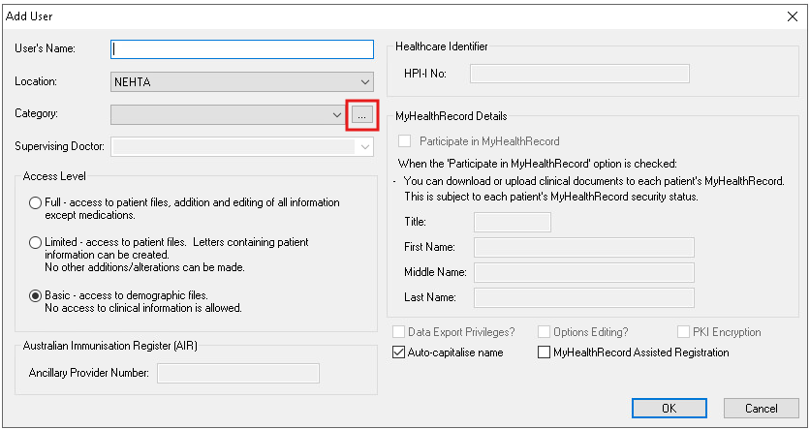
- Click on ‘Add’
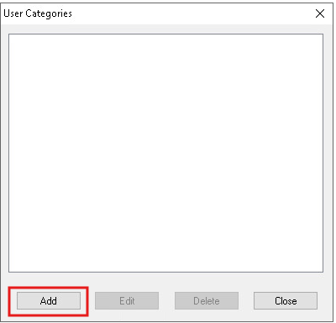
- A free text box will appear, allowing you to add any user category. Remember, whatever you add, the spelling must match exactly with the Medical Director OSR provider list to be included in the report.
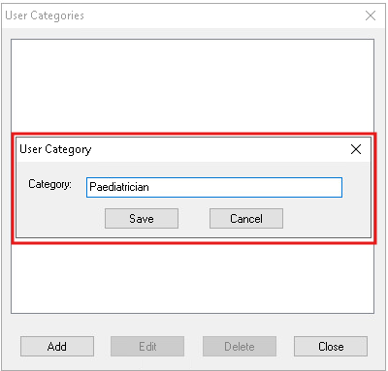
- After the new category has been added, it will show up in the ‘User Categories’ box and be available in the drop-down list for ‘Category’.
- TIP: Use this ‘User Categories’ drop-down list to review the provider types you have added and ensure they match the Medical Director OSR Provider list exactly.
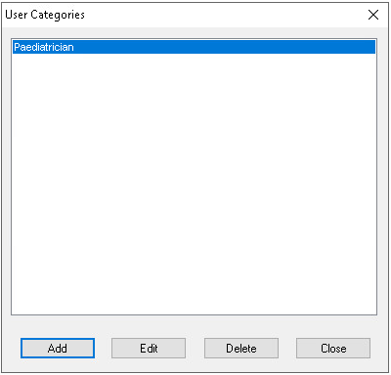 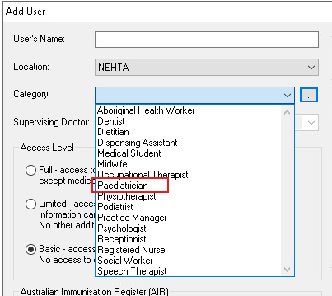

Other/unspecified clinical staff
It is possible to add user categories for some other/unspecified clinical staff. However, interactions with these staff are reported differently across the OSR indicators.
Interactions are counted towards Episodes of Care and Client Numbers. However, in the count of Client Contact where results are filtered by provider type categories, Medical Director does not report on the ‘Other health/clinical staff’, ‘Specialist other or not specified’, ‘SEWB staff other or not specified’ and ‘Allied health other or not specified’ OSR categories. Therefore, contacts with providers in these categories can’t be extracted directly from Medical Director.
TIP: Track these interactions separately and manually enter the number of Client Contacts into the Health Data Portal.
Reporting – MD Insights
MD Insights has no functionality to set a report end date. Instead, it uses a snapshot date, which serves as the reference point for all time-based data, like client age, time since the last visit, or when data was recorded. The snapshot date is the date you run the data collection.
Because all time-based reporting is anchored to this snapshot date, the accuracy of indicators may be affected if the data collection isn’t timed consistently. This could lead to reporting for a time period that doesn’t match the financial year period. For example, one round might reflect data from July to June, while another reflects August to July. This may also yield variations in data trend over time if one reporting round is run early in the reporting round window but in another round run towards the end of the reporting period.
TIP: Setting a reminder or using MD Insight’s scheduling feature can help ensure consistency. Schedule data collections in MD Insights for 1 July each year to align with national reporting periods. Confirm the collection is successful as soon as you can.
Users with multiple profiles
Medical Director supports both clinical and non-clinical user profiles. If a user records clinical activity while logged in under a non-clinical profile (e.g. Practice Manager), it can lead to inconsistencies in reporting. Specifically, the Episode of Care count may be higher than the Client Contacts count which will trigger a validation flag in the Health Data Portal. This occurs because Episodes of Care are not filtered by provider type, whereas Client Contacts are.
TIP: Always ensure you're logged in under the appropriate profile for the task. Clinical activities should be recorded using a clinical profile to maintain accurate and consistent reporting.
Key takeaways:
- Telephone encounters are counted as clinical encounters.
- Only provider types that match exactly with the Medical Director OSR Provider List (see Appendix A) are included in the Client Contacts count.
- MD Insights uses a snapshot date instead of a report end date, which affects all time-based reporting. Inconsistent timing of data collection may result in inaccurate indicator counts. Scheduling data collection for 1 July each year is recommended.

Resources
Links to supporting documents, information and further reading:
- Specifications for nKPI and OSR: This document is for service providers and clinical information system vendors. It gives a detailed overview of foundation data concepts, related data, and a full explanation of each measure—covering inclusions, exclusions, counting rules, measure code disaggregation points, and the nKPI Condition and Pathology Coding Frameworks. It also highlights variances in vendor implementation for selected measures. You can access the Specifications here: https://www.solvinghealth.au/specifications
- CIS User Guides: These explain how vendors report indicators and where data need to be recorded in the CIS to optimise reporting. Refer to the article CIS User Guides for links or visit the link in the Specifications (dot point above) which has links to vendor documents at the end of the web page.
- Vendor scorecard: The vendor scorecard is a one page visual that compares results for nKPI and OSR across CIS: https://www.solvinghealth.au/scorecard
For more data management tips see the other articles in this series available at: Clinical Information System (CIS) Education Articles

Appendix A – Medical Director OSR Provider List
The table below lists the provider categories included in the OSR Client Contacts indicators. Bolded categories are default values, while all other entries are user-defined and must match exactly to be counted in the report.
OSR categories for reporting | Medical Director User/Doctor Categories
ATSI health worker | Aboriginal health worker  Aboriginal and Torres Strait Islander health worker  ATSI health worker
ATSI health practitioner | ATSI health practitioner  Aboriginal health practitioner  Aboriginal and Torres Strait Islander health practitioner
Doctor – general practitioner | Doctor  General Practitioner  General Practice  G.P.  G.P  GP
Nurses | Registered nurse  RN  R.N.  R.N  Nurse  Nurse practitioner
Midwives | Midwife  Midwive
Substance misuse / drug and alcohol worker | AOD worker  Drug and alcohol  Drug and alcohol counsellor  Drug and alcohol worker  Alcohol and drug counsellor  Alcohol and drug worker  Substance misuse counsellor
Tobacco worker / co-ordinator | Tobacco worker
Dentists / dental therapists | Dentist  Dental therapist
Dental support (e.g. dental assistant / dental technician) | Dental hygienist  Dental technician
Sexual health worker | Sex health worker
Traditional healer | Traditional healer
Other health / clinical staff
Transport – work for service | Transport (for practice workers)
Transport – do not work for service | Transport (for non-practice workers)
Paediatrician | Paediatrician  Paediatrics
Endocrinologist | Endocrinologist  Endocrinology
Ophthalmologist | Ophthalmologist  Ophthalmology
Obstetrician / Gynecologists | Obstetrician  Obstetrician and gynaecologist  Obstetrics  Gynaecologist  Gynaecology  OBGYN  OB/GYN  OBG
Ear nose and throat specialist | Otorhinolaryngologist  Otorhinolary surgeon  ENT surgeon  Ear nose throat surgeon  Neck surgeon
Cardiologist | Cardiologist  Cardiology  Cardio
Renal medical specialist | Renal medicine specialist  Renal medicine
Psychiatrist/psychiatric registrar | Psychiatrist
Dermatologist | Dermatologist  Dermatology
Surgeon | Surgeon  Surgeon general  General surgeon
Specialist other or not specified
Psychologist | Psychologist  Clinical psychologist  Educational psychologist  Organisational psychologist  Psychotherapist
Counsellor | Counsellor
Social worker | Social worker
Welfare worker | Welfare Worker
SEWB staff – link up caseworker | SEWB LinkUp caseworkers  SEWB Link Up caseworkers  Social and Emotional Well-Being Link Up caseworker
SEWB staff other or not specified
Audiologist/ audiometrist | Audiologist
Diabetes educator | Diabetes educator  Diabetic educator
Dietician | Dietician  Dietitian
Optometrist | Optometrist
Pharmacist | Pharmacist
Physiotherapist | Physiotherapist  Physio
Podiatrist | Podiatrist
Speech pathologist | Speech pathologist  Speech therapist
Allied health other or not specified

