

First Nations Health Reporting:
nKPI – Medical Director Data Limitations

Introduction
The National Key Performance Indicators (nKPI) is a suite of process of care and health outcome indicators focussing on maternal and child health, preventive health, and chronic disease management for First Nations people. Accurate reporting is essential to support continuous quality improvement in primary health care delivery.
Differences in how clinical information systems (CIS) capture and report data (whether due to system capability, reporting limitations, or both) can affect the accuracy and completeness of these indicators. Understanding these system-specific limitations and how they translate into CIS reports, as well as knowing where to record data within the CIS, is critical for ensuring your activities are comprehensively reported and results interpreted correctly.
This article outlines some key CIS limitations that may impact health service’s data and some practical tips to help manage data.
Medical Director limitations and data quality tips
Telephone visits
Medical Director doesn't distinguish between clinical and non-clinical encounters for telephone visits. As a result, all telephone encounters are counted as eligible visit types for assessing Regular Client status in the nKPI report. This may lead to inflated Regular Client figures, particularly if non-clinical staff are recording their client interactions as telephone encounters.
The Specifications allow for, and accept, this limitation in scenarios where a CIS can’t distinguish between clinical and non-clinical telephone visits.
NOTE: Telehealth visits are categorised separately.
TIP: Knowing this limitation helps you better understand which data are included in the calculation of Regular Client status.
Pathology results – PI05, PI06, PI18, PI19, PI25
Manually entered pathology results
Medical Director enables pathology results to be entered manually but currently only counts them in nKPI reports if they are added in a specific way. Results entered via the ‘Results’ tab are not counted in MD Insights. This is a common method used by health services entering point of care test (POCT) results which appears to be impacting reported data for some services.
Because these manually entered results don’t populate the required ‘Report Date’ field used by MD Insights, they are excluded from reporting. This impacts all pathology related indicators, including PI05, PI06, PI18, PI19 and PI25. Services relying on POCT without pathology laboratory confirmation may be underreporting key activity.
TIP: For PI05, PI06, PI18 and PI19, follow Medical Director’s nKPI technical documentation which explains where to enter results so that they are counted. Refer to the Resources section at the end of this article to locate the current Medical Director user guide.
NOTES:
- For PI25, results will not be counted until a fix is released. Medical Director is aiming to have this completed in time for the January 2026 reporting round. In the meantime, Medical Director has provided some guidance for health services encountering discrepancies in reporting results for PI25. The user guide titled Running a SQL Query in SQL Server Management Studio (SSMS) is available at https://www.medicaldirector.com/wp-content/uploads/2025/06/nKPI-PI25-STI-tests.pdf This guide explains how to calculate PI25 using a SQL query. The results of this can then be entered manually into the Health Data Portal. Once the permanent fix is released this script will not be required.
- Historically, chlamydia and gonorrhoea POCT results were verified by a separate laboratory pathology test. Since this is no longer standard practice, and combined with the current issue preventing manual POCT results from being counted, services may notice a decline in reported PI25 results over time. This should resolve when the fix is implemented.
The Holding File
Pathology results are only included in nKPI reports if the result has been recorded in the client’s medical record. Electronically received pathology results from pathology laboratories must be fully actioned in the Holding File for them to be added to the client record.
Results that are scanned into the record, i.e. stored as a document, cannot be read and therefore will not be counted. Some manual entry of these results may be needed.
Each CIS identifies relevant pathology results differently, usually based on specific test names or codes. You can find the detail for each pathology test in Medical Director’s nKPI Technical Documentation.
TIP: Read the Medical Director nKPI Technical Documentation document to understand which tests are recognised for specific indicators. This is particularly important for indicators like PI05, PI06, PI18, PI19 and PI25 where pathology results play a key role in the reported data.

Smoking status – PI09, PI10, PI11
In PI09, PI10 and PI11, the Specifications for nKPI and Online Service Reports (OSR) (the Specifications) state that smoking status should be recorded within specific time periods or events.
Medical Director correctly includes only smoking status records captured within the time period specified by each indicator. Some services have noticed their reported data has dropped over time. This may reflect a common workflow where clinicians ask about smoking status during consultations but do not update the record if the status has not changed. As a result, even though the information is being reviewed, the recorded status may fall outside the reporting period and no longer be counted.
For optimal data reporting in these indicators a new smoking assessment does need to be recorded periodically. Multiple assessments can be recorded in Medical Director even when the status hasn’t changed. Currently the only way to do this is to do a ‘New Assessment.
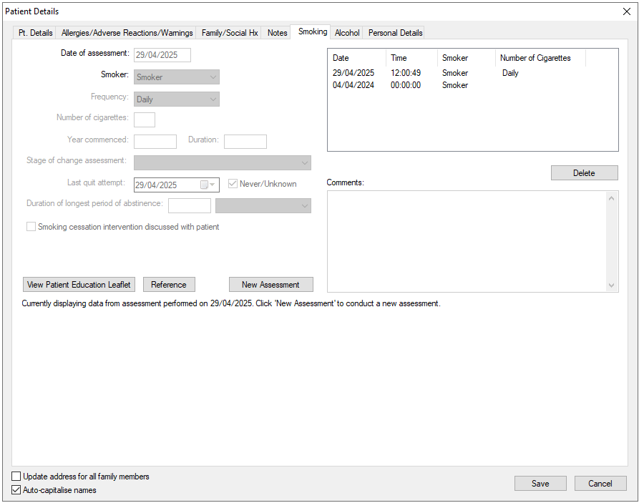

TIP: Medical Director nKPI reports may undercount smoking status assessment activity because it correctly applies a recorded date within specific time periods. Clinical staff are encouraged to complete a new assessment to confirm data are current.
Baby birthweight – PI13
MD Insights previously included all births with a valid birth outcome, even if the gestation was under 20 weeks. This was due to report logic that allowed inclusion if either a valid birth outcome (anything other than miscarriage or termination) or a gestation of at least 20 weeks was recorded.
As of the January 2025 reporting round, the logic has been corrected to align with the Specifications. A birth must now have both a valid birth outcome and a gestation of at least 20 weeks to be included in PI13.
NOTE: The indicator includes births where the birthweight is at least 400g OR has a gestational age of 20 weeks or more. However, MD Insights only uses gestational age to determine inclusion; birthweight is not considered. This means that if a birth meets the minimum birthweight requirement (400g or more) but has a gestation under 20 weeks, it will not be counted, even though it meets the indicator inclusion. As a result, you may see a slight decrease in numbers compared to previous rounds.
Alcohol status – PI16
PI16 counts the proportion of eligible clients who have had their alcohol consumption status recorded. This includes a record of either:
- Whether the client consumes alcohol i.e. non-drinkers and drinkers.
- The amount and frequency of the client’s alcohol consumption.
The only function to record alcohol status in Medical Director is in the Audit-C Alcohol Assessment of the Alcohol Tab. Although Audit-C is predominantly used to identify at risk drinkers it can also be completed for non-drinkers. Noting there is less incentive to complete the questionnaire if the client does not drink, the cohort of clients represented in this indicator are likely to be under-reported.
Health services who are concerned their PI16 data are low may wish to encourage clinicians to record an Audit-C assessment for non-drinkers.
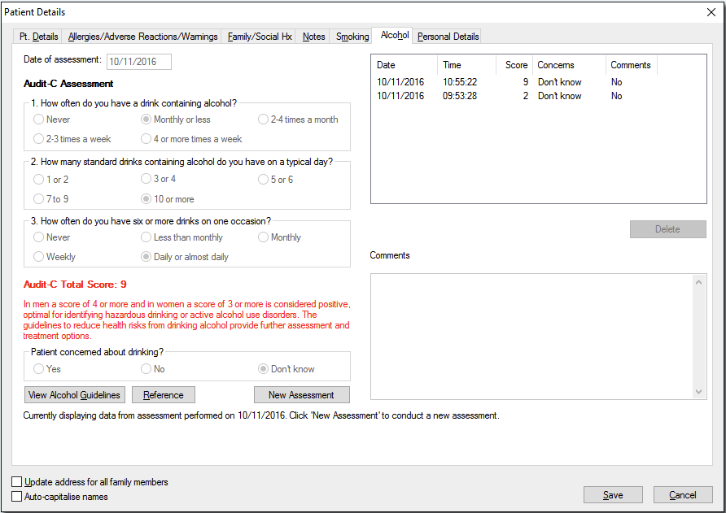
TIP: PI16 records alcohol assessment for all clients including non-drinkers through the Audit-C Alcohol Assessment.
Alcohol consumption must be recorded within the past 24 months to be counted towards PI16. Even when there is no change in status the alcohol history needs to be updated for it to be counted as assessed within the specified time period.
TIP: If there is no change in the client’s drinking status, a new Audit-C needs to be completed to confirm the client’s alcohol status has been assessed; this will ‘date stamp’ the alcohol status to reflect the assessment date.
Cervical Screening (HPV) – PI22
Medical Director counts cervical screening records present in the Cervical Screening tab of the client’s medical record. Results received electronically via the Holding File must be actioned, just like pathology results, and manually added to the client’s medical record using the ‘Add Cervical Screening Result’ capability and completing the information in the Record Cervical Screening Result window. If the result has been added to the client’s medical record from the Holding File, then it needs to be added to the Cervical Screening tab using the ‘Copy Record to Cervical Screening Result’ function.
Screening that is self-collected, and results performed elsewhere, should also be manually added. Results performed elsewhere may be received electronically as results copied to the health service; in these scenarios they are managed as electronically received pathology. When confirmation of screening elsewhere is received in routine correspondence e.g. in scanned referral letters, it will need to be manually entered for it to be counted in PI22.
TIP: When actioning cervical screening records from the holding file remember to add them to the client’s Cervical Screening tab.
NOTE: The National Cancer Screening Register (NCSR) is integrated with Medical Director. This allows you to view a client’s latest NCSR data. However, there is no facility yet to automatically write this data back to the client’s record. Cervical screening history in the NCSR may be relevant to PI22. If you want that information to be counted towards PI22, it must be manually added to the client’s Medical Director cervical screening record.
Reporting – MD Insights
MD Insights has no functionality to set a report end date. Instead, it uses a snapshot date, which serves as the reference point for all time-based data, such as client age, time since the last visit, or when data was recorded. The snapshot date is the date you run the data collection.
Because all time-based reporting is anchored to this snapshot date, the accuracy of indicators may be affected if the data collection isn’t timed consistently. This could lead to variations in the reporting period covered. For example, one round might reflect data from March to February, while another reflects July to June. This may yield variations over time if one reporting round is run early in the reporting round window but in another round run towards the end of the reporting period.
TIP: Schedule data collections in MD Insights for 1 January and 1 July each year to align with national reporting periods. As soon as you can after that period confirm the collection was successful so that not too much time lapses if you need to rerun the collection. Setting a reminder or using MD Insight’s scheduling feature can help ensure consistency without relying on memory.

Key takeaways:
- All telephone encounters are counted as eligible visits. This may inflate Regular Client numbers if non-clinical staff record their client interactions this way.
- Manually entered pathology results via the ‘Results’ tab are not currently counted, which can lead to underreporting for indicators like PI05, PI06, PI18, PI19 and PI25. A fix is planned for the January 2026 reporting round. Use the tips above to optimise reporting in the interim.
- MD Insights uses a snapshot date rather than a report end date, so inconsistent timing of data collection may impact the reporting period covered.

Resources
Links to supporting documents, information and further reading:
- Specifications for nKPI and OSR: This document is for service providers and clinical information system vendors. It gives a detailed overview of foundation data concepts, related data, and a full explanation of each measure—covering inclusions, exclusions, counting rules, measure code disaggregation points, and the nKPI Condition and Pathology Coding Frameworks. It also highlights variances in vendor implementation for selected measures. You can access the Specifications here: https://www.solvinghealth.au/specifications
- CIS User Guides: These explain how vendors report indicators and where data need to be recorded in the CIS to optimise reporting. Refer to the article CIS User Guides for links or visit the link in the Specifications (dot point above) which has links to vendor documents at the end of the web page.
- Vendor scorecard: The vendor scorecard is a one page visual that compares results for nKPI and OSR across CIS: https://www.solvinghealth.au/scorecard
For more data management tips see the other articles in this series available at: Clinical Information System (CIS) Education Articles

