Approve a Data Asset for Publication
Data assets to be published can be approved by anyone in Health with the Publication Publisher role in the Data Portal.
To approve a data asset in the Data Portal:
- Open the Data Portal through Health Data Portal.
- Log in using the information provided in the Registering for and Logging in to the Health Data Portal QRG.
The Data Portal home screen will display.
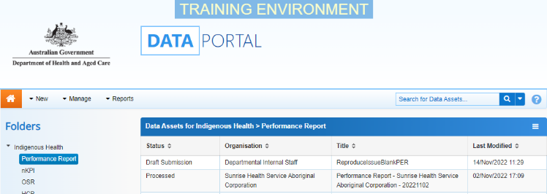
- From the Data Portal home screen, search for the data asset to be approved for publication.
For more information on how to search for a data asset, see the Get Started in the Health Data Portal QRG.
To be eligible for approval, the data asset’s status will need to be Ready for Approval.
- Select the data asset to be approved.
The Data Asset Details screen will display.
- To update the details of the data asset, select at the top of the screen.
The Data Asset Details screen will update so active (white) fields on the screen can be edited if needed.
- Make any required amendments to the information on the Data Asset Details screen.
- To review the contents of the attached publication, select the file title link under File Name in the Files section.
- There are several actions that can be performed on the attached publication, in the Files section, if needed.
Button | Description
 | Select this button under File Name to download and view the publication. A pop up will appear in the bottom left-hand corner of the screen and you can open the file from here and save it as required.
 | Select this button under File Name to replace the file with another file if you have uploaded it incorrectly.
 | Select this button under Actions to view the publication’s previous versions.
 | Select this button under Actions to add text to the Description field.
 | Select this button under Actions to remove the publication from the data asset.
 | Select this button under Actions to view the publication’s download history.
 | Select this button under Actions to see a list of users who will have the required file permissions to view the publication once it is published.
Select this button under Actions to add an updated version of the file if needed.
This will add a second file, rather than replace the existing one.
- To save your changes to the data asset details, select .
- Once the data asset and the attached file have been reviewed as required, select either or the workflow progress bar at the top of the screen and, in the Change Data Asset Status dialog box, in the Action field, select and select the required action.
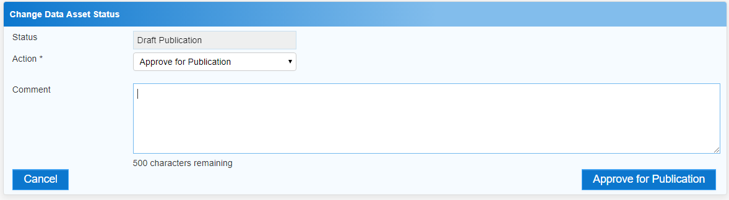
The available actions are:
- Revision Required – Select this action if the data asset needs to be returned to the Publication Producer for amendment.
- Approve for Publication – Select this action to approve the data asset for publication and progress it to the status of Approved for Future Publication (if the publication period is not yet active) or Published (if the publication period is active).
Approve a Data Asset for Publication
- In the Comment field, add any comments regarding the data asset if required.
- One of the following options can now be selected, depending on the action you have selected:
  - To send the data asset back to the Publication Producer for amendment, select . See the Amend a Draft Publication QRG for the next step in the process.
  - To approve the data asset and send it for publication, select . See the Work with Data Assets Approved for Publication QRG for the next step in the process.
To save the data asset as a draft without sending it on to the next stage of the publication process, select .

The data asset has now been approved for publishing and will be published for viewing and downloading as soon as the publishing start date is reached.

