Process an nKPI Submission (the AIHW)
Step 1 – Review the nKPI Data Asset
Once the AIHW has received an approved nKPI data asset from a health service, they will need to review the data asset in the Data Portal to ensure it is ready to go to the next step of the process.
To review an nKPI data asset in the Data Portal:
- Open the Data Portal through Health Data Portal.
- Log in using the information provided in the Registering for and Logging in to the Health Data Portal QRG.
The Data Portal home screen will display.
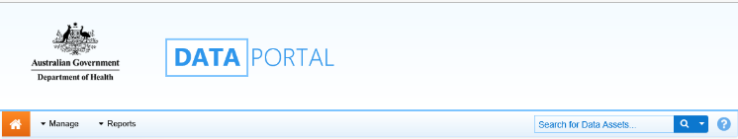
- From the Data Portal home screen, search for the nKPI data asset to be processed.
For more information on how to search for a data asset, see the Get Started in the Health Data Portal QRG.
To be eligible for processing, the data asset’s status will need to be Submission Approved.
- In the Data Assets section of the Data Portal home screen, select the nKPI data asset to be processed.
The Data Asset Details screen will display.
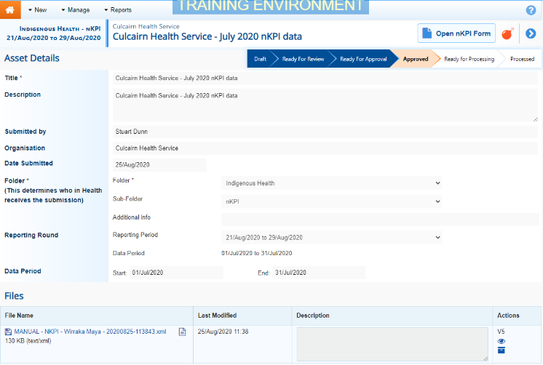
- Review the details of the data asset as needed.
- To review the data in the attached form, select at the top of the screen.
The nKPI form will display and the data in the form can be reviewed for accuracy.
- Once you have finished reviewing the content of the form, select 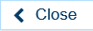 at the bottom of the form.
If upon review of the data in the form you find anomalies, you should start the exception reporting process to add comments about the anomalies in the data and send the data asset back to the health service for amendment. For more information, see the Initiate Exception Reporting (the AIHW) QRG.
The Data Asset Details screen will display.
- To action the data asset, select either or the workflow progress bar at the top of the Data Asset Details screen.
The Change Data Asset Status dialog box will display.
- In the Action field, select and select Ready for Processing.
If the health service has asked you to return the data asset as it has been submitted in error, select Return to Uploader.
- In the Comment field, enter any comments about the action being performed on the data asset.
- To set the data asset to Ready for Processing, select .
The Data Asset’s status will change to Ready for Processing and it is ready to be processed.

Step 2 – Process the nKPI Data Asset
Process an nKPI Submission (the AIHW)
Once a health service’s nKPI data asset has the status of Ready for Processing, it can be processed in the Data Portal by the AIHW.
To process an nKPI data asset in the Data Portal:
- Ensure the Data Portal home screen is displayed.
- From the Data Portal home screen, search for the data asset to be processed.
For more information on how to search for a data asset, see the Get Started in the Health Data Portal QRG.
- Select the nKPI data asset to be processed.
The Data Asset Details screen will display.
- To check to see if any data validation issues are still present in the form, select 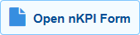 at the top of the screen.
The nKPI form (with the health service’s name at the top of the screen) will display containing the health service’s data, and any indicators still containing data validation flags will show a on the corresponding tab.
- To mark a data validation flag as “complete”, in the Notifications Tray, hover your mouse pointer to the right of the comment title for the applicable indicator and then select .
If the Notifications Tray doesn’t display, select or at the top of the form to open it.
The Reason and Additional Information fields will display.
These fields will only display if you have selected against a data validation flag and/or the last response entered against it. If you select against a comment entered by the health service, the comment will just disappear and be marked as ”complete”.
- In the Reason field, select and select the reason that aligns to what is being done with the data in the indicator the validation issue comment relates to. The options are Completed, all data accepted; Completed, data excluded from national reporting only and Completed, data excluded from organisation level and national reporting.
- In the Additional Information field, if the data in the indicator is being excluded, enter detail about why the data is being excluded.
- To save the comment, select .
- Repeat the process for all indicators with outstanding data validation issues.
A data asset can’t be processed as complete with any outstanding data validation flags.
The data validation flags will now disappear.
- To exit the nKPI form and return to the Data Asset Details screen, select at the bottom of the form.
The Data Asset Details screen will display.
- Once the data asset has been reviewed as needed, select either or the workflow progress bar at the top of the screen.
The Change Data Asset Status dialog box will display.
- In the Action field, select and select Process.
- In the Comment field, enter any comments about the action being performed on the data asset.
- To process the data asset, select 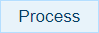
The data asset’s status will change to Processed and the processing of the data asset is now complete.
The information within the nKPI form can now be used in any publications that need to be produced and made available to applicable users of the Data Portal.

