While no changes have been made to the Health Data Portal nKPI form for January 2024 nKPI reporting, some tweaks have been made to the processes associated with indicators 21 (CVD Risk Assessment Result) and 25 (STI Tests).
What’s New/Different for January 2024 nKPI Reporting

PI21 CVD Risk Assessment Result
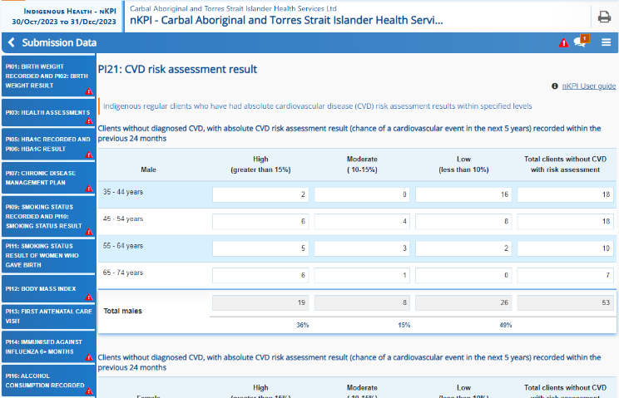
PI21 data will still be collected as normal in January 2024 as part of the six-monthly nKPI reporting, however all PI21 data will be excluded from AIHW’s national reporting.
This is due to the fact that, while new national guidelines for CVD Risk have been recently issued, they have not yet been built into the Clinical Information System (CIS) risk calculators. Consequently, the CVD risk results submitted from your CIS will not be aligned with the updated guidelines, although they may still be useful within your organisation for comparison purposes.

PI25 STI Tests
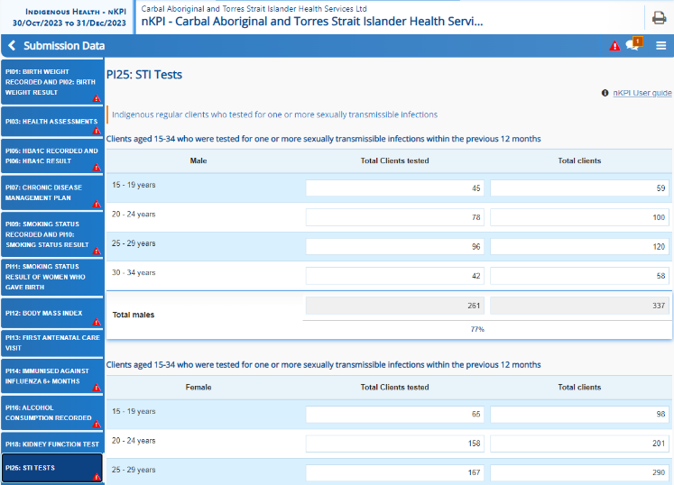
PI25 data will be collected as normal for January 2024 reporting as part of the ongoing STI Tests pilot being conducted in the Health Data Portal.
The following changes have been made though to how this data is collected in the health service Clinical Information Systems (CIS) to help improve the completeness and accuracy of the data collected through the Health Data Portal nKPI form:
- The pathology coding framework for chlamydia and gonorrhoea has been revised to broaden data capture and address missing results.
- Changes have been made to the existing list of LOINC codes and free text terms and some new LOINC codes and test names have been added.
- Depending on which CIS you use, you may see some variability of results compared to your previous PI25 pilot submissions. This is expected during the pilot as we work with the CIS vendors to refine their calculations.

