To print or save a PDF version of your nKPI form in the Data Portal:
Print/PDF your nKPI Form
- Open the Data Portal through Health Data Portal.
- Log in using the information provided in the Register for and Log in to the Health Data Portal QRG.
The Data Portal home screen will display.
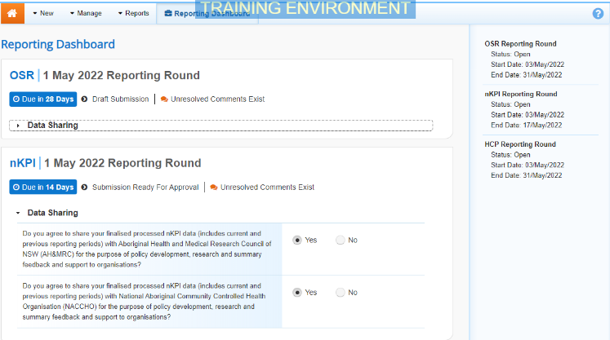
- To open your nKPI form, hover your mouse pointer to the right of the nKPI reporting round text in the Reporting Dashboard and select .
The nKPI form will display.
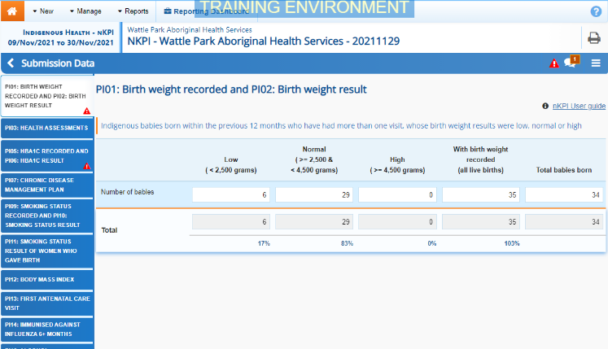
- To print/PDF the data for an individual section of your nKPI form, select the required section from the list of tabs on the left-hand side of the screen and then select .
- To print/PDF your entire nKPI form at once, or more easily print multiple sections of the form, select in the blue Submission Data bar in the top right-hand corner of the form and then select Summary View.
The Summary View contains all sections of your form with the first section of the form defaulting as open, in read-only mode. If there are any comments in the form, these will now display in the Notifications Tray on the right-hand side of the form.
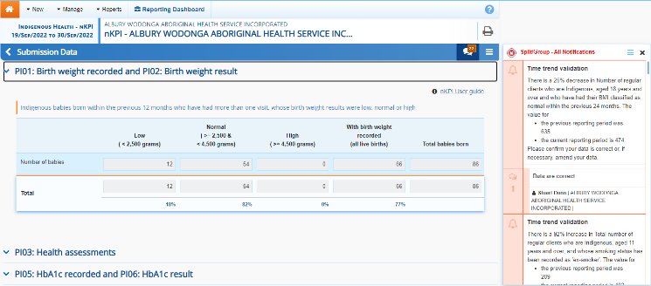
- To expand all the sections at once so your entire form can be printed or saved as a PDF, select at the top of the form and select Expand all tabs.
If needed you can expand and collapse individual sections by selecting next to the applicable section.
- Once all the required sections have been expanded, to print or PDF your entire form, select .
The Print dialog box will display, showing a preview of your form, with any comments now showing in the section of the form they relate to.
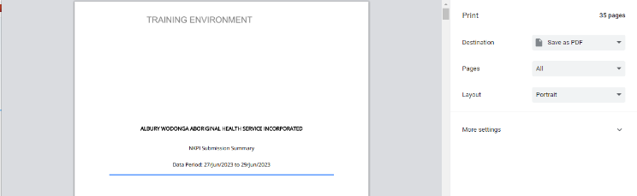
- To continue, select the printer you wish to use.
To save your form as a PDF rather than print it, select the Save as PDF option, and then select the Save button and save the form to the desired location.
- To print your nKPI form, select .
Your nKPI form will now be printed at the selected printer.
Please note, the form will be long when printed in its entirety. You may wish to print individual sections where possible.

