The QLIK IAHP – Performance Report app
The QLIK IAHP Performance Report app for DSS FAMs

The QLIK IAHP – Performance Report app allows DSS Funding Agreement Managers (FAMs) to view all the information entered by health services in their IAHP PHC Performance Reports through the Health Data Portal each September. It allows you to either view complete Performance Reports for a particular health service or focus on aspects of the performance report for all services, or for a grouping of your choice.
To access the QLIK IAHP – Performance Report app:
- From the Data Portal home screen, select Reports > Interactive Reports.
- On the QLIK screen that displays, select Indigenous Health on the left-hand side.
- On the right-hand side of the screen, select the IAHP – Performance Report tile.
The IAHP – Performance Report sheet will display.
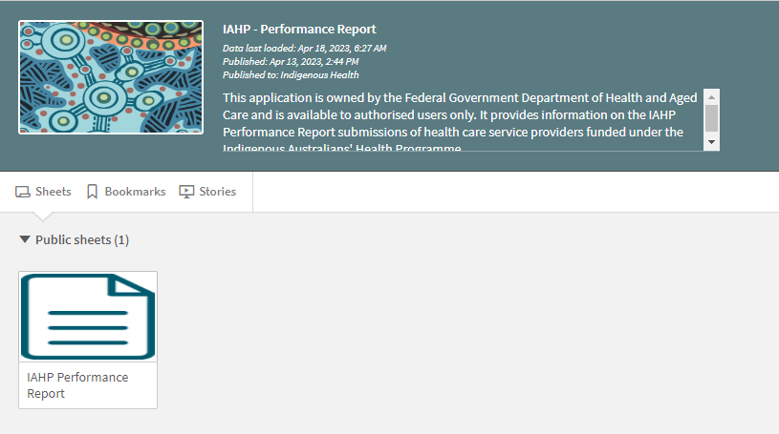
- To display the report, select the IAHP Performance Report sheet.
The IAHP Performance Report screen will display.
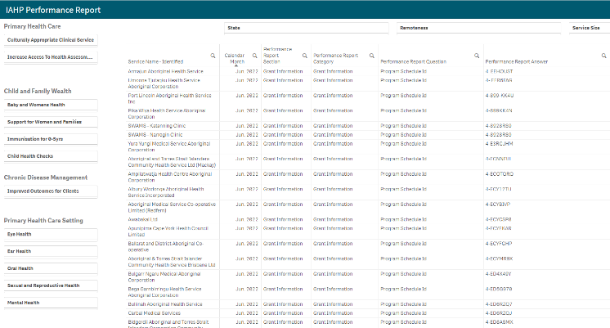
A list of all health services will display, along with their performance report information, broken down by section, with the Grant Information section displaying first.
- If needed, the filter fields at the top of the sheet can be used to filter the information displaying in the table by state, remoteness, or service size.
- The magnifying glasses in the header rows of the table can also be used to filter the information by service name. reporting round, and particular elements of the Performance Report itself.
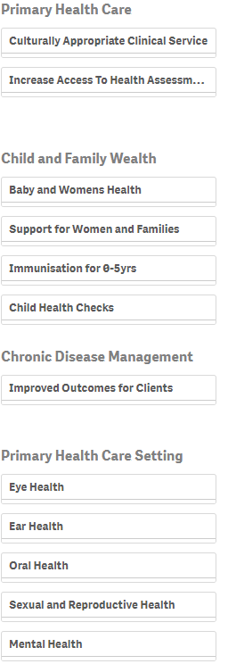
Lastly, the filter section on the left-hand side of the sheet can be used to filter the information displayed in the table by the different PHC services that health services deliver.
- To use this filter section, select the service you wish to focus on (for example Eye Health, Ear Health and Baby and Women’s Health) and then select either Achieved, Partially Achieved or Stalled/Delays.
The table will then be filtered to display a list of services who have nominated the rating for the selected PHC service they deliver.

