Step 1 – Prepare the TIS Performance Report for Review
Review and Action a Health Service’s TIS Performance Report (DSS FAMs)
Once a health service has completed their TIS Performance Report in the Data Portal and submitted it to you for review, you will receive an email notifying you of this.
When you are ready to review the TIS Performance Report in the Data Portal, you will need to set its status to Ready for Processing so you can review its content and add any comments as/if needed.
All DSS FAMs will receive an email notification when a TIS Performance Report is submitted by a health service. If you do not wish to receive these emails, you may need to create an email rule to facilitate this.
To review a TIS Performance Report in the Data Portal:
- Open the Data Portal through Health Data Portal.
- Log in using the information provided in the Registering for and Logging in to the Health Data Portal QRG.
The Data Portal home screen will display.
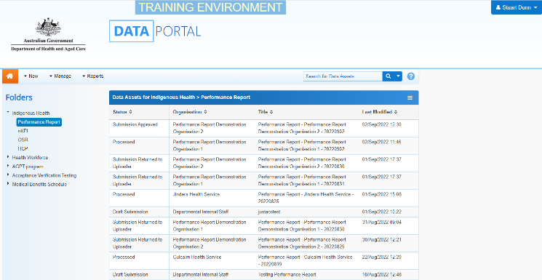
- From the Data Portal home screen, search for the TIS Performance Report you need to review.
The TIS Performance Report will have the status of Submission Approved.
For more information on how to search for a report, see the Get Started in the Health Data Portal QRG.
- In the Data Assets for Indigenous Health table, select the TIS Performance Report to be reviewed.

The Data Asset Details screen will display.
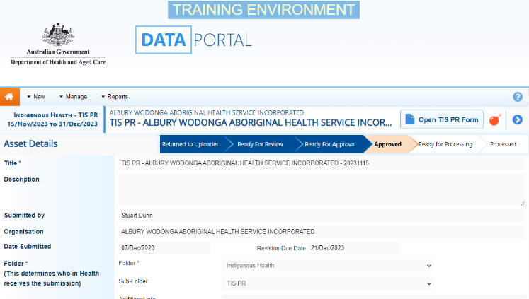
You now need to move the TIS Performance Report to Ready for Processing so you can review its content and progress it as needed.
- To do this, select either or the workflow progress bar at the top of the screen.
The Change Data Asset Status dialog box will display.
- In the Action field, select and select Ready for Processing.
If the health service has asked you to return the TIS Performance Report as it has been submitted in error, select Return to Uploader.
- To set the TIS Performance Report to Ready for Processing, select .
The TIS Performance Report’s status will change to Ready for Processing, and it is now ready to be reviewed and actioned as needed.

Step 2 – Review and action the TIS Performance Report
Review and Action a Health Service’s TIS Performance Report (DSS FAMs)
Once the TIS Performance Report has been set to Ready for Processing, you can start reviewing its content to determine whether it can be processed as complete or requires amendment.
To review a TIS Performance Report in the Data Portal:
- Ensure the Data Portal home screen is displayed.
- From the Data Portal home screen, search for the TIS Performance Report to be reviewed. The report’s status will be Ready for Processing.
For more information on how to search for a report, see the Get Started in the Health Data Portal QRG.
- Select the TIS Performance Report to be reviewed.
The Data Asset Details screen will display.
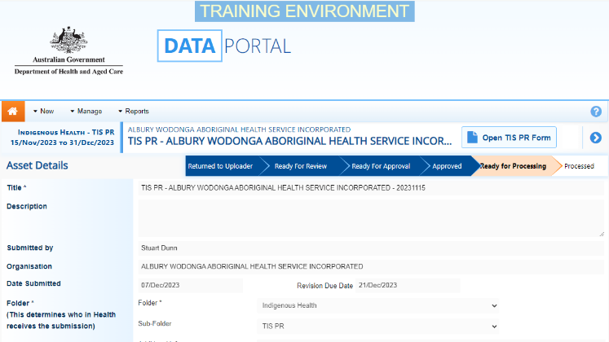
Before opening the TIS Performance Report, you should scroll down the screen to see if the service has uploaded any supporting documentation to the TIS Performance Report, using the Files section.

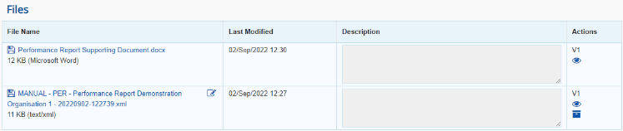
The XML file that displays here is the “backend” of the form and can be ignored. If there are any other documents attached here though (PDFs, Word documents etc) then these are for you and need to be extracted from the Data Portal so they can be reviewed as part of the service’s submission.
- To extract a document from the Data Portal, simply select the applicable File Name link. The document can now be opened and saved as needed, from the download bar at the bottom of the screen.
- To review the contents of the service’s TIS Performance Report, select at the top of the screen.
The health service’s completed TIS Performance Report form will display, broken into tabs on the left-hand side of the screen.
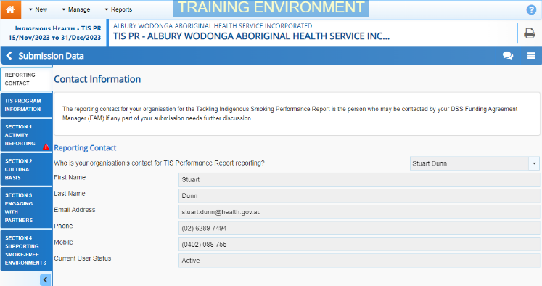
You can now work through each of the sections of the form, by selecting the tab you wish to open, assessing the content as you go.
- If you would like the health service to enter more information in a particular section, or you have questions about the content they have entered, you can add a comment by selecting .
- In the Notifications Tray that displays, select .
- In the Add Comment window, select in the Reason field and select Other.
- In the Additional Information, enter your message for the health service, specifying what it is you need them to do in this section of the form.
- To save your comment, select .
Review and Process a Health Service’s TIS Performance Report (DSS FAMs)
If you wish to delete your comment or make changes, select and select either Edit Comment or Delete Comment.
If one of the tabs on the form has a on it, it means the health service has either added a comment to the section or responded to a data validation flag that has displayed because a cell was left blank in the form.
- In the Notifications Tray, review the comment and:
  - To respond to the comment, providing instructions to the health service regarding what changes they need to make, select , select Other in the Reason field and then add your instructions for the health service in the Additional Information field and Save the comment.
  - To accept the comment and mark it as “complete,” hover your mouse pointer to the right of the comment title, select , select Completed, all data accepted in the Reason field and Save the comment.

- To exit the form and return to the Data Asset Details screen, select at the bottom of the form.
The Data Asset Details screen will display.
- Once the TIS Performance Report has been reviewed as needed, select either or the workflow progress bar at the top of the screen.
The Change Data Asset Status dialog box will display.

If you have added comments or responses to the TIS Performance Report and need to return it to the health service:
  - In the Action field, select and select Return to Uploader.
  - In the Comment field, enter any comments regarding the action being performed on the TIS Performance Report.
  - To return the TIS Performance Report to the health service, select .
The TIS Performance Report’s status will change to Submission Returned to Uploader and it has now been returned to the health service for their amendment.

If you are happy with the TIS Performance Report and are ready to process it as complete:
  - In the Action field, select and select Process.
  - In the Comment field, enter any comments regarding the action being performed on the TIS Performance Report.
  - To process the TIS Performance Report as complete, select .
The TIS Performance Report’s status will change to Processed and the processing of the TIS Performance Report is now complete.

