Download the Spreadsheet
To download a Workforce Profile spreadsheet containing your Workforce Profile FTE data for a previous collection period, from a historical OSR submission in the Health Data Portal, prior to a reporting round opening:
- Open the Health Data Portal through Health Data Portal.
- Log in using the information provided in the Register for and Log in to the Health Data Portal QRG.
The Data Portal home screen will display with the Reporting Dashboard open.
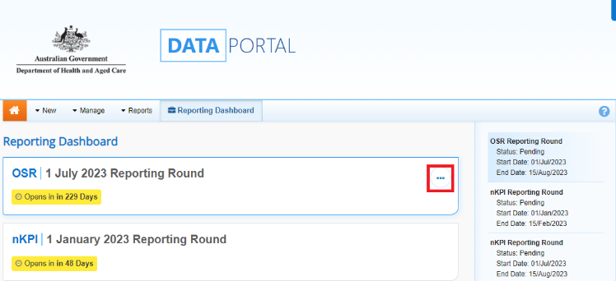
- To download the Workforce Profile Spreadsheet from your most recently Processed OSR submission, hover your mouse pointer to the right of the OSR reporting round text in the Reporting Dashboard, select (highlighted above in red) and then select Download Workforce Profile.
- In the dialog box that displays at the bottom of the screen, select and Open to open the spreadsheet.
The Workforce Profile Spreadsheet will display. 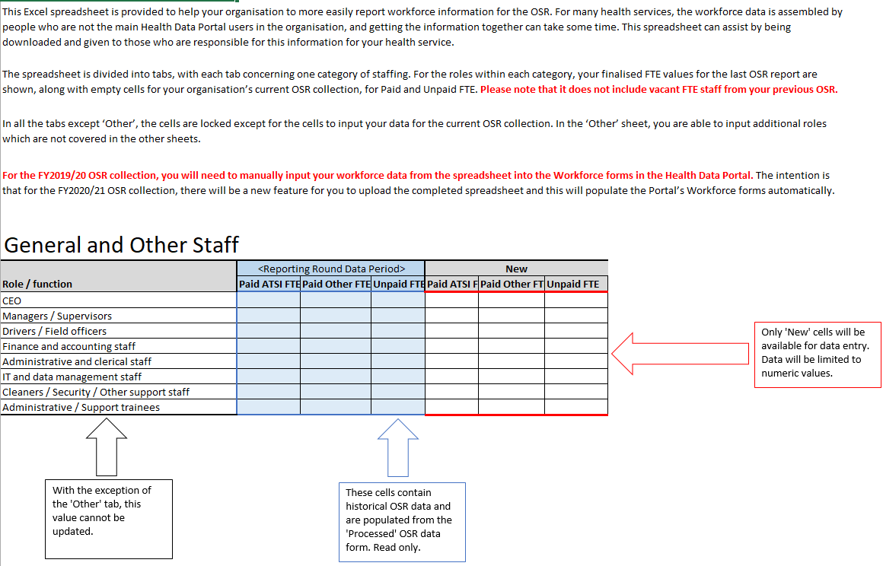
The tab that displays in the Workforce Profile spreadsheet by default is the Instructions tab. This contains instructions on how to fill out each of the different tabs on the Workforce Profile Spreadsheet. The different tabs in the spreadsheet are:
  - General and Other Staff;
  - Health Professionals;
  - Medical Specialist;
  - SEWB;
  - Allied Health Professionals;
  - Health Promotion and Prevention;
  - Training and Trainee, and
  - Other.
Each of these tabs contains a list of your health service’s positions for the applicable category, along with the paid and unpaid FTE values for each from your processed OSR submission from the most recent collection period. It also contains a section where the current FTE values for each position can be entered by the relevant staff members.
- Now share the spreadsheet (either in hard copy or by emailing it) with the applicable staff members within your health service who are going to contribute to confirming the FTE values for the different positions within your health service for the current collection period.
- Once each of these staff members have entered the applicable FTE values into the New table in each tab of the spreadsheet (using the values in the previous collection period table as needed) and returned the spreadsheet to you, compile the values entered by the different contributors into a master version of the spreadsheet as required, in preparation for entering the information into your new OSR submission in the upcoming OSR reporting round.
You are now ready to upload the completed workforce profile spreadsheet into the Paid FTE Positions and/or Unpaid FTE Positions sections of the OSR form once the next reporting round opens.

Upload the Spreadsheet
To upload the completed Workforce Profile spreadsheet to your OSR submission for the current reporting round, once the reporting round has opened:
- Open the Health Data Portal through Health Data Portal.
- Log in using the information provided in the Registering for and Logging in to the Health Data Portal QRG.
The Data Portal home screen will display with the Reporting Dashboard open.
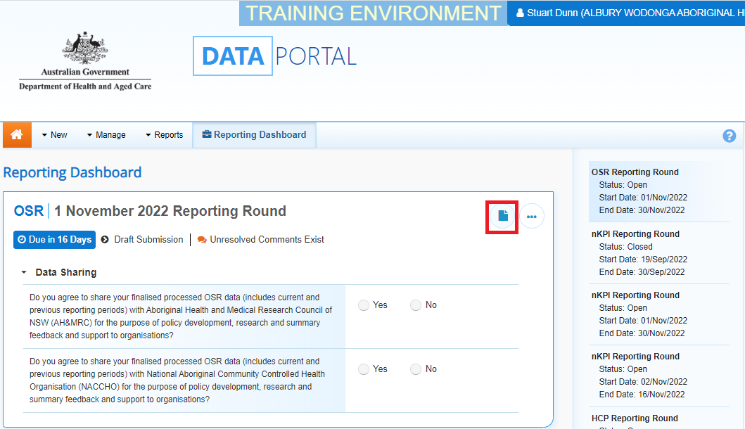
- To open the OSR form attached to the submission, hover your mouse pointer to the right of the OSR reporting round text in the Reporting Dashboard and select .
The OSR Form will display.
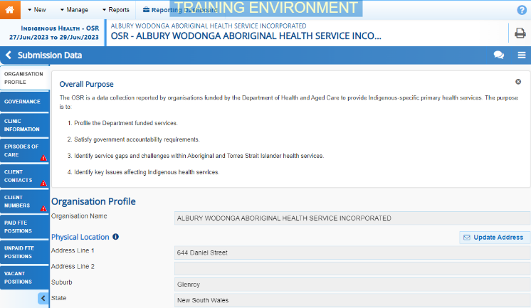
- To upload the Workforce Profile spreadsheet containing the required FTE values, select in the top right-hand corner of the form and then select Upload Workforce Profile.
This option won’t be available if the submission has previously been sent to the AIHW for processing.
- In the window that displays, select .
- Now select .
- In the Open dialog box, navigate to where the spreadsheet is located, select it, and then select .
Once you have done this, a message will display asking you to wait while your spreadsheet is processed. This may take some time.
If the selected spreadsheet is not in the correct format, you will receive an error message.
- Once your spreadsheet has been successfully uploaded, in the window that displays, select .
- Select the applicable FTE tab in your OSR form now and review the values to ensure they have upload correctly.
- Make any changes to the values as needed and then Save and Close the form as normal.

