There may be times when the file attached to your Processed data asset needs to be removed from the Data Portal, once all work has been completed on it as required, due to the sensitive nature of its content.
Purge a File from a Data Asset Submission
Only users with both the Data Purge User and Data Receiver roles can perform this function.
To purge a file from a data asset in the Data Portal:
- Open the Data Portal through Health Data Portal.
- Log in using the information provided in the Registering for and Logging in to the Health Data Portal QRG.
The Data Portal home screen will display.
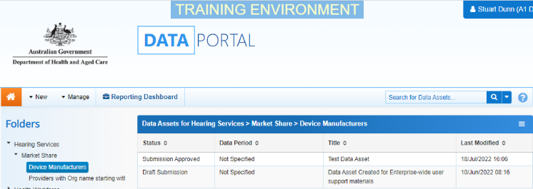
- From the home screen search for the data asset.
For more information on how to search for a data asset, see the Get Started in the Health Data Portal QRG.
- In the Data Assets section select the data asset containing the file to be removed.
The Data Asset Details screen will display.
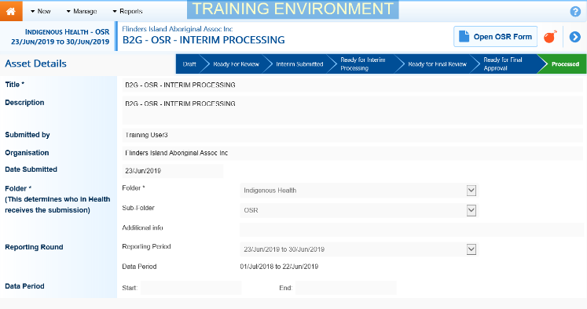
- To remove the attached file from the data asset, select at the top of the screen.
The data asset must be at the status of Processed for the button to be available.
The Purge Data dialog box will display, asking if you are sure you wish to remove all files from the data asset.
- To continue with the data purge, select .
You will be returned to the Data Portal Home screen and the data asset you have removed the file from has now disappeared from view. This data asset’s status will now be set to Queued for purge.
- If you want to search for the data asset to ensure the file has been successfully removed, select next to the Search for Data Assets… field and select the (Select All) check box twice to remove all selections and then select the Queued for Purge check box.
- To continue, select .
All data assets you have access to view, with the status of Queued for Purge, will display.
The file will now be removed from the data asset before midnight that night so, if you open the data asset the day after selecting to purge the file, the file will be gone.

