To approve your service’s nKPI submission after it has been amended by your Submission Uploader/Reviewer as requested by the AIHW:
Approve your nKPI Submission based on AIHW Feedback (Submission Approver)
- Open the Data Portal through Health Data Portal.
- Log in using the information provided in the Register for and Log in to the Health Data Portal QRG.
The Data Portal home screen will display with the Reporting Dashboard open.
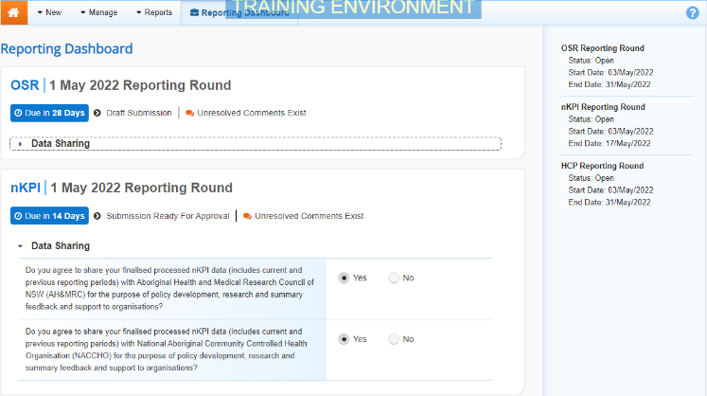
To be eligible for approval, your service’s nKPI submission’s status will need to be Submission Ready for Approval.
- To open your nKPI form, hover your mouse pointer to the right of the nKPI reporting round text in the Reporting Dashboard and select.
The nKPI form will display.
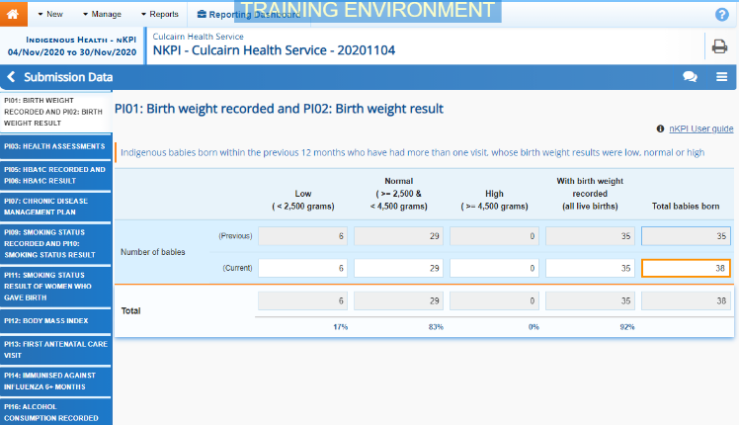
Any value changes made in the form by your Submission Uploader or Submission Reviewer will appear in an additional line with Current next to it and an orange border around the cell that has been changed. Any changes you then make to values will update the Current line with the updated value still highlighted by an orange border. All users viewing the form can now easily identify the original value submitted to the AIHW by the health service, and the updated value that has been changed following AIHW feedback.
- Review the data in your nKPI form as required, focussing on indicators with a displaying on the corresponding tab, if there are any.
- In the first section/indicator of the form displaying a , read the comment that has been left for you in the Notifications Tray.
If the Notifications Tray doesn’t display, select in the top right-hand corner of the form to open it.
- If the comment is just for your information or you’re happy it has been addressed as needed through the data that has been added in the section, select at the top of the comment in the Notifications Tray.
- In the Notifications window that displays, select .
The comment has now been removed from the nKPI form.
- Repeat steps 4 to 7 as needed for each comment that has been left in the form by your Submission Uploader/Reviewer.
If you need to respond to one of the comments that has been left, select in the comment in the Notifications Tray. In the window that displays, select a Reason, and enter your response in the Additional Information field and select . Your response has now been added and can be addressed by your Submission Uploader as needed once you send the nKPI submission back to them for amendment.
- To exit your nKPI form and return to the Data Portal home screen, scroll to the bottom of the form, and select .
The Data Portal home screen will again display with the Reporting Dashboard open.
- To progress your nKPI submission through the submission workflow, select .
- In the Change Data Asset Status dialog box, in the Action field, select and select Approve for Submission.

If you responded to one of the comments in the form and need to send the nKPI report back to your Submission Uploader so they can address your response, select Revision Required and then select .
Approve your nKPI Submission based on AIHW Feedback (Submission Approver)
- In the Comment field, enter any comments about the action being performed on the nKPI submission.
- To approve your nKPI submission and send it for processing by the AIHW, select . See the Process an nKPI Submission QRG for the next step in the process.
Your nKPI submission has now been approved and sent to the AIHW again for processing.

