There may be times when the data asset you have submitted for review or approval is returned to you by the Submission Reviewer or Submission Approver for amendment.
Amend a Data Asset Submission
To amend a data asset in the Data Portal:
- Open the Data Portal through Health Data Portal.
- Log in using the information provided in the Registering for and Logging in to the Health Data Portal QRG.
The Data Portal home screen will display.
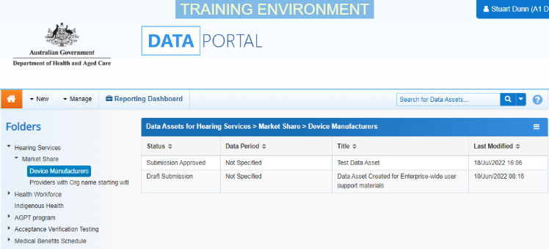
- From the home screen search for the data asset.
For more information on how to search for a data asset, see the Get Started in the Health Data Portal QRG.
- In the Data Assets section select the data asset.
The Data Asset Details screen will display.
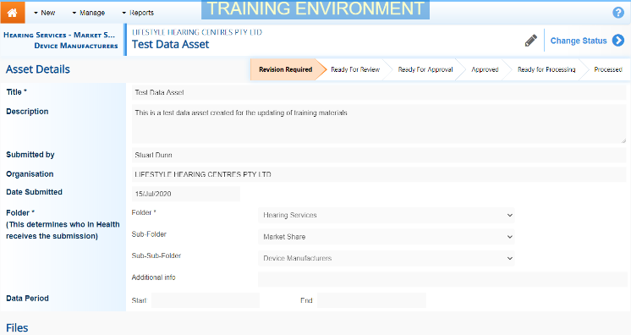
- To update the details of the data asset, select at the top of the screen
The Data Asset Details screen will update so active (white) fields can be edited (including answering Data Submission questions, if needed).
- Make the required changes to the active fields.
- There are several actions which can be performed on the attached file in the Files section.

Button | Description
 | Select this button under File Name to download and vie. A pop up will appear in the bottom left-hand corner of the screen and you can open the file from here and save it.
 | Select this button under File Name to replace the file with another file if it has been uploaded incorrectly.
 | Select this button under Actions to view the file’s previous versions.
 | Select this button under Actions to activate the Description field so a description of the file can be added.
 | Select this button under Actions to remove the file from the data asset.
 | Select this button under Actions to view the file’s download history.
Select this button under Actions to add an updated version of the file if needed.
This will add a second file, rather than replace the existing one.
- To save your changes to the data asset details, select .
- Once the data asset has been reviewed and updated, select either or the workflow progress bar at the top of the screen and, in the Change Data Asset Status dialog box, in the Action field, select and select the required action.
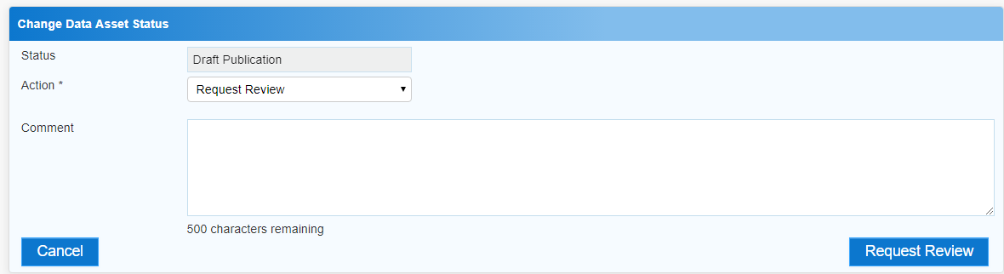
The Submission Reviewer or Submission Approver should have added comments to the Comment field with the changes that need to be made to the data asset.
The available actions are:
- Request Review – Select to send the data asset for review again.
- Request Approval – Select to send the data asset on to the appropriate person within the organisation for approval.
- Remove Data Asset – Select if the data asset is to be deleted from the Data Portal (it may have been created in error).
If you can approve data asset submissions, you will see the Approve for Submission option in the action list. This allows you to approve the data asset and submit it directly to an external data receiver for processing.
Amend a Data Asset Submission
- Add any comments regarding your amendment of the data asset in the Comment field.
- One of the following options can now be selected:
  - To send the data asset for approval, select 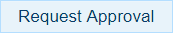. See the Approve a Data Asset Submission QRG for the next step in the process.
  - To send the data asset for review again, select 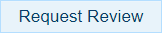. See the Review a Data Asset Submission QRG for the next step in the process.
  - To remove the data asset from the Data Portal, select .
To save the data asset as a draft select .
The data asset has now been amended and submitted to the next stage of the process.

